

Faculty of Applied Sciences  
Bachelor of Science in Computing

**COMP490 Final Year Project  
Final Report**Academic Year 2022/23

|  |  |
| --- | --- |
| Parsons problem generator and solver | |
|  |  |
| Project number: | 19 |
| Student ID: | P-19-0834-5 |
| Student Name: | Jane Liu |
|  |  |
| Supervisor: | Philip Lei |
| Assessor: | Charles Lam |
|  |  |
| Submission Date: | 24/11/2022 |

Declaration of Originality

I, Jane Liu, declare that this report and the work reported herein were composed by and originated entirely from me. This report has not been submitted in any form for another degree or diploma at any university or other institute of tertiary education. Information derived from the published and unpublished work of others has been acknowledged in the text and a list of references is given in the bibliography.



Jane Liu

02/11/2022

Abstract

Parsons problem is a convenient study tool used in introductory programming courses since it can reduce students’ cognitive load for writing codes directly. But in Data Structures and Algorithm, the traditional Parsons problem is not so applicable because of the change in course focus.

This project attempts to build an application of Parsons problem in website form for assisting students in learning Data Structures and Algorithms. Based on the analysis of concrete problems in this course, more flexible question types are expanded in this project, including splitting into multiple steps, algorithm comparison and algorithm analysis. In addition, more ways to handle difficulty level is applied, and switching difficulty level is allowed.

The results of this project show that it can provide students with help in familiarizing themselves with intermediate-level programming involved in this course. And experiment will be done in the future to verify the effectiveness.

Acknowledgement

I would like to express my sincere graduate to my supervisor Philip Lei for his guidance and support throughout this project. Under his patient guidance, I was able to basically understand the difference between a research-based project and a development-based project, and to capture the key parts of this project to have a better development and presentation results in a limited time frame. In addition, my supervisor was very attentive in reviewing the project and making detailed suggestions. With his suggestions, I was able to achieve complex functions, improve user experience, and have clear description in the report and presentation. During the past year, my supervisor has not only taught me how to conduct research but also imparted a scientific and rigorous research spirit to me. Without my supervisor's help, I would not have been able to complete my final year project successfully.

I am also sincerely grateful to our school. In the past four years, our school equipped me with necessary knowledge of programming, internet programming, database design and management. With the knowledge, I have the capabilities to develop my final year project individually. Besides, with the facilities provided by our school, I can finish my project efficiently and conveniently.

Finally, I would like to thank my parents and my elder sister. With their help in applying master’s degree for me, I can keep focus on developing my final year project.

Table of Contents

1 Introduction 14

1.1 Objectives 14

1.2 Risk Assessment 16

1.2.1 Risk 1: The computer used for implementation may break down 16

1.2.2 Risk 2: The system does not support different devices 16

1.2.3 Risk 3: Users reject this website because of the inferior user interface 16

1.3 Summary 17

2 Background and Related Work 18

2.1 Background 18

2.2 Related Work 19

3 Design Approach 20

3.1 Parsons Problem Analysis 20

3.1.1 Object-oriented programming 21

3.1.2 Algorithm analysis 23

3.1.3 Recursion 25

3.1.4 Data structures implementation comparison and algorithms comparison 26

3.2 Balance the Degree of Difficulty 29

3.2.1 Switch different difficulty levels 29

3.2.2 Pre-scaffold 30

3.2.3 Context 30

3.3 Holistic Analysis 31

3.4 Dynamic Modelling 33

3.5 Data Modelling 34

4 Implementation 39

4.1 Major Techniques and Tools Used 39

4.1.1 Front-end 39

4.1.2 Back-end 40

4.1.3 System architecture 40

4.2 Traditional Parsons Problem 41

4.2.1 Overview of implementation of traditional parsons problem 41

4.2.2 Drag-and-drop 44

4.2.3 2D view 45

4.2.4 Check and show feedback 48

4.2.5 Distractor 50

4.3 Contextual Clues 51

4.3.1 Customize solution 51

4.3.2 Show in answer pool 52

4.3.3 Check and feedback 53

4.4 Multiple Step 54

4.4.1 Customize solution 54

4.4.2 Show and check 56

4.5 Algorithm Comparison 57

4.6 Switch Difficulty Level 57

5 Results and Discussion 59

5.1 Results of Basic Process: Present Home Page 59

5.2 Results of Basic Process: Register and Login 60

5.3 Results of Basic Process: Create Question 62

5.4 Results of Basic Process: View Exercise Detail and Do Exercise 64

5.5 Results of Basic Process: View Records 66

5.6 Results of Different Question Types: Traditional 70

5.7 Results of Different Question Types: Contextual Clues 71

5.8 Results of Different Question Types: Multiple Step 74

5.9 Results of Different Question Types: Algorithm Comparison 78

5.10 Results of Other Function: Distractor 79

5.11 Results of Other Function: Switch Difficulty Level 81

5.12 Compare with the Traditional Parsons Problem 87

5.12.1 Object-oriented programming 87

5.12.2 Recursion 89

5.12.3 Comparison 90

5.13 Opinions from the Questionnaire Survey 92

5.13.1 Reorder codes by dragging and dropping 92

5.13.2 Check and feedback 93

5.13.3 Comparison 93

5.13.4 Switching difficulty level 94

5.13.5 View students’ exercise records 94

5.13.6 Online platform 94

5.13.7 User experience 94

5.14 . Limitation 95

5.14.1 Limitation caused by the Parsons problem itself 95

5.14.2 Limitation caused by the tight time 96

6 Conclusion and Future Work 97

References 98

Appendix A. Project Management 100

Appendix B. Reflection 102

Table of Figures

Figure 1: Probability impact matrix – initially (left) and solutions (right) 17

Figure 2 Changing method positions does not affect the correctness of codes 21

Figure 3: The description of methods in a stack (left) and the corresponding codes (right) 22

Figure 4 The traditional Parsons problem (above) and the variation of Parsons problem (below) 23

Figure 5: Performance of a heap-based priority queue 25

Figure 6 The recursion example code of the Tower of Hanoi 25

Figure 7 Steps for solving Fibonacci Sequence 26

Figure 8: The array-based stack and the linked-list-based stack 27

Figure 9 The ordered array stack code pool (left) and the unordered linked-list stack code pool (right) 28

Figure 10 Selection sort (left), insertion sort (middle) and the mixed code pool (right) 29

Figure 11 Example for inserting key code fragments 30

Figure 12 Student activity diagram 33

Figure 13 Teacher activity diagram 34

Figure 14 ER diagram 38

Figure 15 System architecture diagram 41

Figure 16 Related methods about storing codes in database 43

Figure 17 Example of ‘FragmentSeq’ of ‘Block’ in database 43

Figure 18 Get fragments according to question id 44

Figure 19 Get order of codes 44

Figure 20 Drag-and-drop 45

Figure 21 Example of Vue Grid Layout 46

Figure 22 Example of Vue Draggable Nested 47

Figure 23 Increase or decrease indent 48

Figure 24 Check and get feedback 49

Figure 25 Distractor in customize solution 50

Figure 26 Show distractor 51

Figure 27 Check distractor 51

Figure 28 Example of context type of question in customizing solution procedure 52

Figure 29 Showing context or insert key code 53

Figure 30 Check and feedback about context or insert key code 54

Figure 31 Multiple step in customize solution (script) 55

Figure 32 Multiple step in customize solution (template) 56

Figure 33 Multiple step in showing and checking 56

Figure 34 Algorithm comparison 57

Figure 35 Create easier version pointer 58

Figure 36 Home page 60

Figure 37 Example for filtering python basis question 60

Figure 38 Login page 61

Figure 39 Hashed password stored in database 61

Figure 40 Register page 61

Figure 41 Different navigation bar for visitors (1), teachers (2) and students (3) 62

Figure 42 Create new question page 62

Figure 43 Choose question type page 63

Figure 44 Upload solution page 63

Figure 45 Customize solution page 64

Figure 46 Question detail page 65

Figure 47 Drag and drop 65

Figure 48 Feedback alert 65

Figure 49 Codes with different background colors 66

Figure 50 Students’ personal center 67

Figure 51 Edit user’s name 67

Figure 52 Teachers’ personal center: view students’ exercise records 67

Figure 53 Teachers' personal center: manage question 68

Figure 54 Edit question 68

Figure 55 Delete question 68

Figure 56 Teachers' personal center: manage classes 69

Figure 57 Create class 69

Figure 58 Edit class 69

Figure 59 Delete class 70

Figure 60 Traditional: customize solution page 70

Figure 61 Traditional: exercise detail page 71

Figure 62 Context: customize solution page 72

Figure 63 Context: exercise detail page 73

Figure 64 Insertion in binary search tree 73

Figure 65 Insert key code: customize solution 74

Figure 66 Insert key code: exercise detail page 74

Figure 67 Multiple step: customize solution 75

Figure 68 Multiple step: divide into steps 76

Figure 69 Multiple step: exercise detail page 76

Figure 70 Example: insert and delete nodes in binary search tree 77

Figure 71 Algorithm comparison: customize solution page 78

Figure 72 Algorithm comparison: exercise detail page 79

Figure 73 Distractor: customize solution page 80

Figure 74 Distractor: exercise detail page 80

Figure 75 Feedback for correct code 81

Figure 76 Feedback for distractor 81

Figure 77 Switch question type: customize solution page 83

Figure 78 Switch question type: choose question type for easier version 83

Figure 79 Switch difficulty level: choose question type for easier version (with more description) 84

Figure 80 Switch difficulty level: customize solution for easier version 85

Figure 81 Switch difficulty level: exercise detail page of original question 86

Figure 82 Switch difficulty level: exercise detail page for easier version 87

Figure 83 Example: multiple correct answers caused by changing method positions (1) 88

Figure 84 Example: multiple correct answers caused by changing method positions (2) 88

Figure 85 Example: pin the method headers to have fix order of methods 89

Figure 86 Tower of Hanoi 90

Figure 87 Divide recursion problems into several steps 90

Figure 88 Selection sorting 91

Figure 89 Insertion sorting 91

Figure 90 Compare selection sort and insertion sort 92

Figure 91 Program plan 100

Figure 92 Gantt chart 101

List of Tables

Table 1: Table of prioritized risk 17

Table 2 Entity 35

Table 3 Relationship between entities 35

Table 4 Attributes in each entity 36

Table 5 Logical Data Model 37

# Introduction

In recent years, with the computer industry boom, a growing number of people prefer to major in science in computing at their universities in order to find decent jobs after graduating. However, for some of the learners of this program, the courses are not straightforward, especially some courses having programming practices. To equip students with the programming skills, an advanced learning method, Parsons problem, has been introduced into the introductory programming courses (CS1 [1]). With the drag-and-drop programming style, this method allows the students to reordering the mixing up prepared blocks of codes to build the predefined solutions, which provides students with preparation steps by giving them sterling answers to refer before they need to write codes by themselves. Although Parsons problem gives notable assistance in programming study, it is limited in the programming practices in CS1 and it has never been used in teaching activities in higher-level programming courses such as Data Structures and Algorithms (CS2 [1]). Admittedly, students taking intermediate-level programming courses should be able to write code instead of just rearranging the order of provided answer blocks. However, because of the abstractness and complexity of programming in this course, it is also a challenging task for students to write it by themselves directly. Thus, it is of the essence to introduce Parsons problem to build a “bridge” for students to grow their programming capability. However, since there are some differences between CS1 and CS2, the traditional Parsons problem cannot be applied in CS2 without any adjustment. Therefore, in this project, how to use Parsons problem in new ways to fit the programming exercises in CS2 is discussed.

## Objectives

This project aims to design and build a web application for computer usage to let teachers input problems and solutions (in Python), generate Parsons problems according to the inputs, make students solve the generated Parsons problems, and provide feedback for the solutions. The major objectives of this project are as follows:

* Study the existing Parsons problem components (question description, correct code fragments and distractors) and common methods to reduce the difficulty (pre-scaffold and context)
* Design new ideas for using Parsons problem in CS2 according to the concrete questions in exercise of CS2
* Design the system architecture to have a blueprint of the project
* Design and implement a database to store the data about accounts, questions, solution code fragments, distractors, and feedbacks
* Design and implement a web page for teachers to input the questions with corresponding solutions
* Design and implement a function to generate Parsons according to the inputs problem, including cutting the whole python file into code fragments and presenting these code fragments in a random way
* Design and implement a web page showing code pools with code fragments in random orders and structured place with vertical dimension and horizontal dimension
* Design and implement a function for students to drag and drop code fragments from the pools and put them in the structures places in proper order with proper indentation
* Design and implement a function for students to evaluate the code generated by students and give them some feedback

In this project, the Parsons problem will be used to handle the exercises in CS2 to have preparation steps for students to write codes by themselves. The variation of Parsons problem can not only take the advantages of the existing Parsons problem (like improving students’ engagement and reducing students’ cognitive load [2]), but also have some new benefits. To be more specific, the new design can handle the specific concepts only existing in CS2. In addition, it can help students to build excellent habits to solve problems. Last but not least, it can help students to consolidate what they have learned through many different ways.

There are several challenges in this project. Firstly, it needs to study intensively the concrete exercises in CS2 to figure out the possible amelioration of existing Parsons problem. Secondly, it needs to design and develop proper Parsons problem fitting the exercises in CS2. Last challenge is to implement a 2D view for dragging and dropping the code blocks.

## Risk Assessment

This section will describe three risks encountered in the project, illustrate the severity priorities of these three risks, and show the effectiveness of the related solution by comparing the impact and possibility before and after.

### Risk 1: The computer used for implementation may break down

Since the whole project work, including codes and documents, is stored on the computer, it will be a disaster when computer errors occur. All work will disappear in a moment, and the previous effort will go down the drain, which will seriously affect the project's progress.

Solution: Take advantage of online backups such as GitHub or Google Drive to ensure the progress will not be affected when the computer acts up.

### Risk 2: The system does not support different devices

Although this web-based project is designed to be used on computers majorly, some users may try to open it on their tablets. Since the changes in screen sizes between these three kinds of devices, some interfaces of web pages may look too small or too strange, which may bring users an awful experience and reduce their motivation for further use of this website. In that case, it does not seem conducive to the future growth of this project.

Solution: Design a responsive website to fit the size of different devices satisfying users’ needs on various devices.

### Risk 3: Users reject this website because of the inferior user interface

If the user interface is unfriendly, the user may misunderstand some instructions given by this website and repeat some unexpected wrong actions again and again, which wastes a lot of users’ time and may cause users to be impatient and give up easily. And this situation is not beneficial for the long-term development of this project.

Solution: Apply common design principles like Eight Golden Roles to the interfaces. In addition, simulate a user to access some related projects and get some ideas from their design.

To sum up the severe level of these previously mentioned risks, a priority risk table has been shown in Table 1.

Table 1: Table of prioritized risk

|  |  |
| --- | --- |
| Priority | Risk Identifier and Description |
| 1 | Risk 1: The computer used for implementation may break down |
| 2 | Risk 3: Users reject this website because of the inferior user interface |
| 3 | Risk 2: The system does not support different devices |

As shown in Table 2, there are three related risks. Specifically, the first risk has the highest priority since it may redo the whole work, which may significantly delay the development of this project. Subsequently, the third risk has lower priority than the previous risk since the project can still perform when affected by this risk. However, this risk may cause the users to feel confused and fretful, so they may not want to use the website again, which is unsuitable for the popularization of the website. Lastly, the second risk has the lowest priority since this website will be major used on computers, and only a few people using other platforms are affected by this risk.

The probability impact matrixes have been shown in the following two figures to directly show between before and after using solutions.

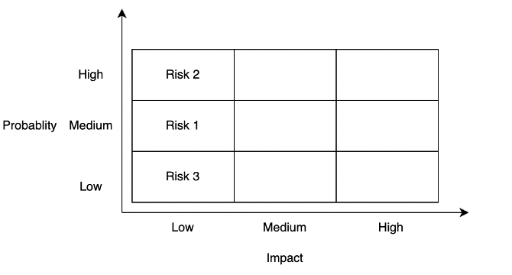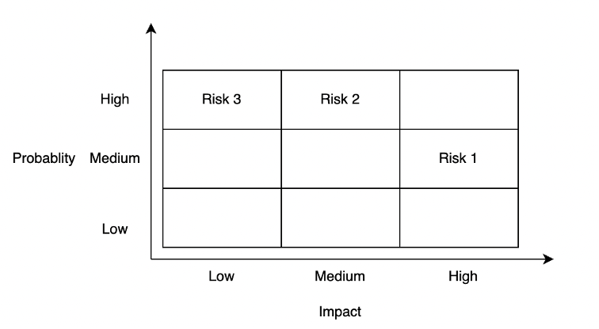

Figure 1: Probability impact matrix – initially (left) and solutions (right)

## Summary

This report is organized as follows: Chapter 2 introduces the background and related work of Parsons problem. Chapter 3 presents high-level design. Chapter 4 shows the detailed implementation. Chapter 5 is the result and discussion. Chapter 6 is the conclusion.

# Background and Related Work

This chapter explains the background and related work of Parsons problem. In the background section, the components and structures of Parsons problem are explained. In addition, the brief difference between the existing Parsons problem and the common limitations of these work are also explained.

## Background

The Parsons problem is a drag-and-drop-style code-reordering problem. Precisely, in a Parsons problem, a prepared correct, complete solution code of a specific problem is cut into plenty of small code fragments in lines. These code fragments are provided to students in a random order in a code pool with some incorrect or improper ones (distractors). And students should select the correct code fragments from the code pool and drag and drop these code fragments to place them the correct order. During this period, students can get some instruction feedback based on their reordered answers, and they need to improve their answers based on the feedback until they get the same answer as the predefined answer [2].

The Parsons problem contains the following four components:

* **Question descriptions** illustrate the questions in text or activity diagrams. Using activity diagrams in Parsons problem, students can understand the problem’s solution logic before they begin solving it [2].
* **Correct code fragments** are lines in correct solution codes. Since students only need to choose and reorder prepared code fragments instead of writing codes directly, the cognitive load is reduced, so the difficulty of programming questions is discounted [2]. In addition, this design provides magnificent solution examples as reference material for students to analogize some similar questions.
* **Distractors** are some incorrect or improper code fragments mixing with the original correct ones. By comparing with the correct code fragments, students can not only distinguish some common errors but also cultivate good coding habits like using meaningful and conforming naming rules names [2].
* **Feedback** is used to give students improving hints based on students’ solutions. There are two different types of feedback – line-based feedback and execution-based feedback. Line-based feedbacks evaluate students’ solution by comparing them with the prepared solution, while execution-based feedbacks evaluate students’ solution by running codes directly. Both kinds of feedback can provide students with instant feedback to give students some instructions for improving [3].

Besides the contribution of Parsons problems components in reducing difficulties of programming questions, there are two common methods to ease the programming problem further:

* **Pre-scaffold**: it reduces difficulty by providing hints of the organization of solution codes. It can be achieved by indicating some structures like loop structures based on braces or indentations [4]. Moreover, it also can be achieved by giving subgoals [5].
* **Context**: some settled code is provided around the sorting codes [6].

## Related Work

This method has been used in many previous work about programming education. To be more specific, Parsons and Haden developed a web-based tool for generating Parsons problems for introductory programming in BASIC with jumbled distractors, pre-scaffolding, and absolute line-based feedback [2] [3]. Besides, Karavirta et al. developed a Parsons problems project called js-parsons for introductory programming in Python with no distractors, student-scaffolding, and relative line-based feedback [3] [6]. Lastly, Amruth developed Epplets for introductory programming in C+, C#, and Java with distractors and relative line-based feedback [3] [7]. In conclusion, although the previous work provides Parsons problem practice in several programming languages with different structures, these projects have one thing in common – they are only applied for introductory programming, which gives this project room for improvement.

# Design Approach

This chapter explains the design approach in high level, including Parsons problem analysis, balance the degree of difficulty, holistic analysis, dynamic modelling and data modelling. In Parsons problem analysis, the differences in questions between CS1 and CS2 are explained. In balance the degree of difficulty, the ways to reduce the difficulty are explained. In holistic analysis, the overall blueprint of Parsons problem summarizing the before two sections are defined. In dynamic modelling, the activity diagram of teachers and students are illustrated. In the final section of this chapter, the database design is explained.

## Parsons Problem Analysis

The traditional Parsons problem has shown its advantages in exercises of CS1. However, since there are plenty of differences between the exercises in CS1 and CS2, it is not so proper to apply Parsons problem directly in CS2 without tailored improvement. Thus, some new ideas should be introduced to Parsons problem. The limitation of the traditional Parsons problem and new ideas will be discussed in the following paragraphs by comparing the difference between CS1 and CS2.

Unlike CS1, the codes in CS2 are much more complex and abstract in the following three general aspects. To be more precisely, students are supposed to not only understand the meaning of every line but also be able to organize these single lines into larger blocks (like methods, classes, even algorithms) in order to have a deeper understanding of the features of data structures, the recursive solving method, and the algorithms analysis. In addition, codes are no longer the only points covered in Parsons problem. Some new abstract elements like pseudocode and algorithms analysis should also be involved in exercises of CS2. Finally, high comparing ability is required in CS2 since there are plenty of similar concepts like stacks and queues, different types of trees, and different algorithms to solve the problems.

The difference between the CS1 and CS2 courses mentioned above leads to deficiencies in applying the traditional Parsons problem. To show these limitations in detail and introduce the improvement aiming at these limitations, the exercises in the famous textbook *Data Structures and Algorithms in Python* [8]were analyzed, and four common question types were identified.

### Object-oriented programming

Object-oriented programming is a programming model based on objects, which includes attributes and methods [9]. In CS1, since all the programming parts are Structured Programming, the object-oriented programming concept has never been involved. However, in CS2, this concept becomes one of the focal points since it is the foundation to build different data structures. But after introducing this concept, Parsons problem for data structure questions cannot have unique answers since the methods in the classes can change their positions without affecting the correctness of the results (for example, Figure 2).

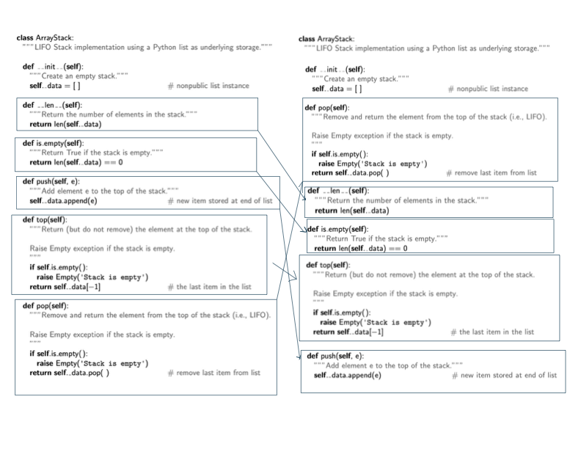

Figure 2 Changing method positions does not affect the correctness of codes

To have a unique answer, some paragraphs describing the functions of the methods should be listed in a specific order in the question description, and students are asked to build methods one by one in a matching order. For example, in Figure 3: The description of methods in a stack (left) and the corresponding codes (right), the left part shows the description of methods of an abstract data type stack in a specific order, and the corresponding methods are implemented in a matching order in the right part. In this way, a unique order of answers is defined by design. Thus, Parsons problem can not only fit the object-oriented programming type of questions but also keep some of its reordering features simultaneously. More importantly, this new design idea enhances students’ understanding of the whole method instead of just every individual line. Further, by this design, students also can have a general idea about what features of a specific abstract data type (ADT) should have [8].

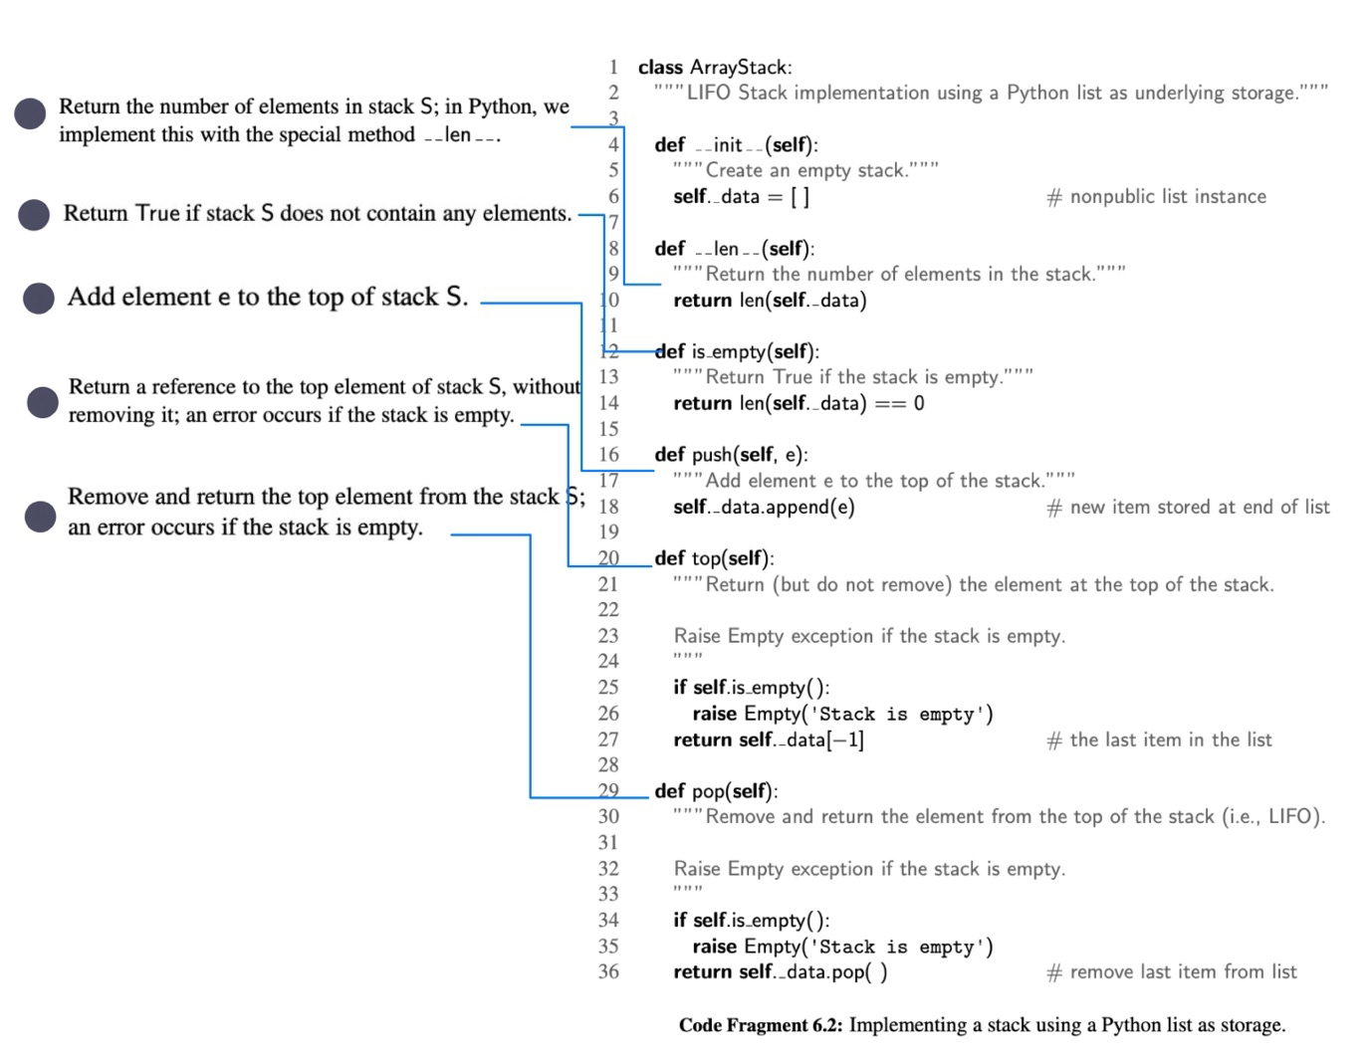

Figure 3: The description of methods in a stack (left) and the corresponding codes (right)

Another way to handle this problem is only to check the availability of methods and the contents of methods but ignore the positions of the methods. This variation of Parsons problem is significantly different from the traditional Parsons problem (Figure 4). Specifically, in the traditional Parsons problem, the interchangeable lines are combined into a larger block to have a unique answer [6]. In this way, it ignores the smaller parts (lines) and focuses on the bigger ones (blocks). By contrast, the new design looks the opposite way compared to the previous design. It ignores the bigger parts (order between different methods) and focuses on the smaller parts (lines inside the methods).

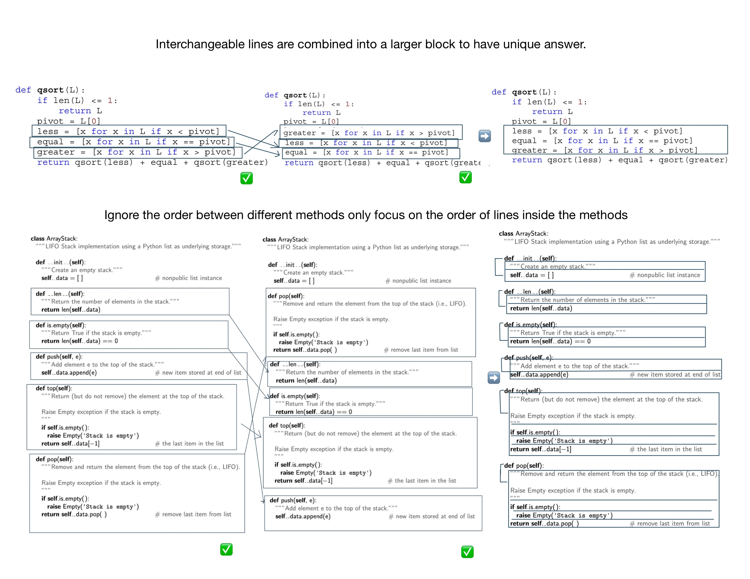

Figure 4 The traditional Parsons problem (above) and the variation of Parsons problem (below)

### Algorithm analysis

Algorithm analysis, which is a core part of CS2, is to use the running time to evaluate whether a data structure or an algorithm is efficient or not [8]. Since the growth rate of running time as a function of the input size n is vital for algorithm analysis, big O, which shows the significant parts affecting the growth, is introduced in algorithm analysis [8]. Since the only major data structure used in CS1 is array – one of linear data structure, the algorithm analysis in CS1 can be done simply by counting the number of times a statement runs. In other words, the algorithm analysis in CS1 mostly depends on the loop structures in the codes so that there are only four functions (the constant function, the linear function, the quadratic function, and the cubic function and other polynomials) are used in programming. By contrast, the codes in CS2 involves more complicated non-linear data structures such as trees or graphs, which means that students should not only consider the impact of code structures but also non-linear data structures when analyzing the codes. For example, a loop to traverse a balance tree will consume O(log n) steps, not O(n) steps (where n is the number of nodes in the tree). Thus, more big O classes are used commonly in CS2 (the constant function, the logarithm function, the linear function, the N-log-N function, the quadratic function, the cubic function and other polynomials, and the exponential function) [8]. It is strenuous to ascertain which functions are the correct functions to describe the efficiency of the specific data structures and algorithms. Besides the impact of non-linear data structure, the recursion is another reason to make the analyzing experiencing learned from CS1 impractical. It is not straightforward to observe how many times a recursion function done. For these reason, the algorithm analysis parts are always ignored in CS1, so the traditional Parsons problem for CS1 certainty cannot handle this algorithm analysis questions, which is another drawback for using traditional Parsons problem directly in CS2.

To involve the algorithm analysis, only operating the code cannot satisfy the situation anymore. Thus, a new component – comment – is introduced in Parsons problem. To be more specific, the comments are used to provide different big O classes for choosing. Students need to select the correct corresponding big O class comments and insert them into codes to do algorithm analysis of the whole code. Unlike the previous reordering questions, this question is more like a multiple-choice question since students can put the comment wherever they like. Furthermore, this new idea also can be expanded in two ways. One way is to provide not only big O but also the described reasons to get big O. In this way, students can have a deeper understanding of algorithm analysis instead of just guessing big O classes according to their feelings. Another way is to let students match different big O classes with different parts in codes. This way can be used to track the change points of big O classes (like outer for loop and inner for loop), or it can be used to compare different methods in a data structure and let students know the characteristics of a data structure (For example, a heap is quick to get the min value, but it is slow to add nodes, shown in Figure 5).

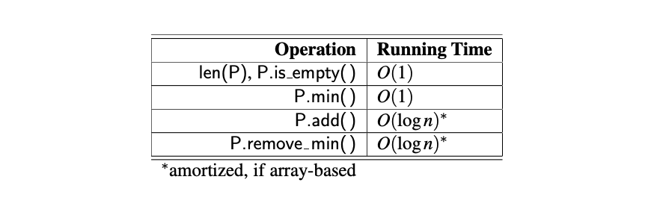

Figure 5: Performance of a heap-based priority queue

### Recursion

Recursion is solving a problem by solving a subproblem with the same structures as the original problem. It is achieved by calling the function itself, passing smaller argument values to build subproblems, finding the answers to subproblems, and using these answers to solve the original problem. Unlike in CS1, the recursion method is called inside instead of outside of the method body, which requires students with deeper understanding in the whole picture of entire methods besides concrete lines in the methods. For this reason, it leads to a dramatic increase in the difficulty of problems, and the traditional Parsons problem cannot significantly reduce complexity. Concretely, the traditional Parsons problem reduces difficulty by providing some code fragments for students to read. However, in the recursion type of question, it is arduous to understand the meaning of every line of code even if the whole code is given in order (like the recursion example code of the Tower of Hanoi in Figure 6 [10]). Thus, the assistance coming from code reading of Parsons problem is notably shrunk, and it is almost like letting students write code directly. That is why the traditional Parsons problem needs to be improved to give students more hints in solving recursion questions.

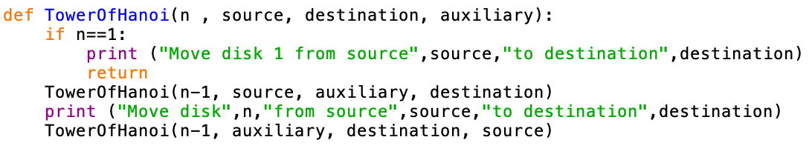

Figure 6 The recursion example code of the Tower of Hanoi

According to the suggestions for designing recursive algorithms provided by the textbook, it is beneficial to find a few specific subproblems which have the same structures as the original problems [8]. To achieve the suggested way, a new pre-scaffold way – organizing in several steps – is introduced into Parsons problem. To be more specific, one recursion question is divided into some steps. The first step is to let students reorder the code of base cases (the end point of every recursion chain [8]). Subsequently, change the values of parameters used in this recursion algorithm to have other subproblems. And in this step, the previous base cases should also be involved. In other words, students need to build these subproblems by calling the method in the base cases. In the following step, students should choose the correct method headers with proper signatures. In the final step, students are required to reorder the actual recursion codes with all the previous codes as references. This new pre-scaffold way can be partially helpful for students to solve the recursion problems. In this new way, students are provided with more hints (like subproblems) than directly solving recursion questions. Thus, they are less like to be all at sea (Figure 7).

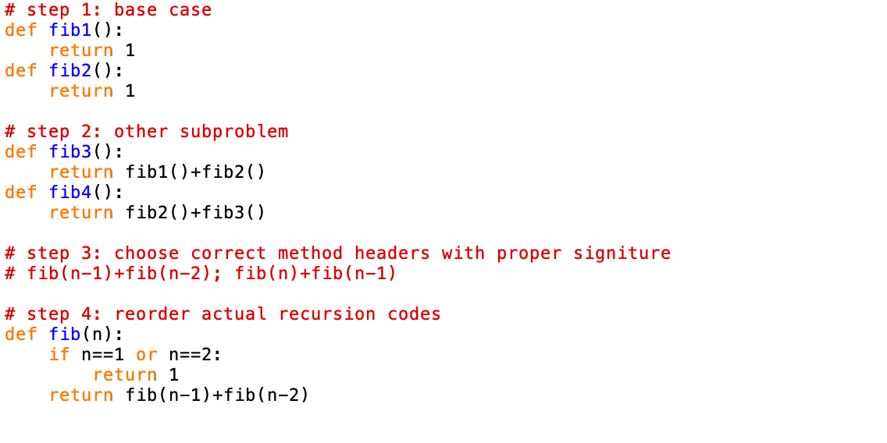

Figure 7 Steps for solving Fibonacci Sequence

### Data structures implementation comparison and algorithms comparison

One of the characteristics of code in CS2 is similar to each other. For example, the codes can have the same data structures but are implemented in different ways (like the array-based stack and linked-list-based stack in Figure 8) or different solving algorithms for the same problems (like bubble sort and selection sort for sorting numbers problem). Although it is ok to use the traditional Parsons problem individually for each code, it would be more worthwhile to help students to compare these similar codes and consolidate the difference and similarities between these codes. Therefore, the students can distinguish them and have a better understanding.

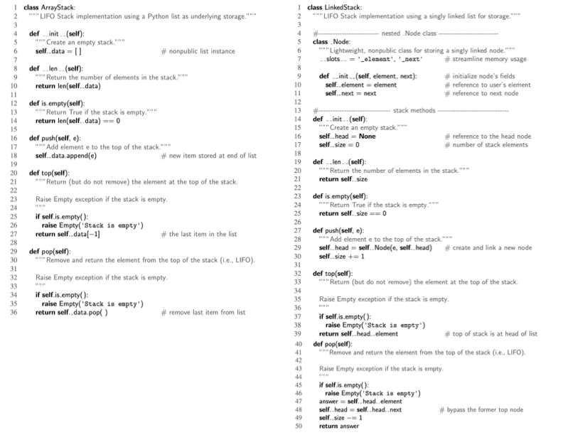

Figure 8: The array-based stack and the linked-list-based stack

The transfer learning method is used to compare the same data structures implemented in different ways. In other words, two different codes with some common parts are provided, and students need to choose the common parts from one of the codes using these common parts to build another one. In this way, students can understand new knowledge by transforming what they have learned before. Taking the two implementation ways of a stack as an example, students can drag and drop the method headers in an array-based stack as some components to build a linked-list-based stack. In such a manner, students can have a general idea about the common parts (the methods supported in a stack abstract data type) and what differences are (implementation details caused by array structure or linked list structure). Besides, the completed ordered array-based stack codes also can be hints to support students in building the linked-list-based stack Figure 9.

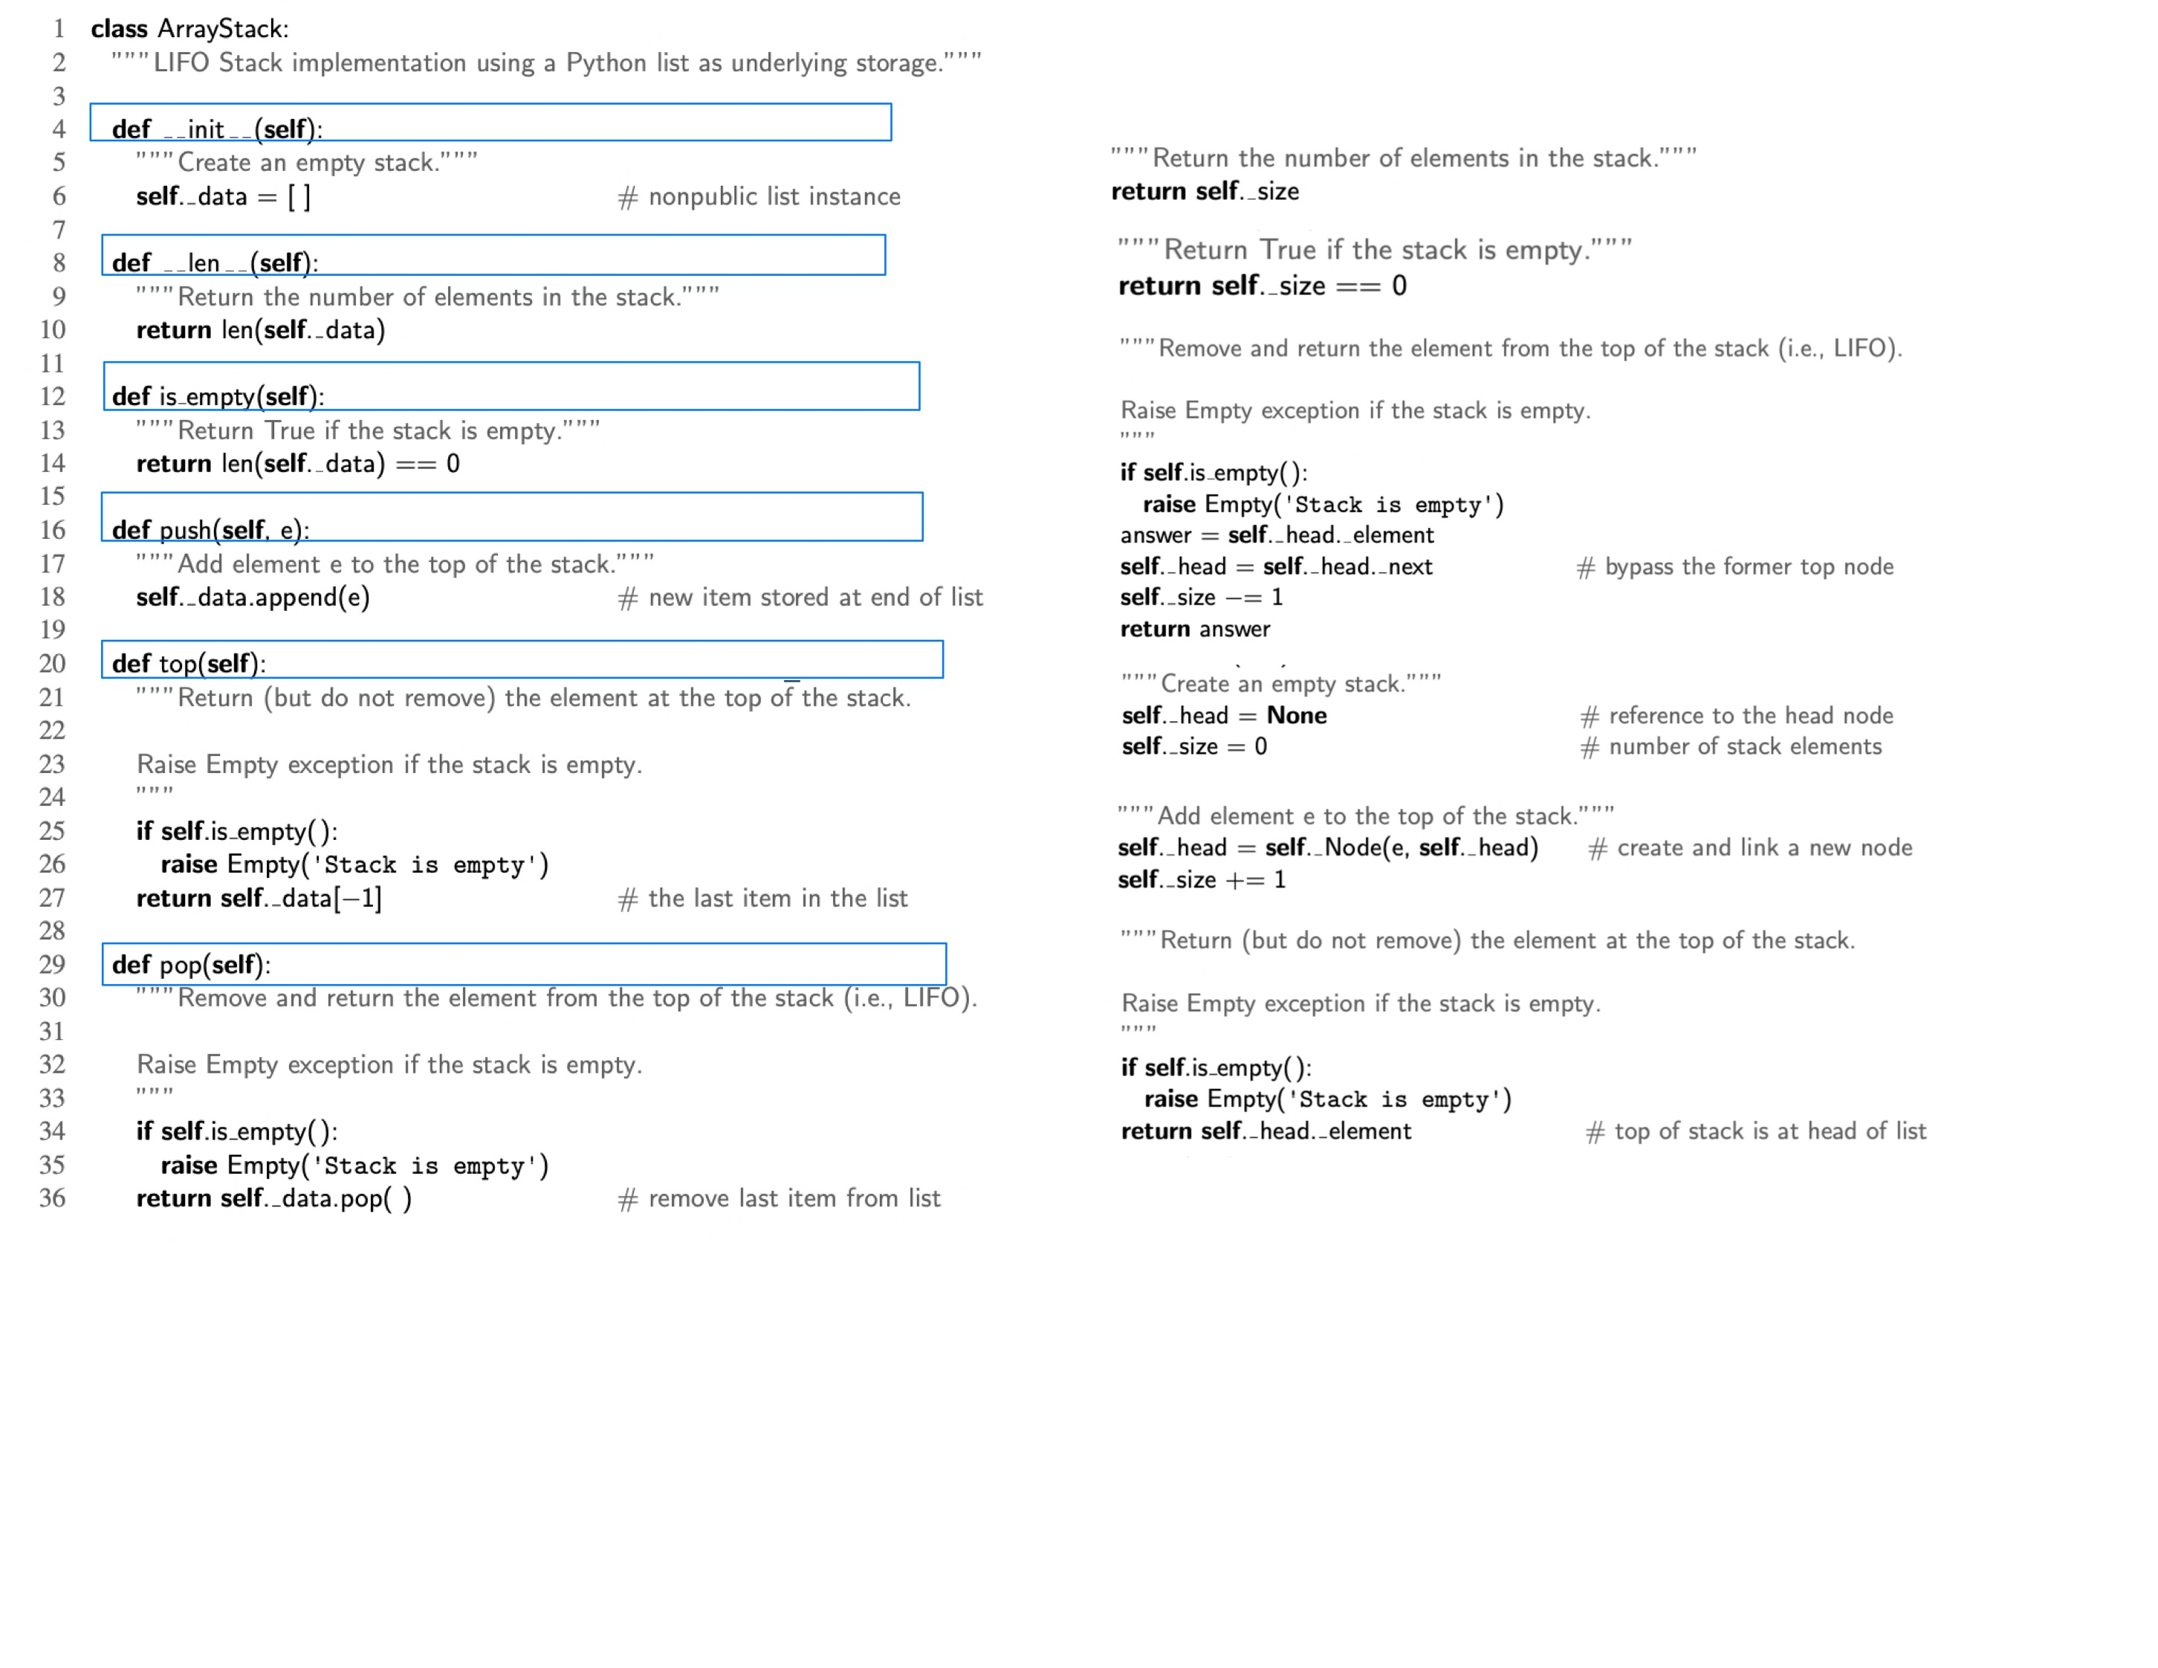

Figure 9 The ordered array stack code pool (left) and the unordered linked-list stack code pool (right)

To compare different algorithms of the same question, two algorithms are mixed by using distractors, and students are supposed to distinguish and order each of them from the mixing code pool. More specifically, unlike traditional distractors, which are all used to show some incorrect or improper code [2], a group of correct, complete codes of an algorithm is introduced as distractors to mix with another algorithm. In other words, the jumbled code fragment pool includes two different correct algorithms, and students should pick up, rearrange, and submit the code fragments in these two algorithms separately. This setting method is significantly applicable in CS2 since many questions have this characteristic – one question with several solving algorithms, for example, bubble sort, selection sort, insertion sort for sorting numbers, and breadth-first search, depth-first search for searching. In this way, it can help students to distinguish similar algorithms in the same categories mentioned before. It is worthwhile when students have learned more than one algorithm and begin to use them mostly because of blurry memory Figure 10.

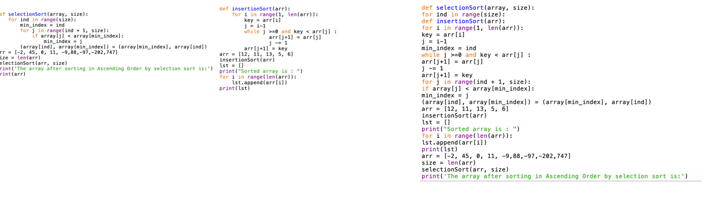

Figure 10 Selection sort (left), insertion sort (middle) and the mixed code pool (right)

## Balance the Degree of Difficulty

The critical function of Parsons problem is to add a preparation stage before students begin to write codes. This preparation stage is achieved mainly by reducing the difficulty caused by directly writing codes. In other words, one of Parsons's key issues is to find a balance point in the degree of difficulty, which is more accessible than writing codes from scratch but still valuable to practice. To fulfill this demand, three different methods (selecting difficulty level, pre-scaffold, and context) are introduced in the following paragraph.

### Switch different difficulty levels

In the traditional Parsons problem, whether pre-scaffold or not, the problem is always predefined with a fixed difficulty level, which means that students cannot ask for further help with additional hints if they meet problems in solving this Parsons problem. Since the codes in CS1 are pretty simple, this problem may not happen frequently and may not affect students solving problems. However, due to the increase in the complexity of the codes in CS2, this problem begins to become a huge issue. Multiple difficulty levels are set to handle this issue, and students are allowed to switch to a more accessible version of this question halfway. For example, three different difficulty levels are set. Specifically, Level 0 is to just cut codes in lines and allow students to reorder them. Subsequently, in Level 1, the headers of methods and predefined description comments are placed in the correct positions for hints. In Level 2, the codes are grouped by methods so that students can only reorder smaller parts of codes for every method instead of selecting from the whole mixing codes pool. In Level 3, some codes in methods are fixed as context and only some core parts need to be reordered. If students find the present version of Parsons problem too difficult, they can change to a more accessible version.

### Pre-scaffold

Pre-scaffolding is to give students some structures for hints. This kind of method to handle the difficulty has already been used in the existing Parsons problem, like providing loop structures. This method is also used in CS2 courses but with some extension. To be more specific, pre-scaffolding can be achieved by separating codes by different methods like the example shown before. In addition, pre-scaffolding also can be achieved by separating codes into different steps, like the example shown in recursion questions. Finally, this method also can be achieved by separating codes according to different subgoals helping students to divide a vast, complex problem into more minor simple questions [5]. A hint for each subgoal is provided as a comment.

### Context

Context is used to provide some ordered codes as information and let students only reorder some smaller parts in the middle of these ordered codes. Context can be done a step further, which means that students only need to insert some key code fragments into the correct location of the whole code file. And to keep the question valuable, some wrong codes are also provided to confuse students. This kind of question is extra valuable for iterator and recursion questions (Figure 11).

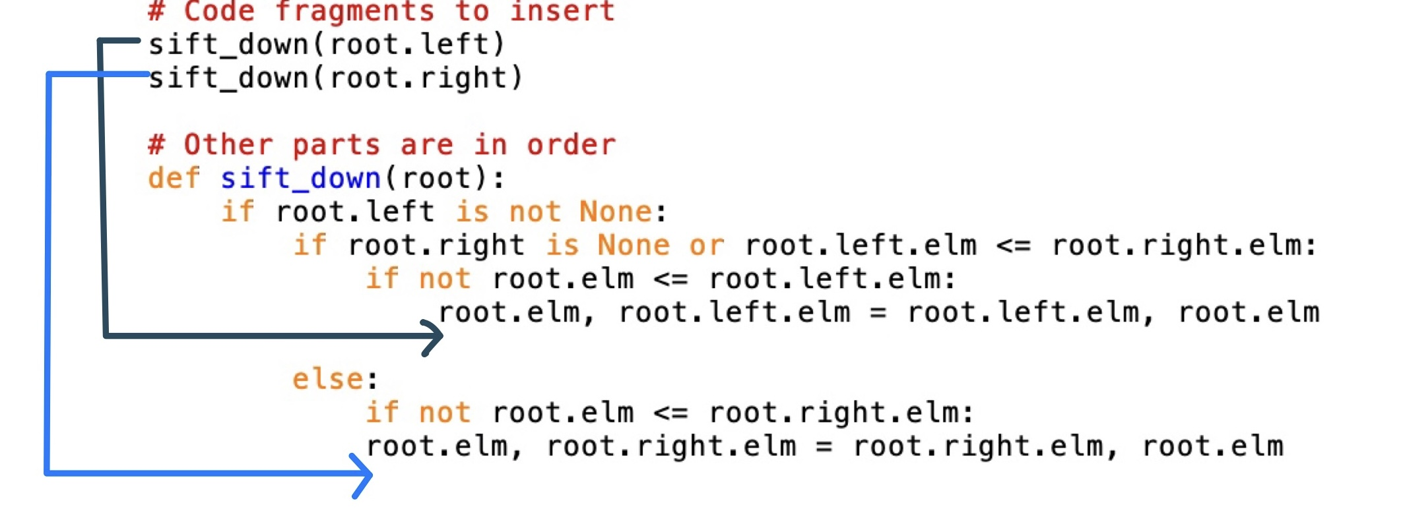

Figure 11 Example for inserting key code fragments

## Holistic Analysis

To sum up all descriptions of Parsons problem mentioned in chapter 2, chapter 3.1, and chapter 3.2, the project should be able to handle nine different types of Parsons problems grouped into the following five categories:

* **Traditional**: in this category, the Parsons problem only has the basic functions - rearranging jumbled predefined codes and getting feedback about the reordered answers. This category has one type of Parsons problem:
* **Traditional**: this type of Parsons problem is the one used in introductory programming courses in the existing work mentioned in chapter 2. The example is shown in the chapter 5.4.
* **Contextual clues:** in this category, some ordered codes are provided as hints in Parsons problem. This category has two types of Parsons problems:
* **Context:** this type of Parsons problem is used as one of the ways to handle the difficulty mentioned in chapter 2. It can also be used to fix the order of methods in data structure implementation to have unique answers (chapter 3.1.1) by providing the method headers as context. The example is shown in Figure 63.
* **Insert Key Code:** this type of Parsons problem is the advanced version of the Context Parsons problem mentioned in chapter 3.2.3 to reduce the difficulty further. Compared to the Context Parsons problem, fewer code lines are involved, and the concrete insertion positions are not shown to students directly. The example is shown in Figure 66.
* **Multiple-lines-based Block Code:** in this category, multiple lines can be grouped as a unit to show, drag and drop, or check. It is no longer limited to comparing line by line, which means that the codes can be organized in a more flexible way. This category has three types of Parsons problems:
* **Multiple Step:** this type of Parsons problem divides the original codes into several steps to let students solve complex problems by solving each small part. This type of Parsons problem can be used for the recursion problem (chapter 3.1.3) or setting as a pre-scaffold Parsons problem (chapter 3.2.2). The example is shown in Figure 69.
* **Check Only Inside Block:** this type of Parsons problem allows students to switch the order between blocks and focus on the order of lines inside every block. It can be used to handle not-unique-answer situations caused by changing the positions of methods in a class (chapter 3.1.1).
* **Link together:** this type of question is just to bind multiple lines as a whole block. Being different from the previous two types of questions, the order of lines inside the block is no longer considered. This type of question can handle the not-unique-answer situation caused by interchangeable lines (chapter 3.1.1).
* **Multiple Solutions:** this category allows the comparison between multiple related solutions. There are two types of Parsons problems in this category:
* **Data Structures Implementation Comparison:** this type of question is used to compare the same data structures with different implementations (chapter 3.1.4). In this type of question, students combine one answer by using the codes coming from two solutions.
* **Algorithm Comparison:** this type of question is used to compare related algorithms (chapter 3.1.4). In this type of question, students split two solutions from one group of jumbled codes. The example is shown in Figure 72.
* **Comment:** in this category, the correctness of comments is also under consideration. This category has one type of Parsons problem:
* **Algorithm Analysis:** this type of question can introduce the time complexity of algorithm analysis mentioned in chapter 3.1.2.

After declaring the nine different types of questions, the additional characteristics of Parsons problem in this project can be summarized from the following perspectives – allowing some special-marked code fragments (context, key code, or comment); allowing the coexistence of lines and blocks; allowing multiple solutions. These new characteristics significantly change the workflow of generating or solving Parsons problems. Specifically, teachers need to take some time to customize the predefined solutions instead of just inputting the solutions inside the system (like marking special code fragments or grouping several code fragments as blocks). In addition, because of these characteristics, the way of checking the answers and giving feedbacks is also changed. Concretely, the answer can not simply be checked by comparing it with the original predefined files (line-based feedback) since switching the orders of blocks should be allowed. Besides, it may also not be so proper to check the answer by execution (execution-based feedback) since the comment should also be checked. Actually, in this project, the answer is checked based on comparing codes with the original file, but it supports the switch order of blocks. More details will be declared in the next several sections.

## Dynamic Modelling

In this section, the interaction between the users and the system is illustrated by activity diagrams.

Figure 12 illustrates the activity diagram of students. Students need to register or login first, otherwise, they can only browse the question list. After registering or login successfully, students can select a question from the question list, view the exercise detail, reorder the jumbled codes by dragging and dropping code fragments, check the answer, and get feedback. If they achieve 100% correctness, the solving procedure of this question is finished, and they can do other questions. If they do not achieve 100% correctness, they are supposed to adjust the answers based on the feedback and check it again. If they meet problems when doing exercise, they can view and finish the easier version of this exercise (if it is applicable), and then go back to finish the original version. In addition, students can also browse answer records in history and redo some questions they do not satisfy with their score or think important.

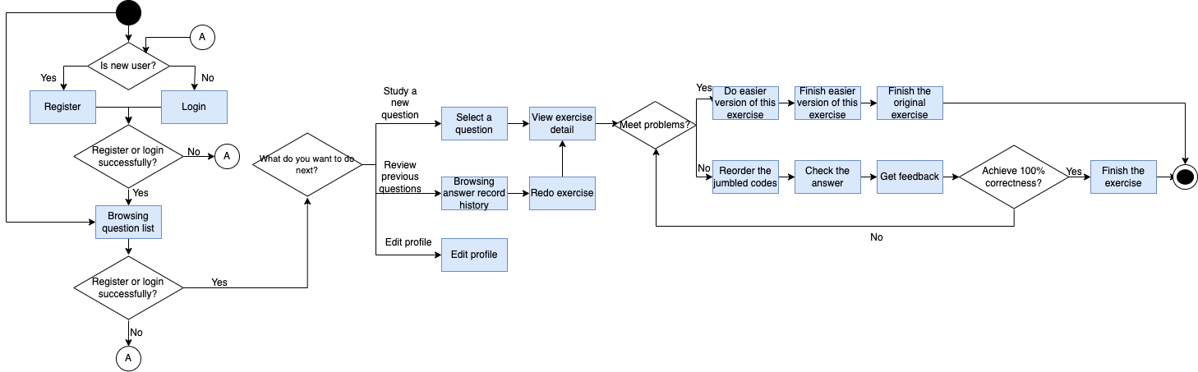

Figure 12 Student activity diagram

Figure 13 illustrates the teacher activity diagram (omitting the activities which are the same as student activity diagram). Besides the activity involved in student activity diagram, teachers can also manage classes and questions (create, edit and delete classes or questions). It is worth mentioning that for the creating question process. Teachers can create a new question after registering or login by inputting question information, choosing question type, uploading prepared solution file, and customizing solution based on question type. In the process of customizing solution, if the question is context type, the context code should be marked. If the question is multiple step type, the code grouping information should be recorded. And for the traditional or algorithm comparison type of question, there is no special customized action for the question itself. In addition, the distractor can also be added for the traditional or context type of question. Besides, the easier version of question can also be set for the traditional, context and multiple step type of question in this customization process. Specifically, the easier version of question can be set as three different types – context, multiple step and insert key code (since the insert key code is extremely simple, it is only shown when creating easier version of question). The context and multiple type of easier version can be customized just like the original question. But for insert key code type, key codes should be marked when customizing. After finishing the customizing original or easier question, teacher can view the exercise detail page to check whether the question is created as they expect.

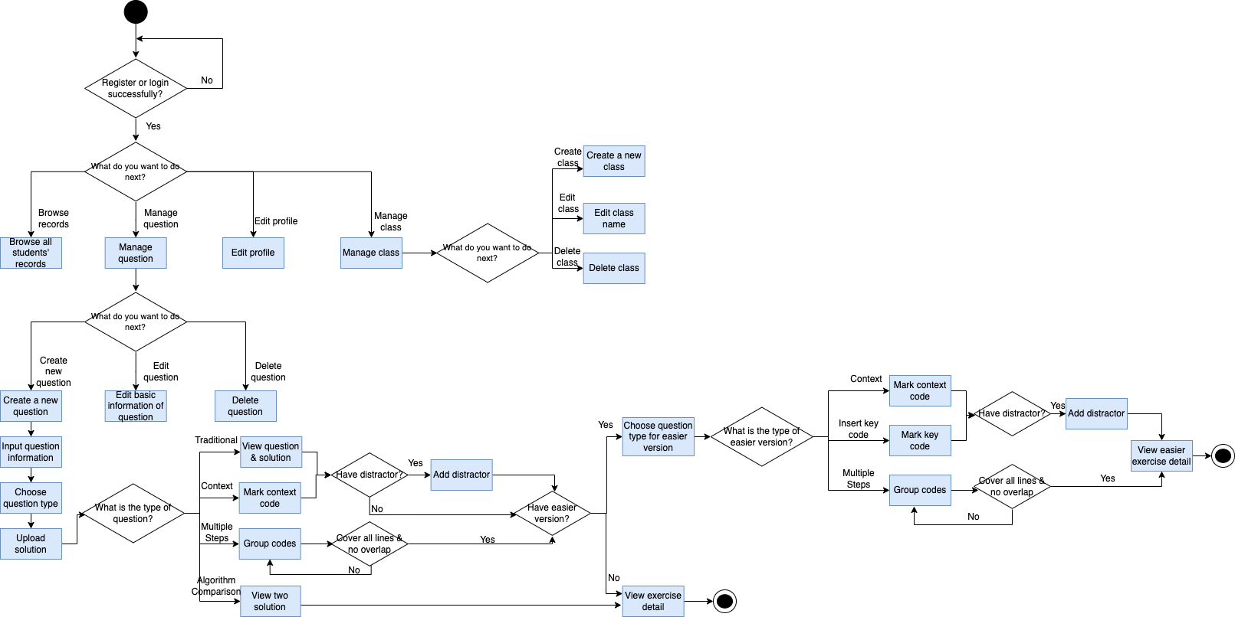

Figure 13 Teacher activity diagram

## Data Modelling

In this section, the entities, the attributes, and the relationship between entities are illustrated. Besides, the ER diagram is also shown.

The stored information is majorly about the class, user, question, solution, codes and code organization (fragment, block, difficulty level), distractor, easier version and record.

Table 2 Entity illustrates the entity used in this database.

Table 2 Entity

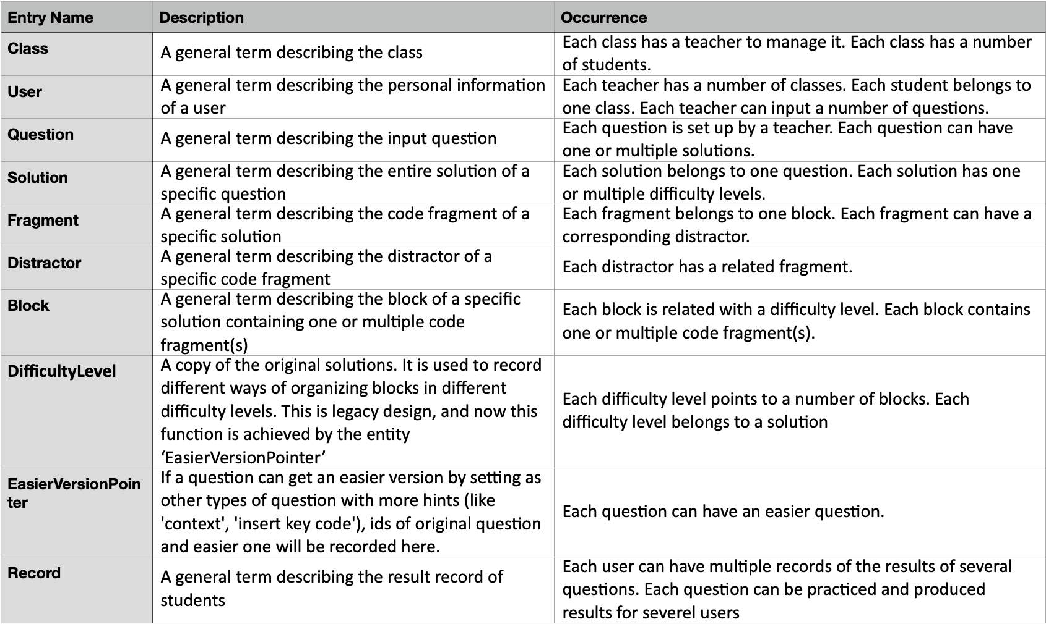

Table 3 illustrates the relationship between entities.

Table 3 Relationship between entities

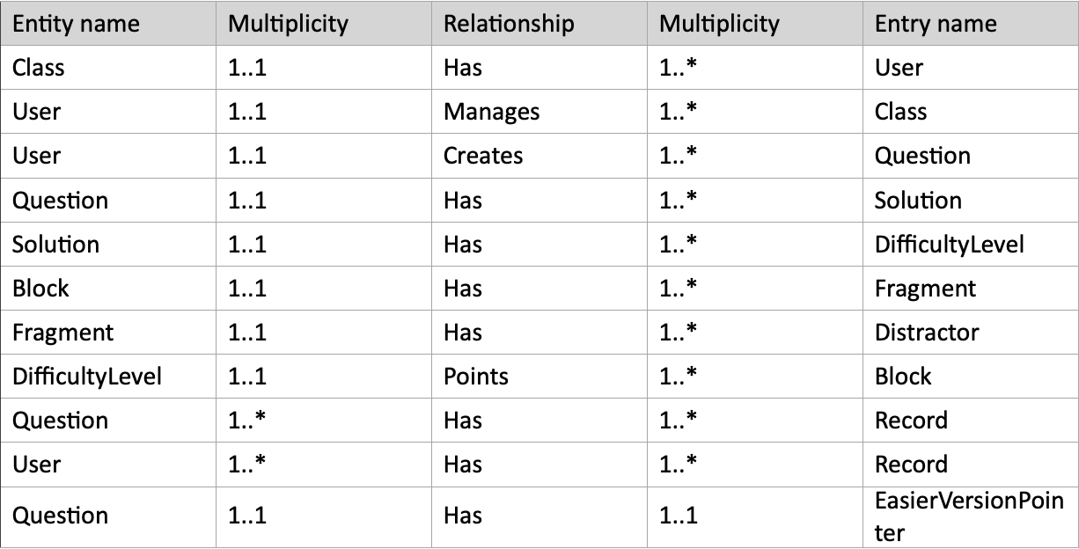

Table 4 illustrates the concrete attributes of every entity. By means of recording the code line in the ‘fragment’ entity plus recording the block id and fragment id in the correct order in the attribute ‘BlockSeq’ of ‘DifficultyLevel’ entity and in the attribute ‘FragmentSeq’ of entity ‘Block,’ the coexistence of block and line is achieved.

Table 4 Attributes in each entity

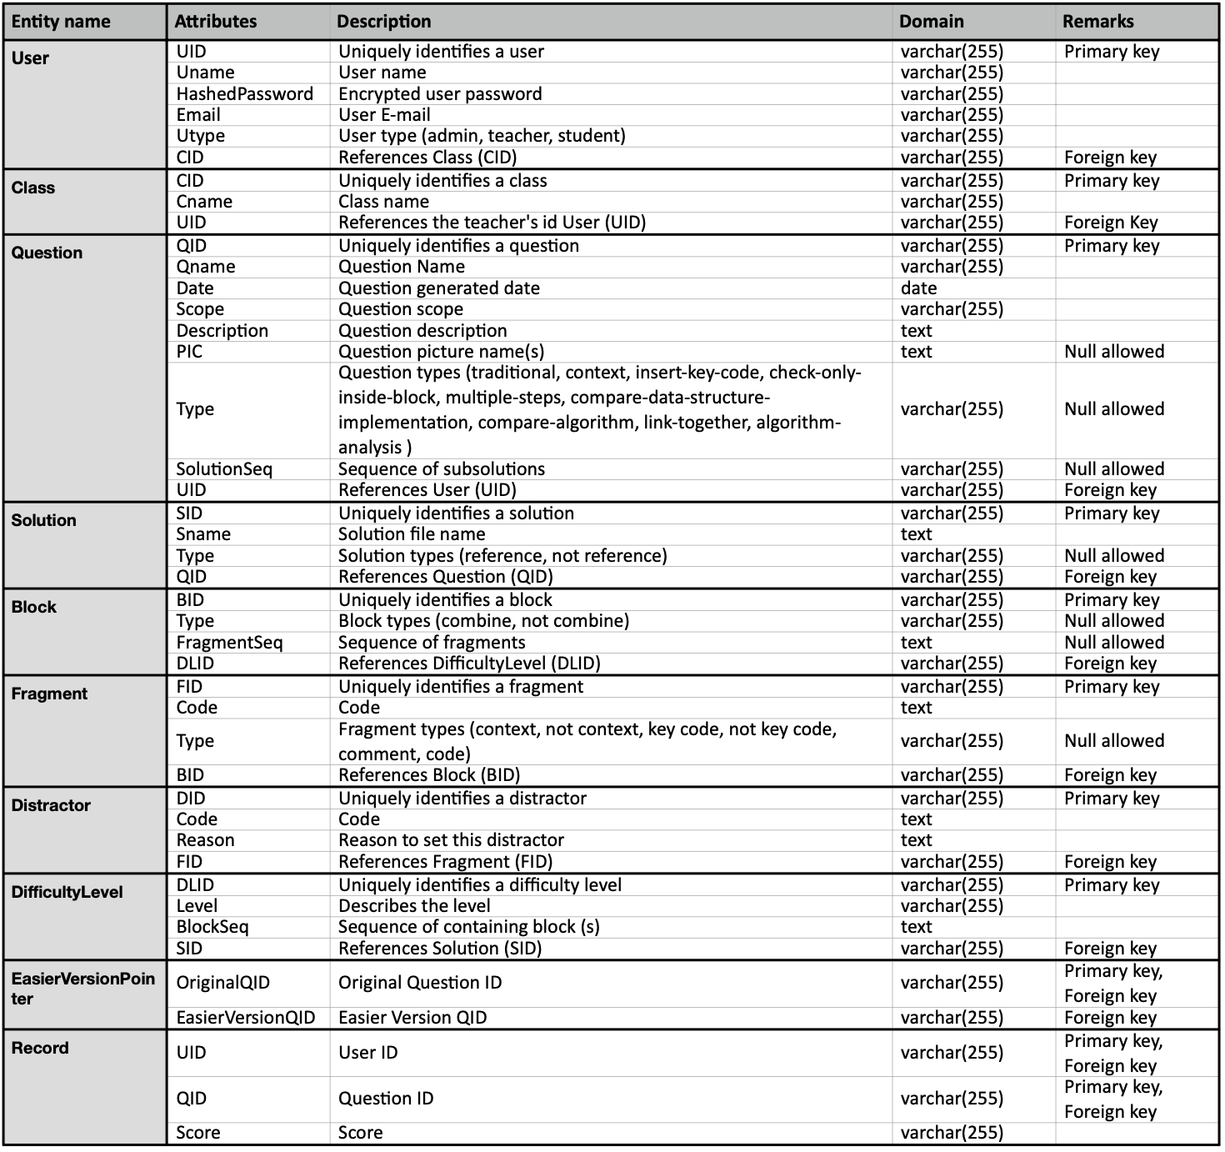

Table 5 illustrates the logical data model between entities.

Table 5 Logical Data Model

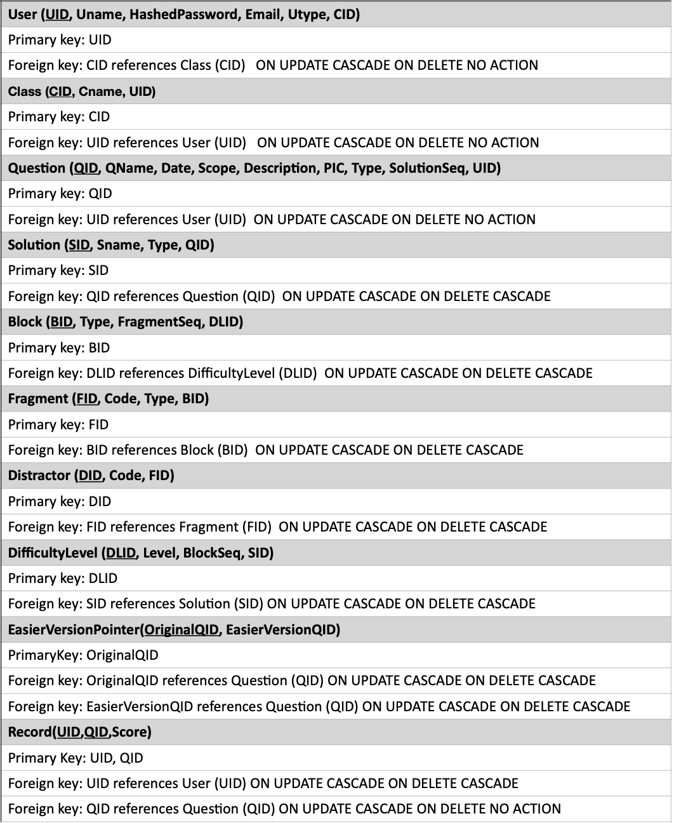

The ER diagram is defined as Figure 14 according to the information of data model mentioned previously.

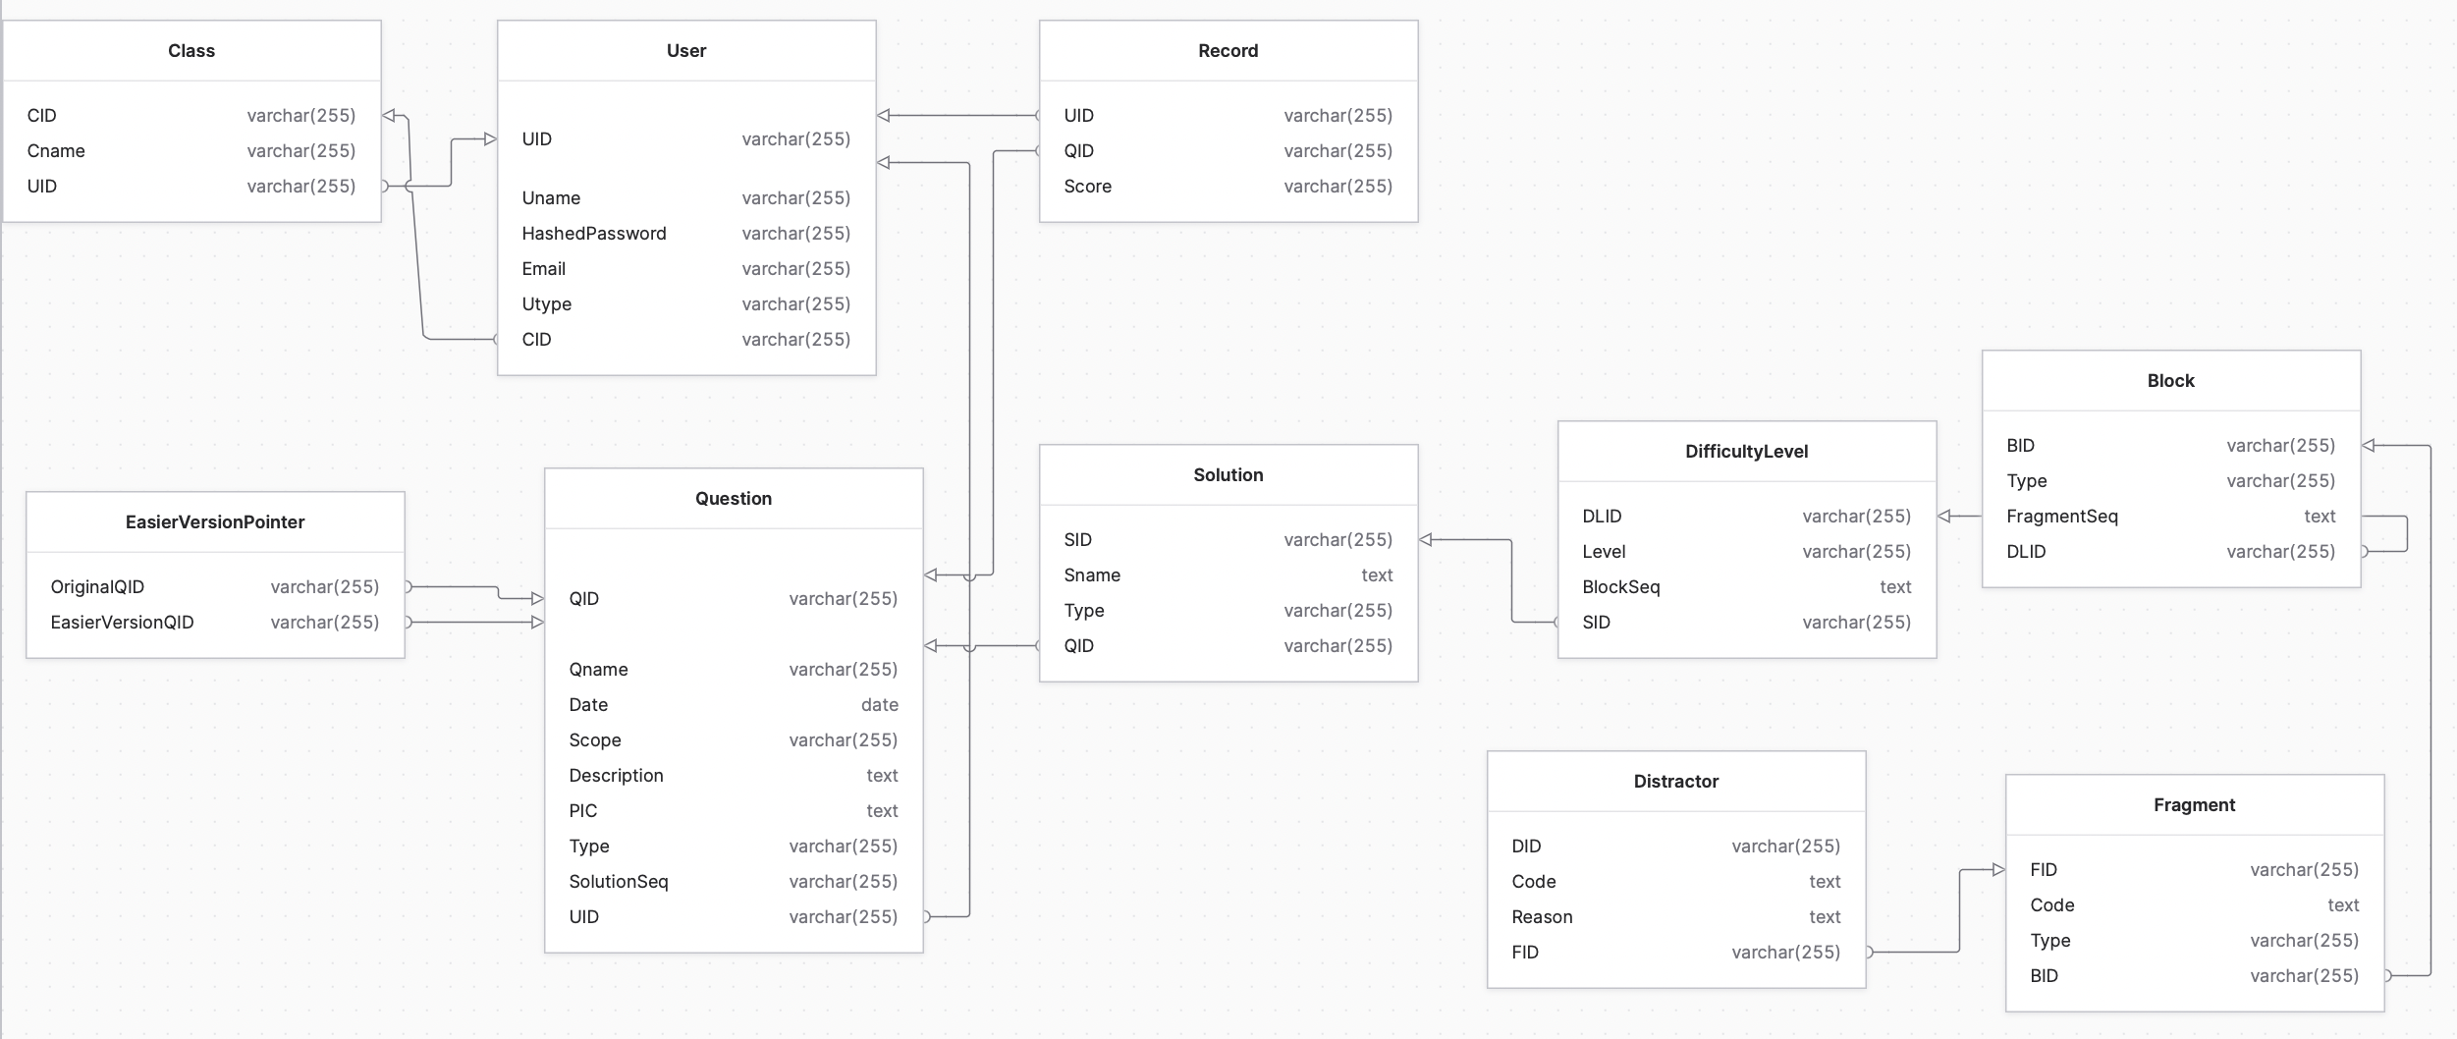

Figure 14 ER diagram

# Implementation

In this chapter, the detailed implementation is explained. Firstly, the major techniques and tools used are introduced. The next part is to explain how to develop the traditional Parsons problem in this project. Subsequently, the implementation of other types of questions (contextual clues, multiple step, and algorithm comparison) will be explained based on the development of the traditional Parsons problem. Finally, the development of switching the difficulty level will also be described.

## Major Techniques and Tools Used

In this project, modern web application solution – separation of front-end and back-end is adopted. Thanks to the separation, different parts of this project can be developed more independently, which is convenient for future expansion or maintenance. For this reason, the techniques and tools are classified into two different parts: front-end and back-end.

### Front-end

The front-end is mainly based on the combination of Vue.js, Tailwind CSS, and TypeScript. In addition to those major techniques, some Vue tools (Vue Router, Vuex, Vue Draggable) are also used in this project. Finally, Axios is also involved in this project.

The front-end is mainly built with the framework Vue.js [11]. Vue.js is lightweight but high-performance. It also combines HTML, CSS, and TypeScript codes into components, which increases the code readability and reusability [12].

The visual design is implemented with the CSS framework Tailwind CSS [13] instead of raw CSS. With the predefined class, the process of creating a custom CSS style is simplified, and the responsive layouts are achieved effortlessly [14]. Besides, since Tailwind CSS is a low-level framework, it can provide more flexibility and control than other CSS frameworks like Bootstrap [15].

TypeScript [16] is used in this project instead of JavaScript. TypeScript is a superset of JavaScript. And it contains not only all advantages of JavaScript, but also can prevent some runtime errors caused by unexpected types of value when using JavaScript [17].

Vue Router [18], the official router for Vue.js, is used in this project. Vue Router makes the navigation between different pages in the project much easier than the direct redirection in JavaScript [19].

Vuex – a state management pattern and library – is used in this project. It acts as a centralized information store for all components in the project, which makes storing users’ data locally simple [20].

Vue Draggable [21] is used as the key tool to support drag-and-drop action in the project. In addition to the basic drag-and-drop action, it also supports clone and replace. The tutorial about Vue Draggable is referred [22].

To communicate with the back-end, Axios [23] is used in the front-end scripts. Compared with fetch in JavaScript, Axios supports the automatic transformations of JSON data, which is convenient to handle response data. In addition, Axios is more secure than fetch for preventing Cross-site request forgery [24].

### Back-end

Back-end is mainly based on Python. Besides, FastAPI and MariaDB are used separately as API server and database.

Back-end codes are written in Python [25]. The reason for using Python is that codes in Python can be much shorter than the same codes in Java, which means that it is easier to write.

FastAPI [26], a web framework for building APIs with Python, is used to handle the request from front-end, call related methods to interact with database, generate and send the response back to the front-end. It is fast and has high performance.

MariaDB is a perfect choice for database. MariaDB is open source and has high performance.

### System architecture

The system architecture diagram (Figure 15) is shown below to illustrate the connection between the main techniques and tools used in this project.

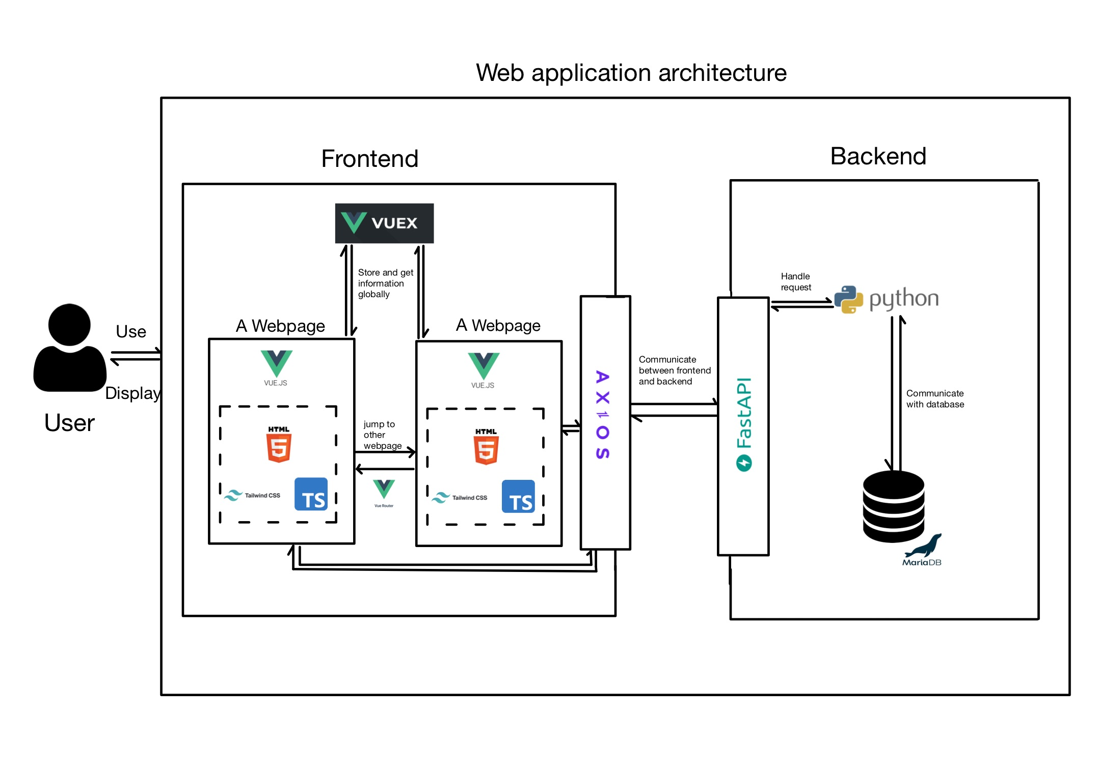

Figure 15 System architecture diagram

## Traditional Parsons Problem

In this section, the implementation of traditional Parsons problem in this project is introduced briefly to pave the way for the implementation of other types of Parsons problem. Among these implementation details, the parts about drag-and-drop, showing in 2D view, checking, and showing feedback will be introduced systematically. In addition, the implementation about distractor is also introduced.

### Overview of implementation of traditional parsons problem

The core parts of this project are to develop several functions for teachers and students. In the following two paragraphs, only the key parts (how to communicate with the database) of these functions are explained, and the codes about presenting web pages, and communicating between front end and back end of these functions are omitted.

From the teacher’s point of view, the major functions are inputting question, uploading predefined solution, and customizing solution. To be more specific, firstly, for the function about inputting question, the collected question information (question name, question type, question scope, question description) is stored as a new record of entity ‘Question’ in the database. The next step is to upload solution. After receiving the uploaded solution, a new record is inserted into the entity ‘Solution’ in the method ‘create_solution’ shown in Figure 16. And then, the solution Python file is read line by line in the method ‘cut_solution’ shown in Figure 16. These lines are inserted as new records of entity ‘Fragment’ belonging to single ‘Block’ and single ‘Difficulty Level’ (‘Level’ in ‘Difficulty Level’ is set as ‘1’) in the method ‘create_fragment_prototype’ shown in Figure 16. The order of lines of the solution is recorded by tracking the fragment ID in ‘FragmentSeq’ of entity ‘Block’ with separating by semicolons Figure 17. Up to this point, the basic order of codes is recorded. The following part – customizing solution is mainly about adding distractors, marking some special fragments, grouping fragments, and creating easier version. This part will be introduced later.

From the student’s point of view, the major functions are presenting exercises and checking. To be more specific, the fragments are got according to the question id (Figure 18). These fragments will be used as jumbled codes in the code pool for students to reorder later. And to achieve the checking function, the correct order of fragments is got according to the ‘FragmentSeq’ recorded in the method ‘create_fragment_prototype’ (Figure 19). And the contents of students’ answers and the standard answers are compared to achieve checking and giving feedback functions. More details about checking and feedback will be introduced later.

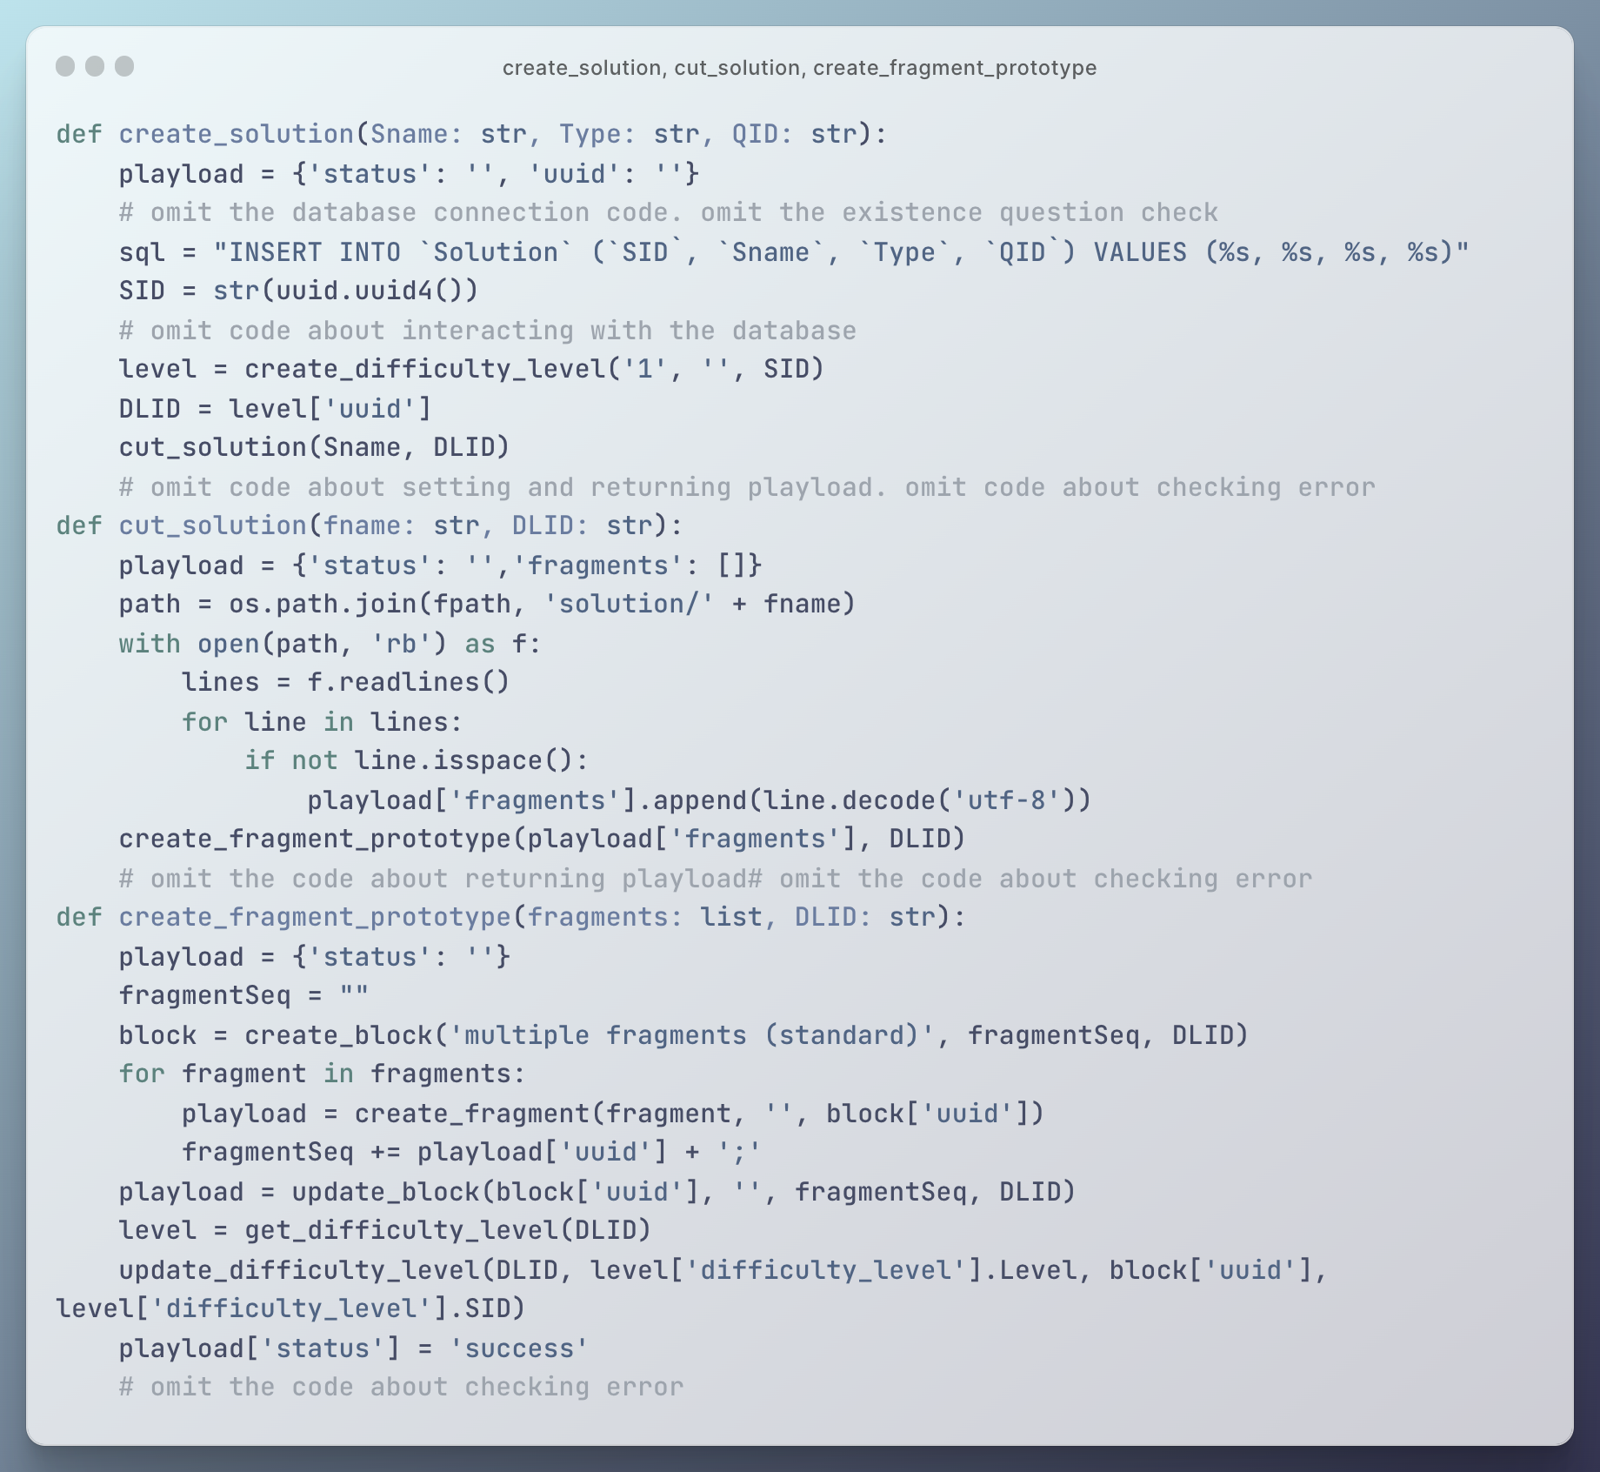

Figure 16 Related methods about storing codes in database



Figure 17 Example of ‘FragmentSeq’ of ‘Block’ in database

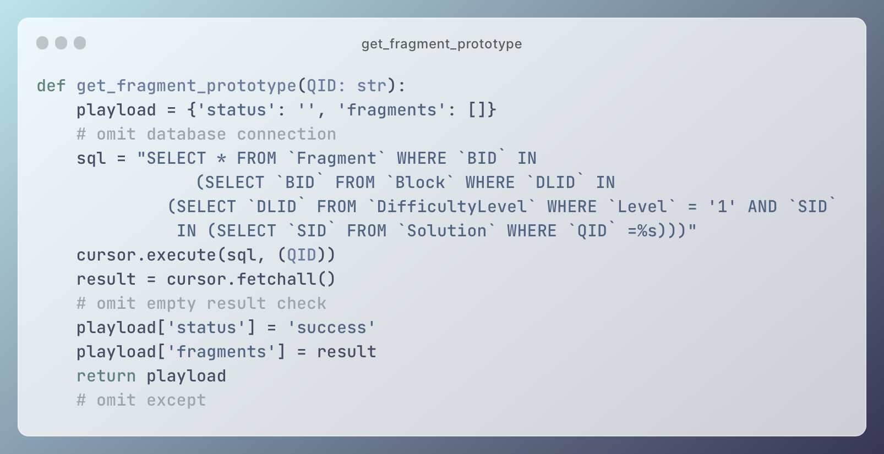

Figure 18 Get fragments according to question id

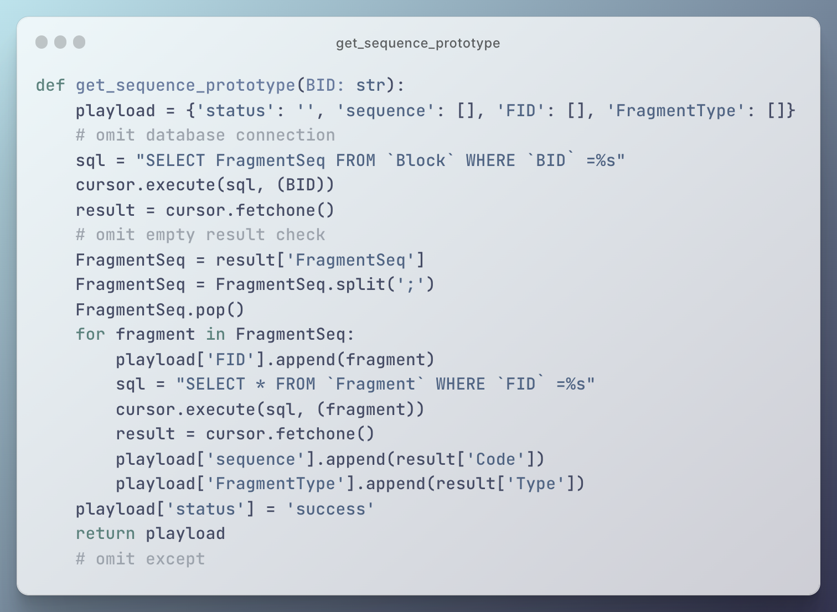

Figure 19 Get order of codes

### Drag-and-drop

The drag-and-drop action is implemented by the tool Vue Draggable. By using the component ‘VueDraggableNext’, the codes can be dragged and dropped between the code pool and the answer sheet. By setting ‘:list=‘pool.code’’, the component can be bound with reactive list variable ‘pool.code’ and be able to handle the fragment changes in the code pool (Figure 20). It is similar to the answer sheet. The component is connected with ‘pool.answer’ by setting ‘:list=‘pool.answer’’.

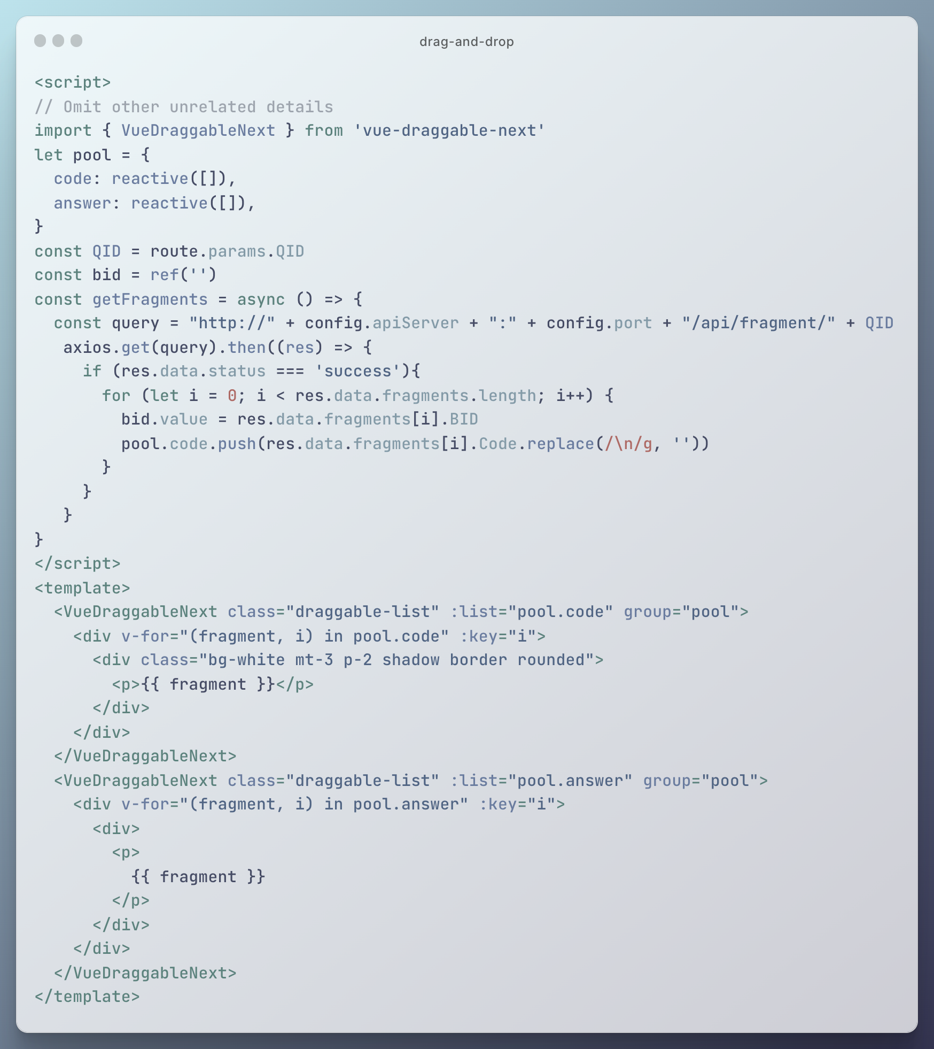

Figure 20 Drag-and-drop

### 2D view

Unlike other programming languages, Python indicates the code blocks by using indentation. For this reason, the codes of Parsons problem in Python should not only be shown in vertical way but also horizontal way.

Unfortunately, although the Vue Draggable can support to put items either in horizontal or vertical way, it does not support put in two ways at the same time. There are some alternatives on the Internet to achieve similar effects of showing horizontally and vertically. Specifically, Vue Grid Layout [27] can show different items in a grid layout as shown in Figure 21. But this tool does not suit needs for showing indentation of Python codes because of the following two reasons. Firstly, when the block is moved to other columns, the block below will automatically replace the original place of the moved block. If this tool is used to show the Python codes, it is possible that the indentation or code in the next line fill in the place in this line. That is a disaster for user experience. Secondly, the width and height of blocks can be customized, which seems unduly flexible for the fixed height of code lines. Other alternatives are Vue Draggable Nested [28] or he-tree [29]. Both tools can show nested elements by using multidimensional arrays (for example, Vue Draggable Nested in Figure 22). Since one dimensional array is used for the 1D view, as shown in 4.2.2, previous code cannot be reused because of changing data structures, which causes a lot of problems and wastes time.

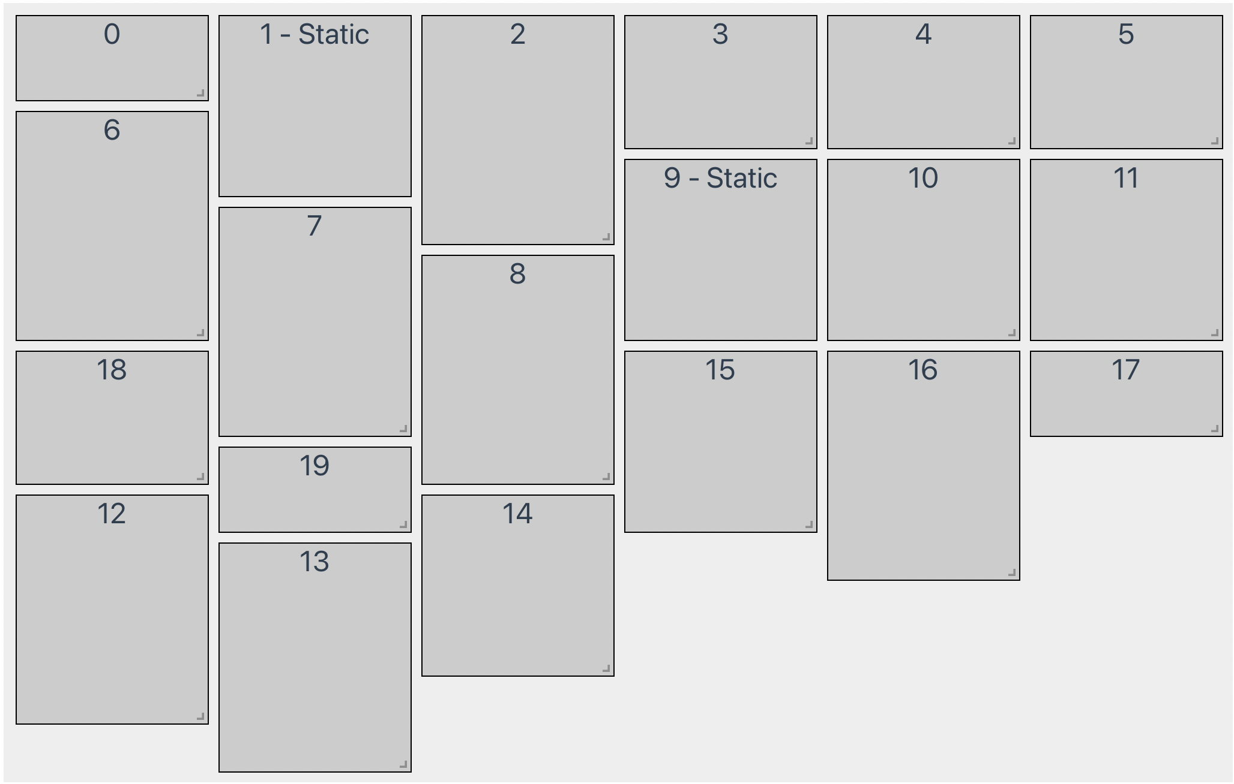

Figure 21 Example of Vue Grid Layout

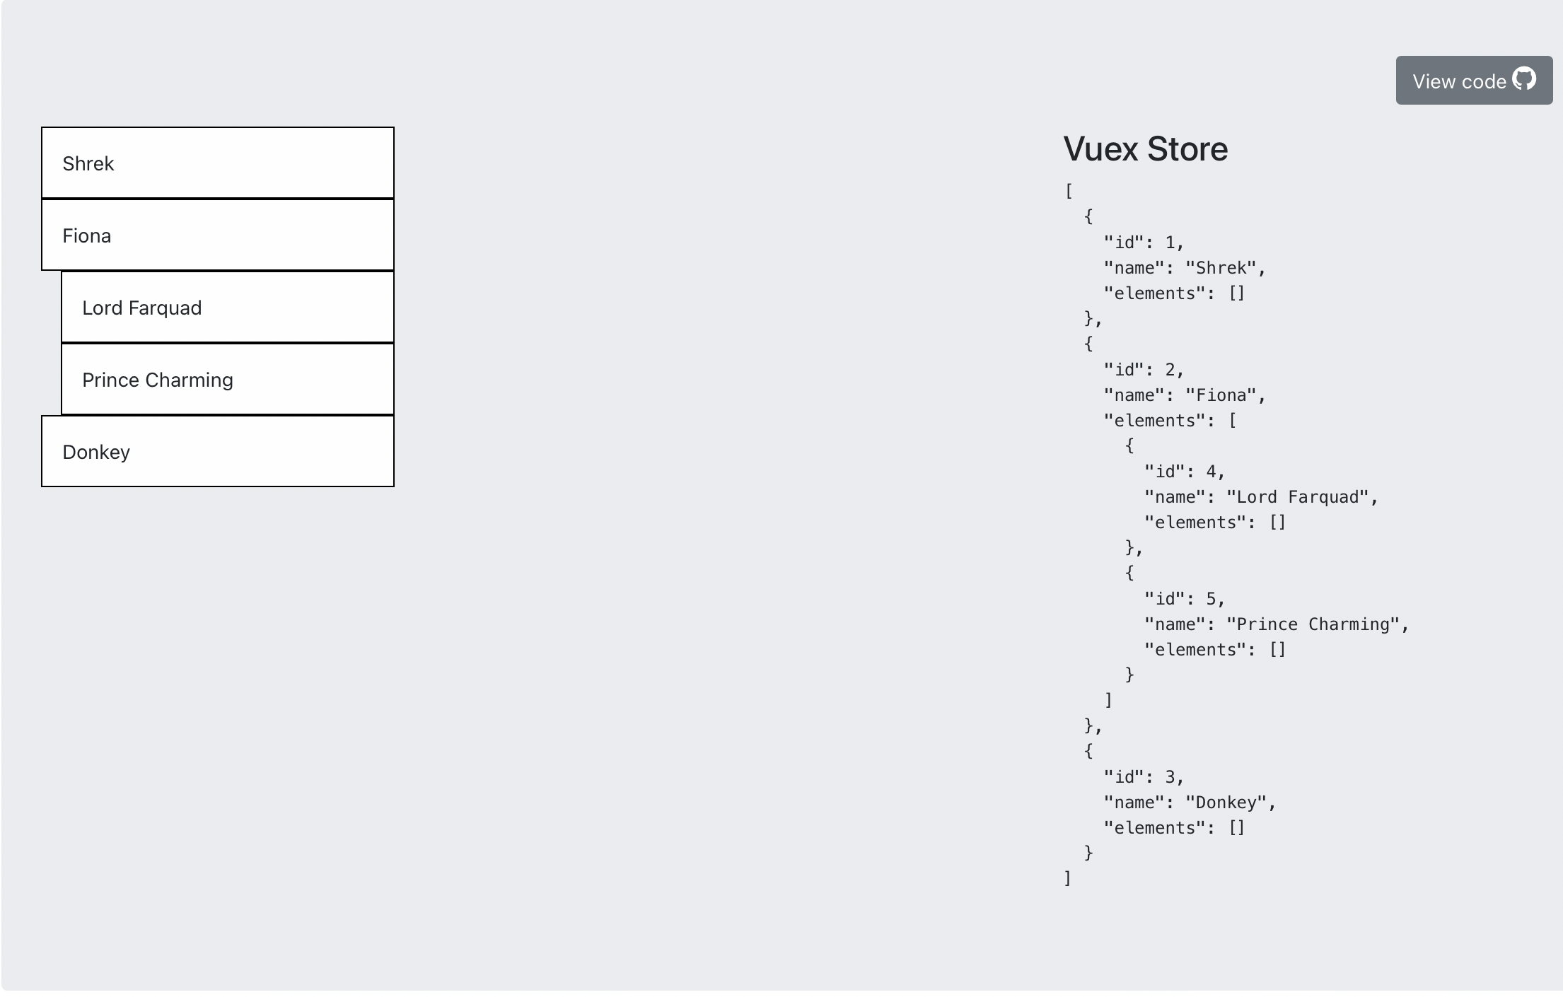

Figure 22 Example of Vue Draggable Nested

By analyzing the above 2D tools, it is obvious that the best way is to simulate 2D view by just 1D view. In addition to the basic codes shown in 4.2.2, the buttons of increasing or decreasing indentation are added in each code line in answer pool. By click these two buttons, the indentation of the line can be changed by adding or deleting four empty spaces before the actual code. And the indent number is also recorded in a list for further checking Figure 23.

Using buttons for 2D view is also good for use experience. It can help users to aware of indentation levels. Besides, code ordering and code nesting are specified using different UI actions (drag-and-drop and buttons).

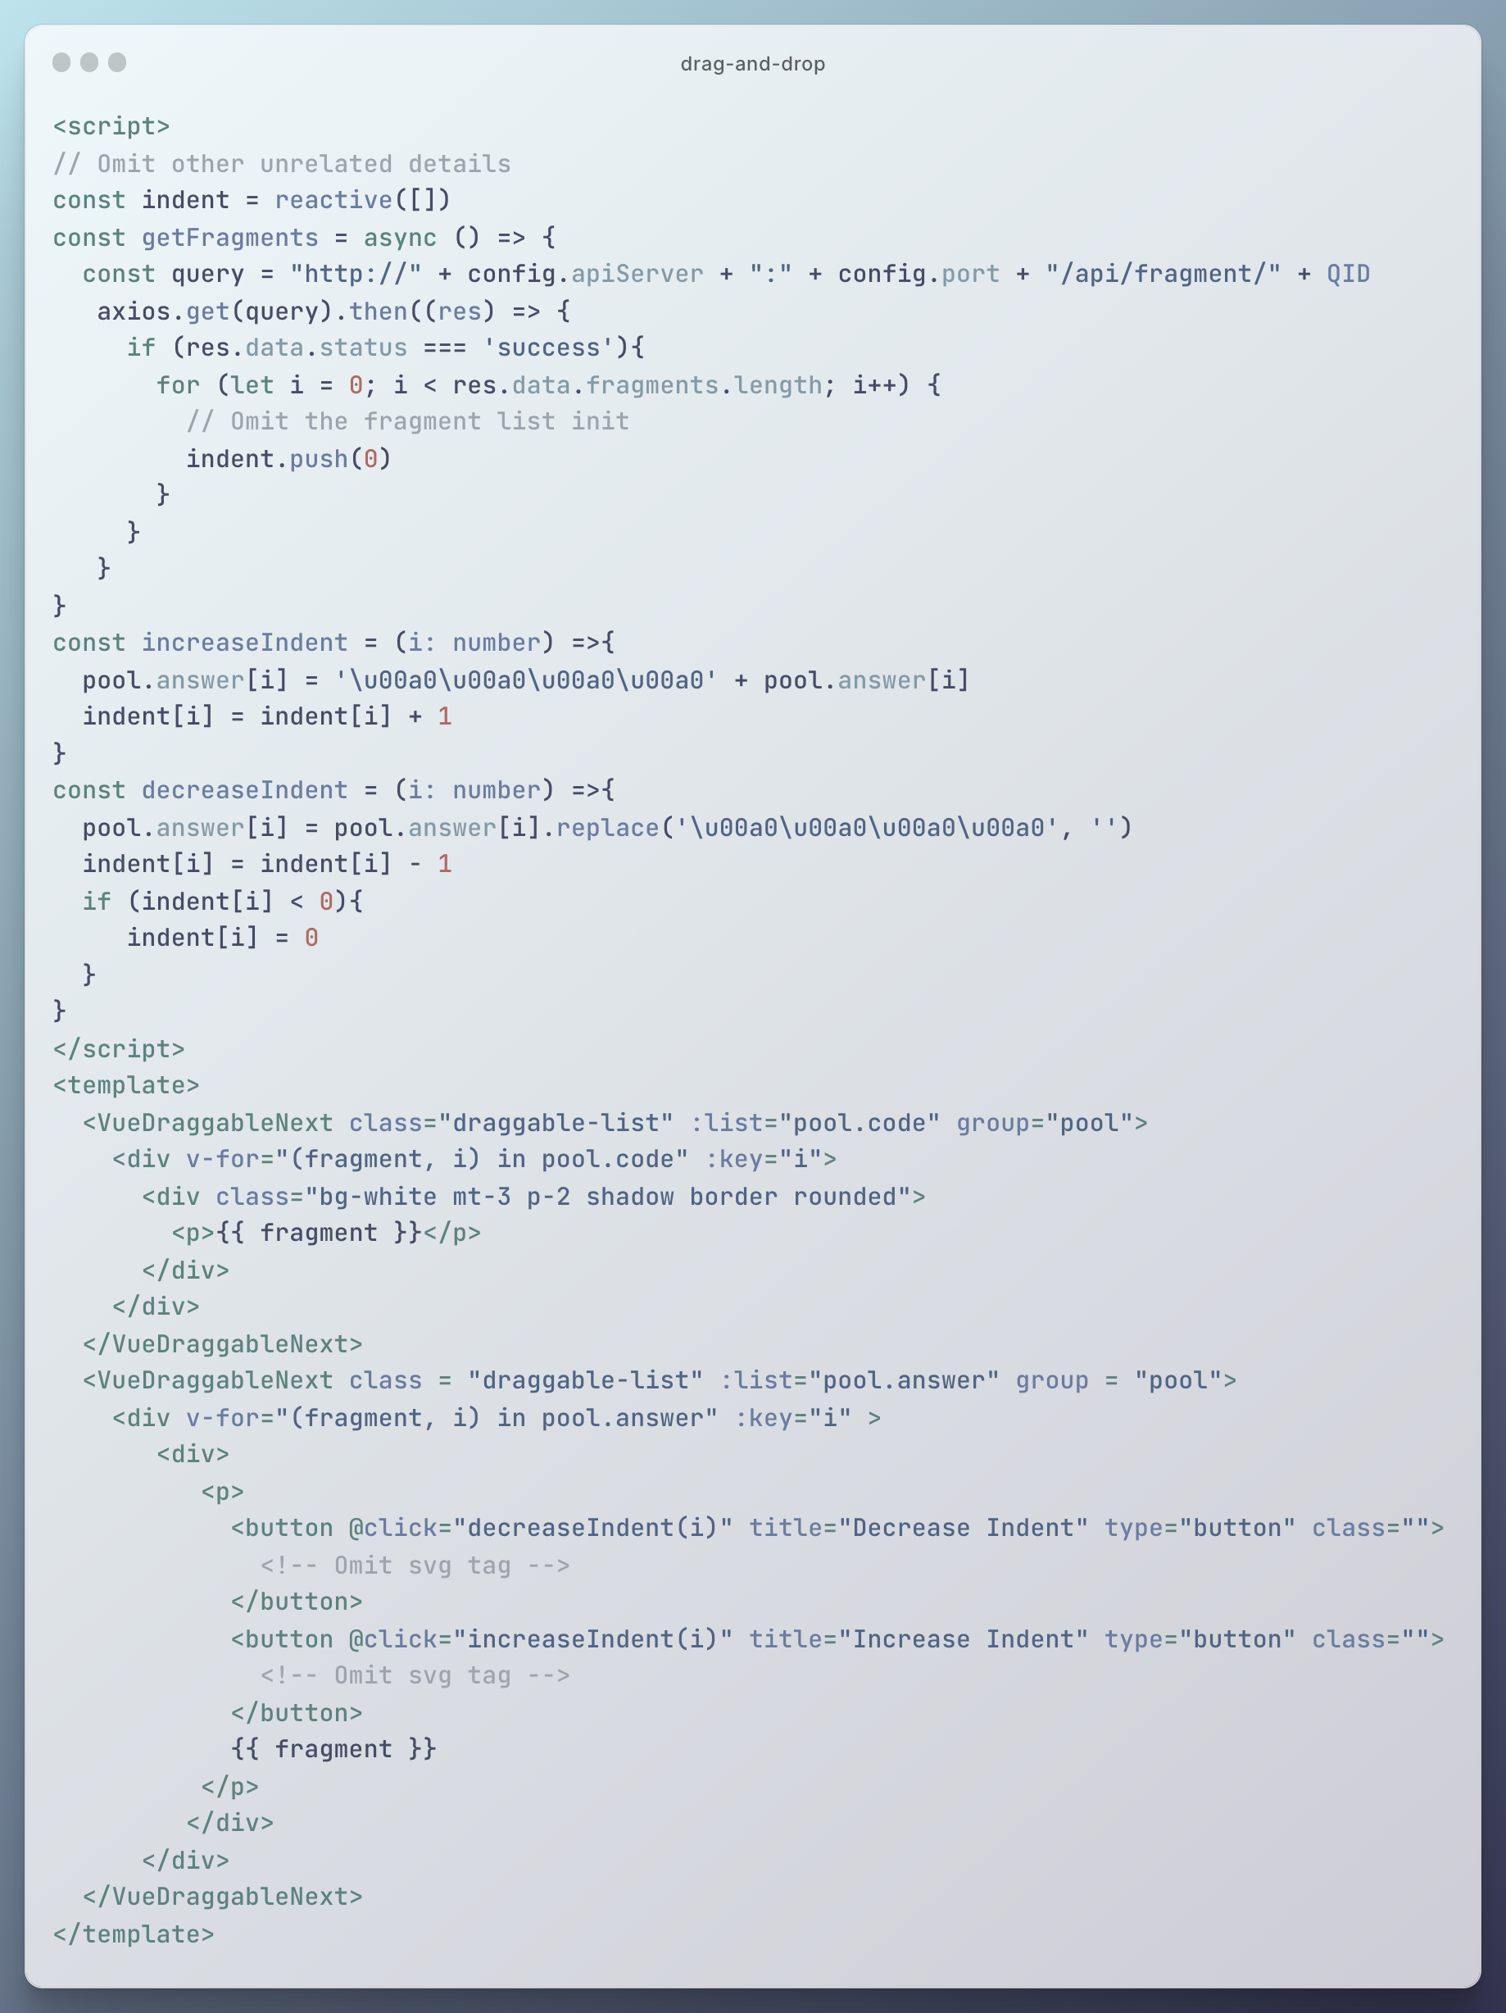

Figure 23 Increase or decrease indent

### Check and show feedback

Students’ answers are checked by comparing with the content of standard answers based on the recording fragment sequence. The space in the code is removed in advance to have an accurate string comparison. And the indent number is compared individually. After comparison, different background colors are set to the code line to give students further tips to modify their answers. Moreover, the score (percentage of completion) is also shown to students and stored in the database (Figure 24).

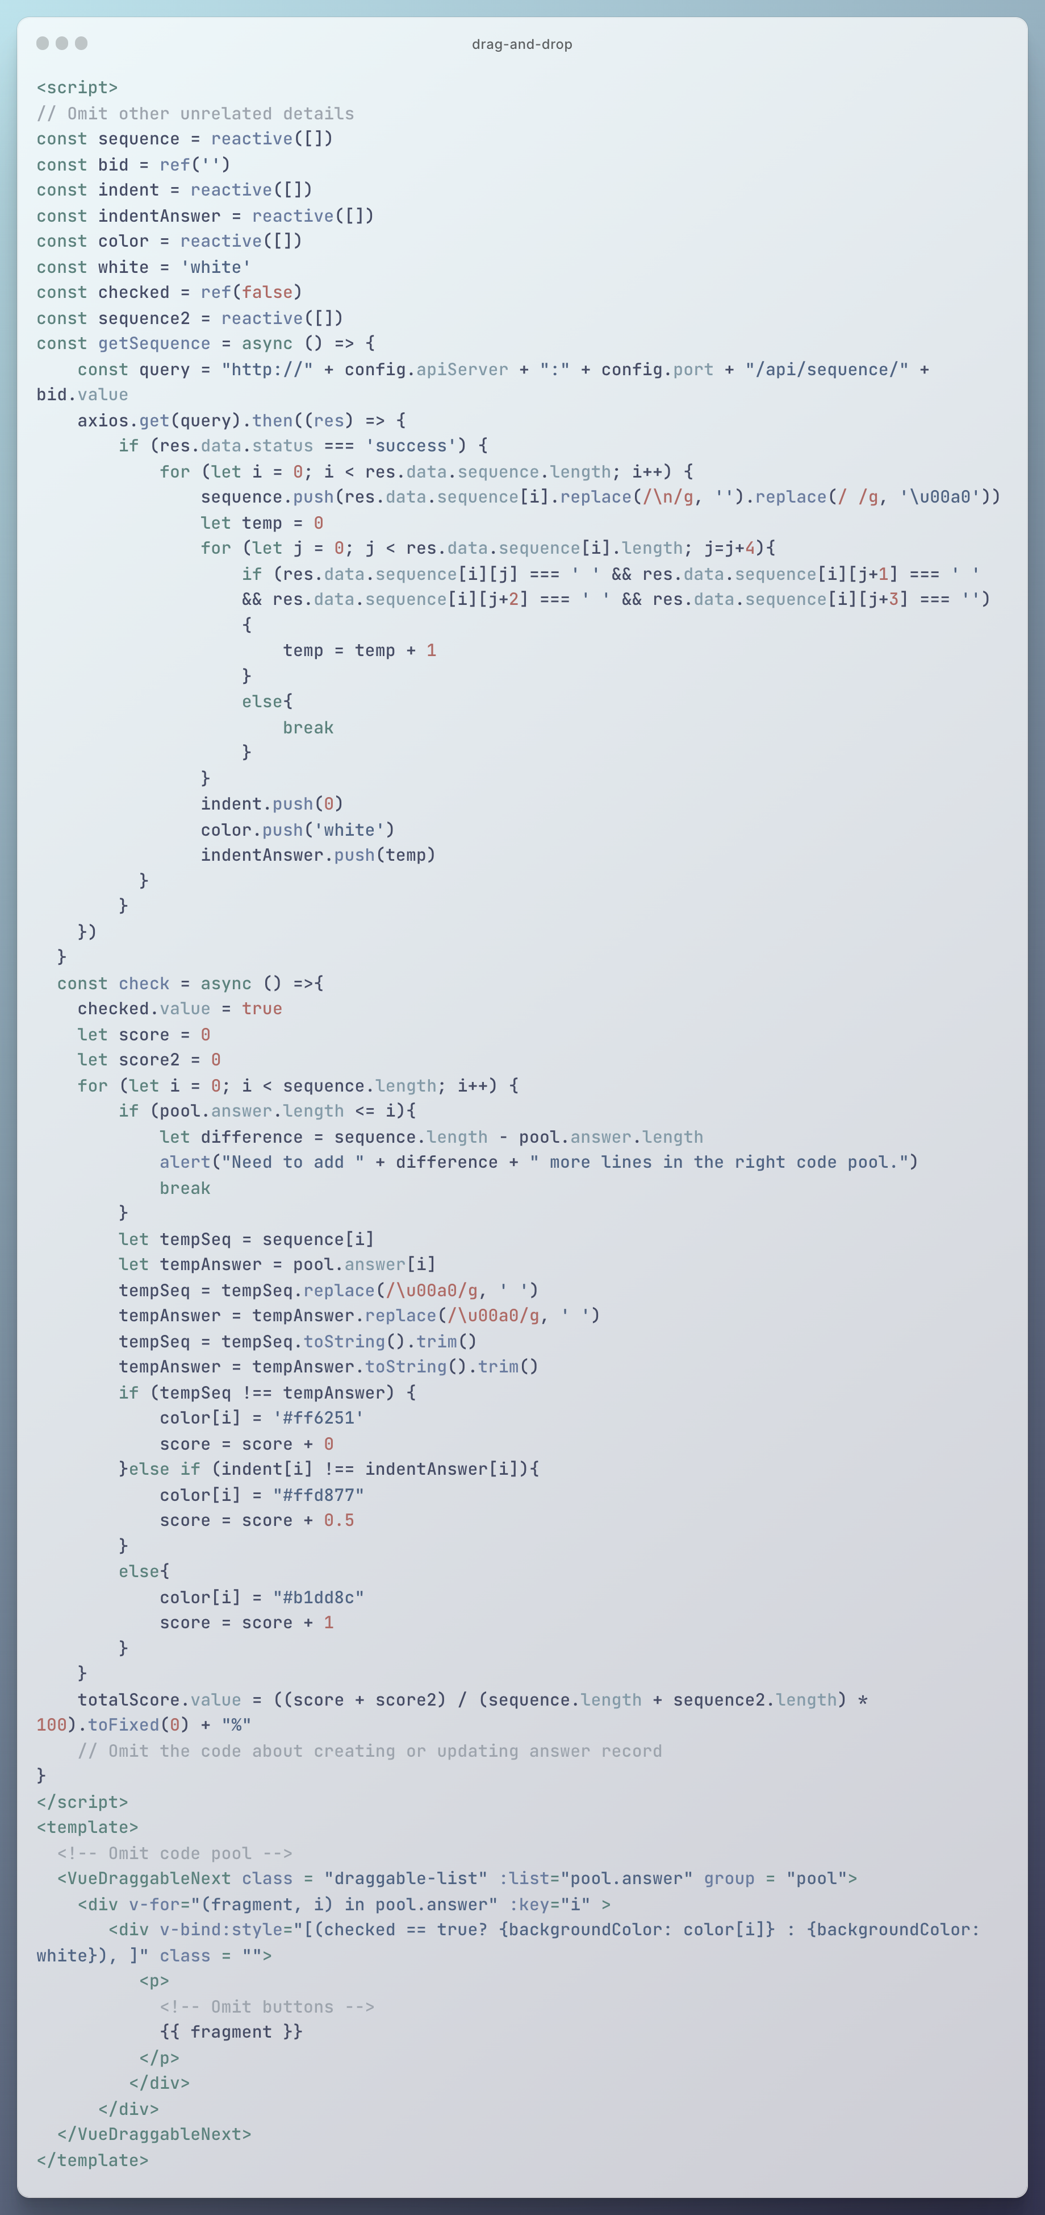

Figure 24 Check and get feedback

### Distractor

The codes about distractor are an important feature in customize solution, showing, and checking. In customize solution, the ‘add distractors’ button is clicked to show the content about adding distractors, and after that, the information about distractor is inputted and stored in as a ‘Distractor’ in database (Figure 25). When getting fragments, the existence of distractor of every fragment is checked. If there is a distractor, the distractor is also pushed into code pool (Figure 26). The predefined reason is shown when distractor is selected (Figure 27).

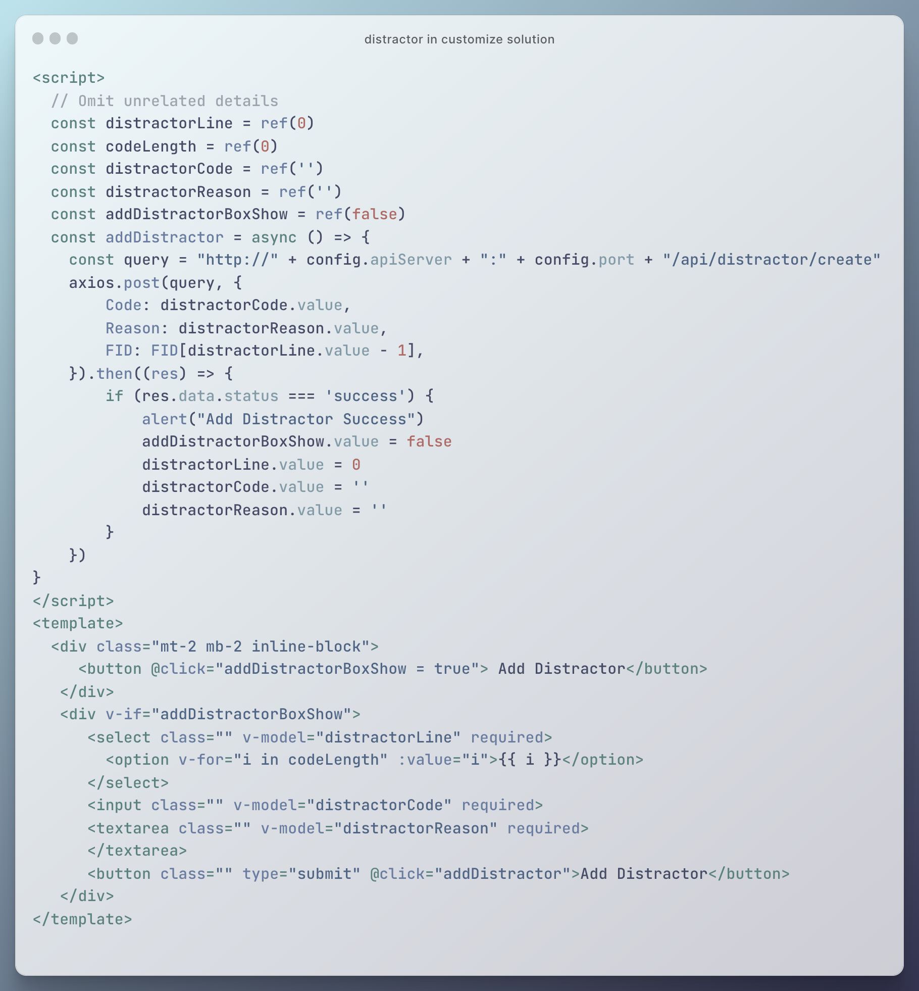

Figure 25 Distractor in customize solution

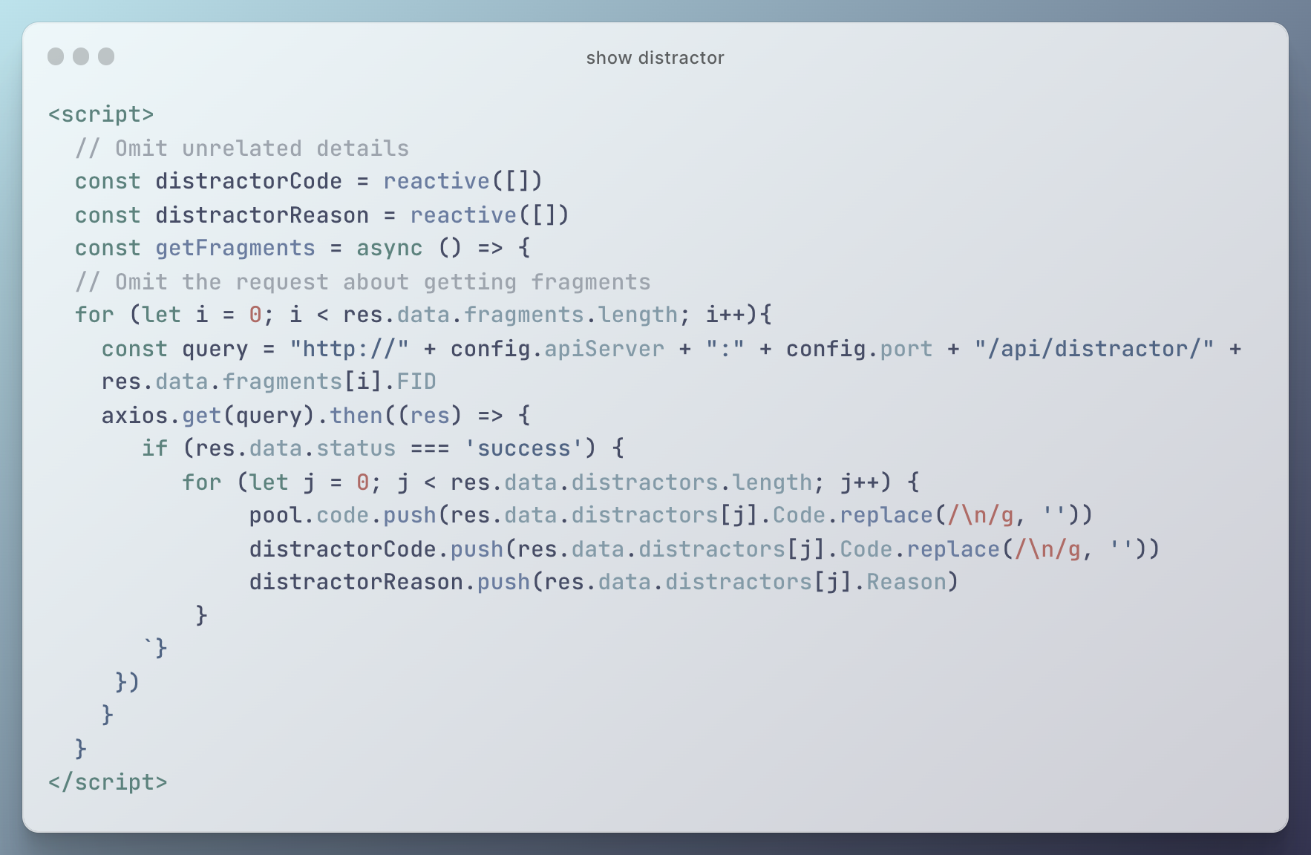

Figure 26 Show distractor

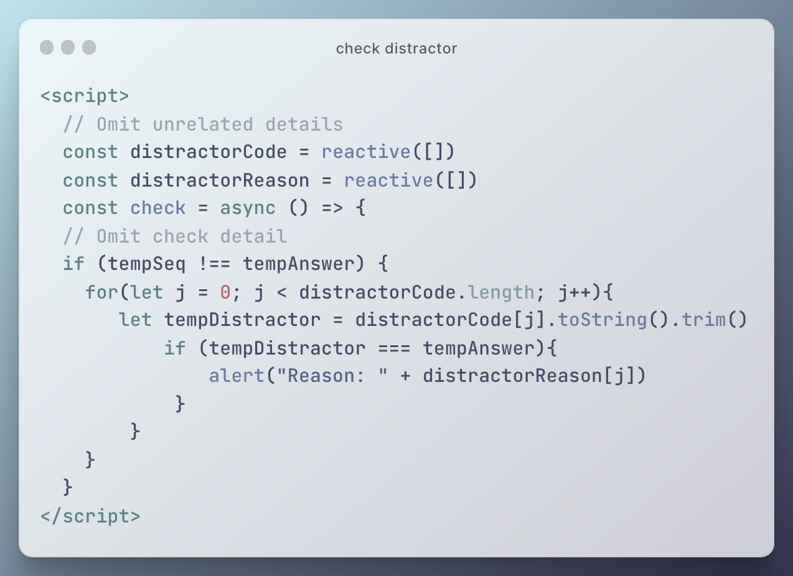

Figure 27 Check distractor

## Contextual Clues

This section focuses on the implementation of the category ‘Contextual Clues’ mentioned in 3.3. This category contains two different types – context and insert key code. These two types of questions will be introduced in different procedures – customizing solution, showing, and checking.

### Customize solution

In the procedure of customizing solution, both types of questions need to mark special code fragments (context or key code). To achieve this function, teachers can click buttons to input the marking information. This information is stored in a list. And according to this list, the corresponding fragment type will be updated after confirmation. Figure 28 shows an example of context type of question in customizing solution procedure. Another type is quite similar.

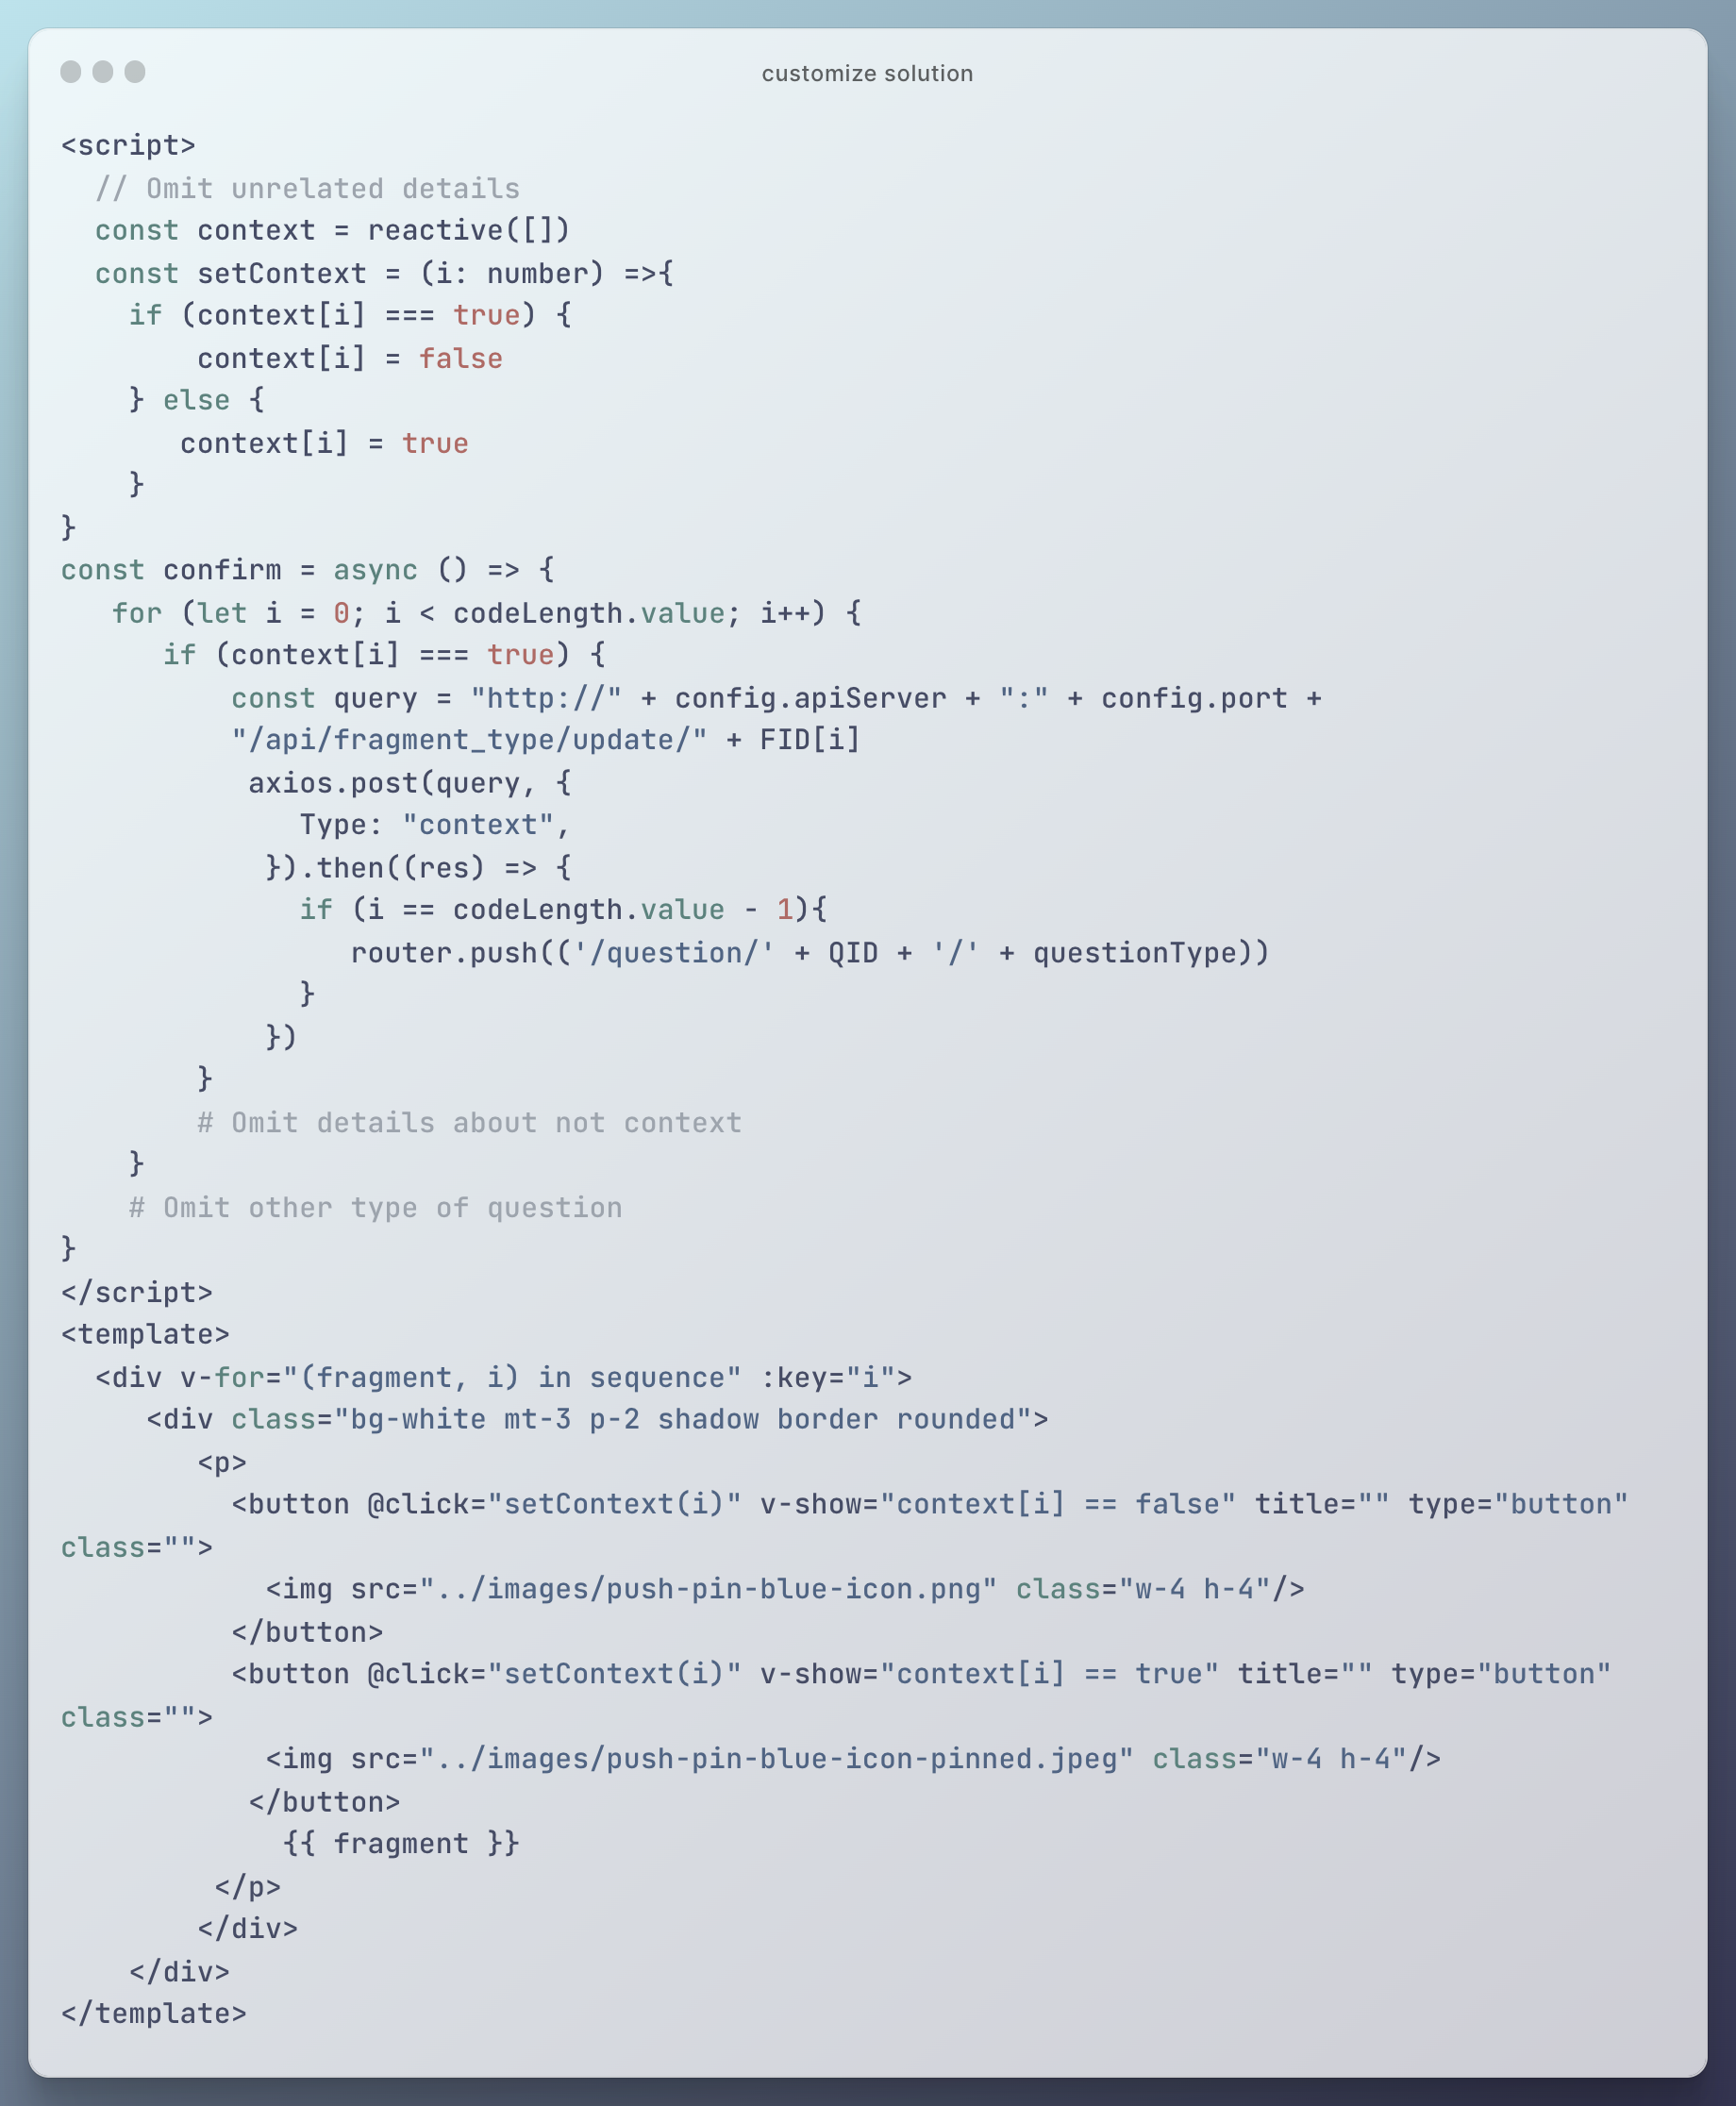

Figure 28 Example of context type of question in customizing solution procedure

### Show in answer pool

Unlike the traditional Parsons problem, the ‘context’ or ‘not key code’ codes are directly put in the answer pool. To get codes in order, these kinds of codes are pushed into the answer sheet when getting the correct answer. Only the remaining types of fragments are obtained in the original get fragment method. In the context type of question, the placeholders are also filled in the answer pool as tips of code positions, which is different from the insert key code type (Figure 29).

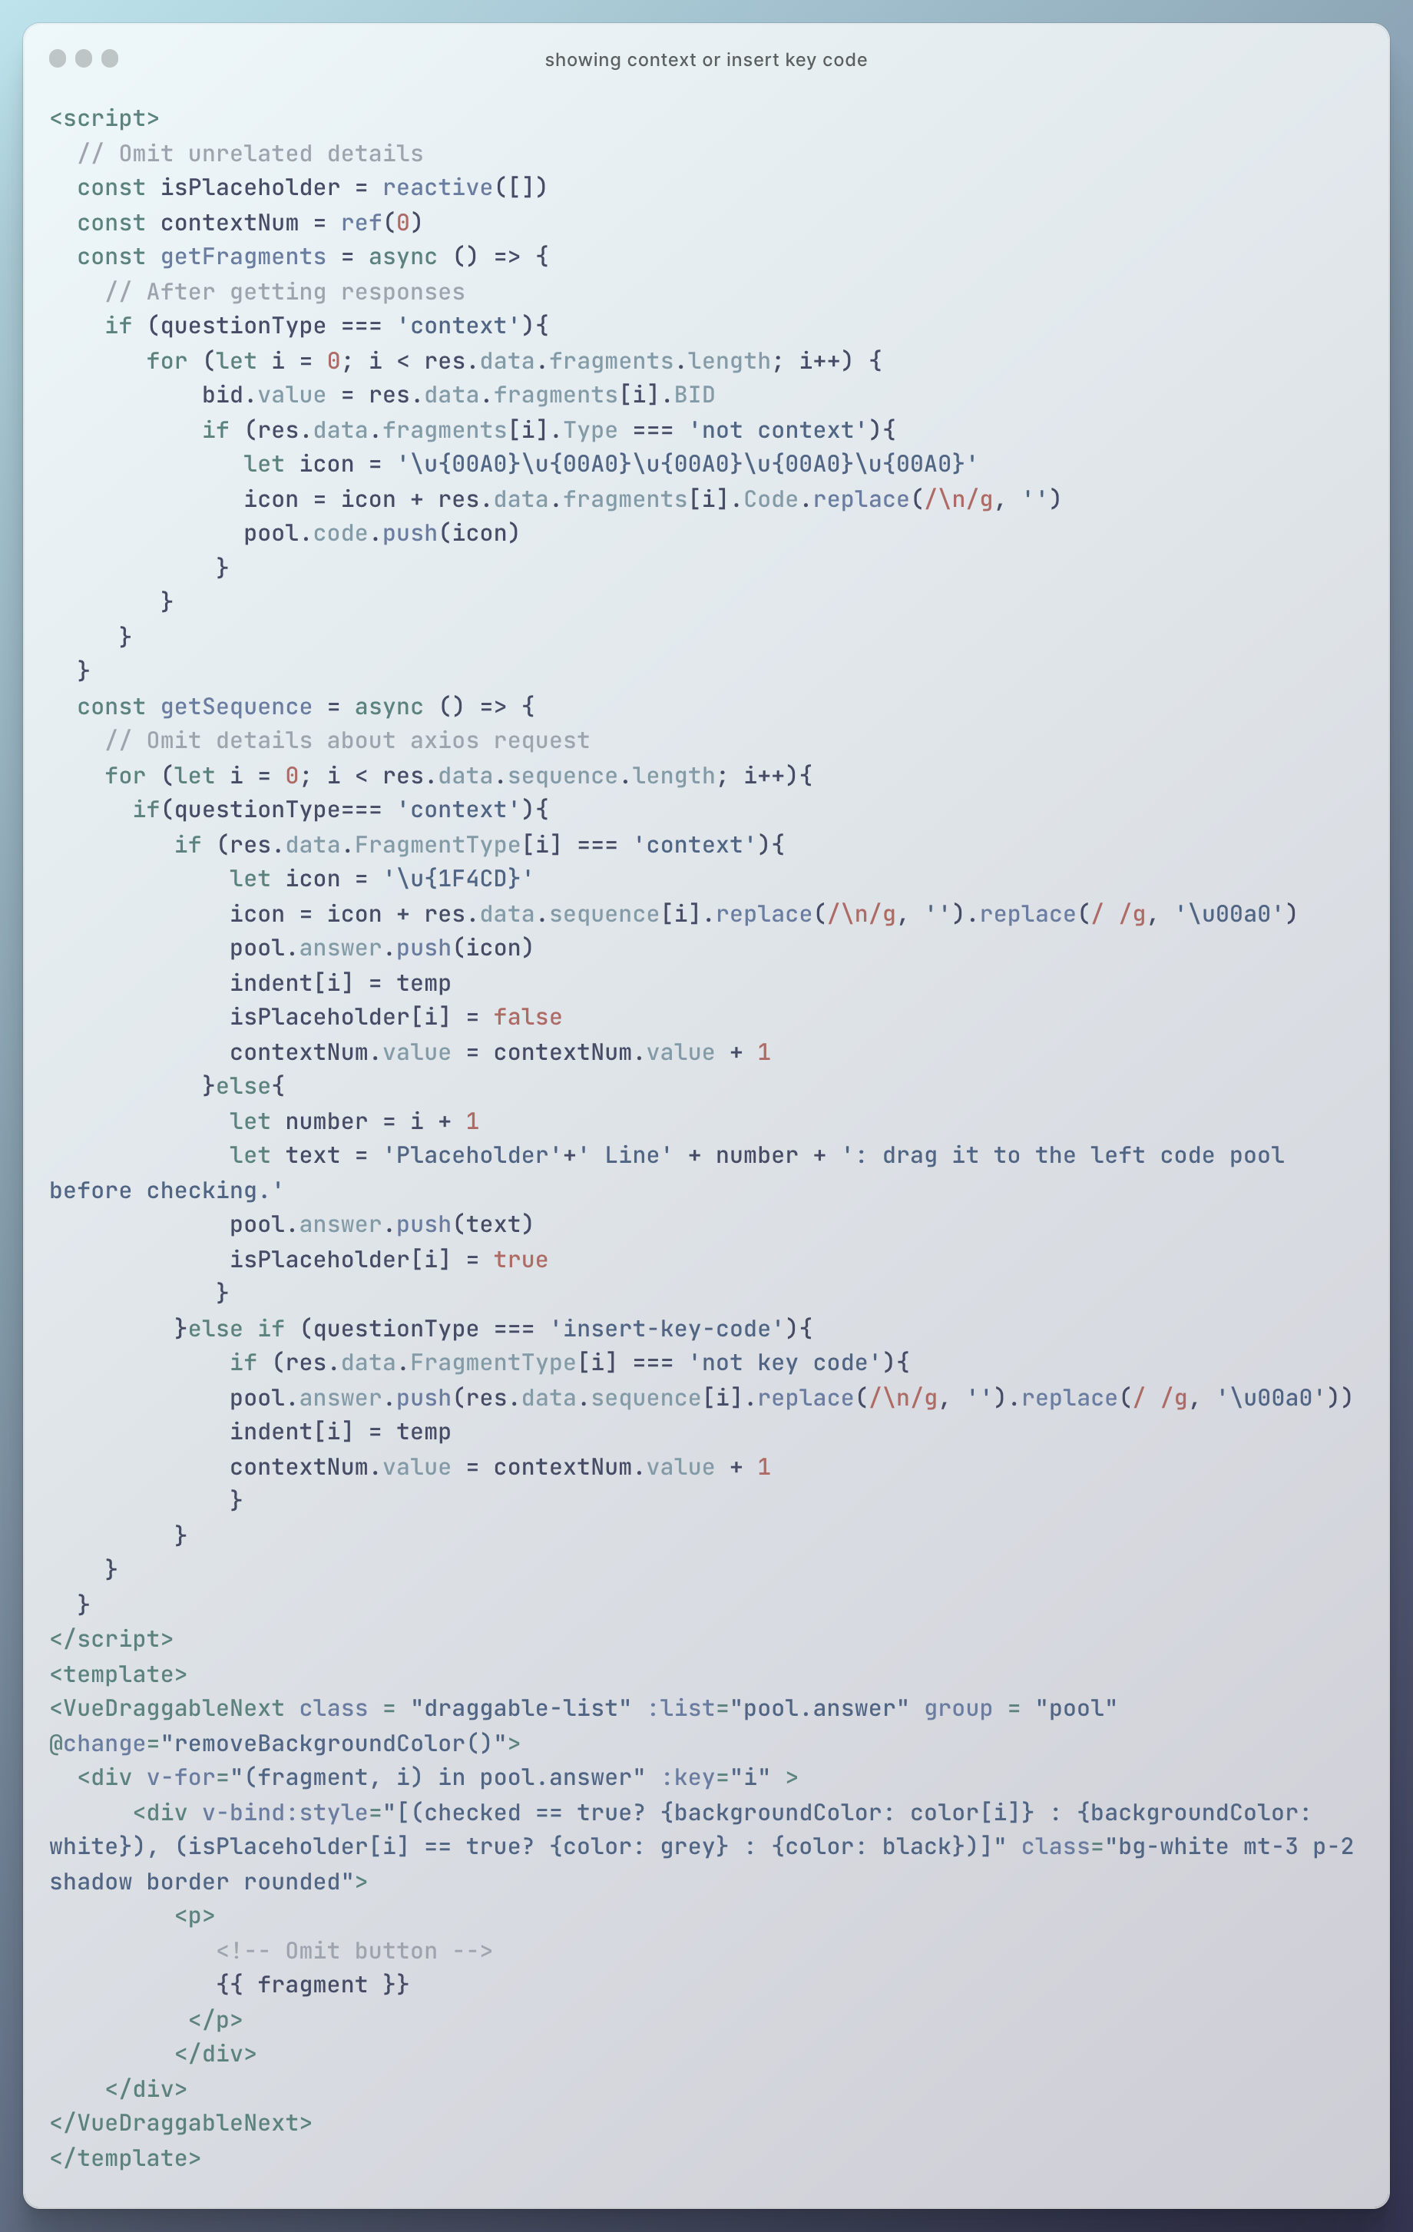

Figure 29 Showing context or insert key code

### Check and feedback

Checking is almost the same as the traditional one except for three small differences. Firstly, in the context type of question, the placeholders are moved to the code pool before checking. Secondly, the extra icons are removed before comparing them with the correct answer contents. Thirdly, the additional marks coming from the given code are reduced. In other words, only the marks about the codes that students actually manipulate are recorded (Figure 30).

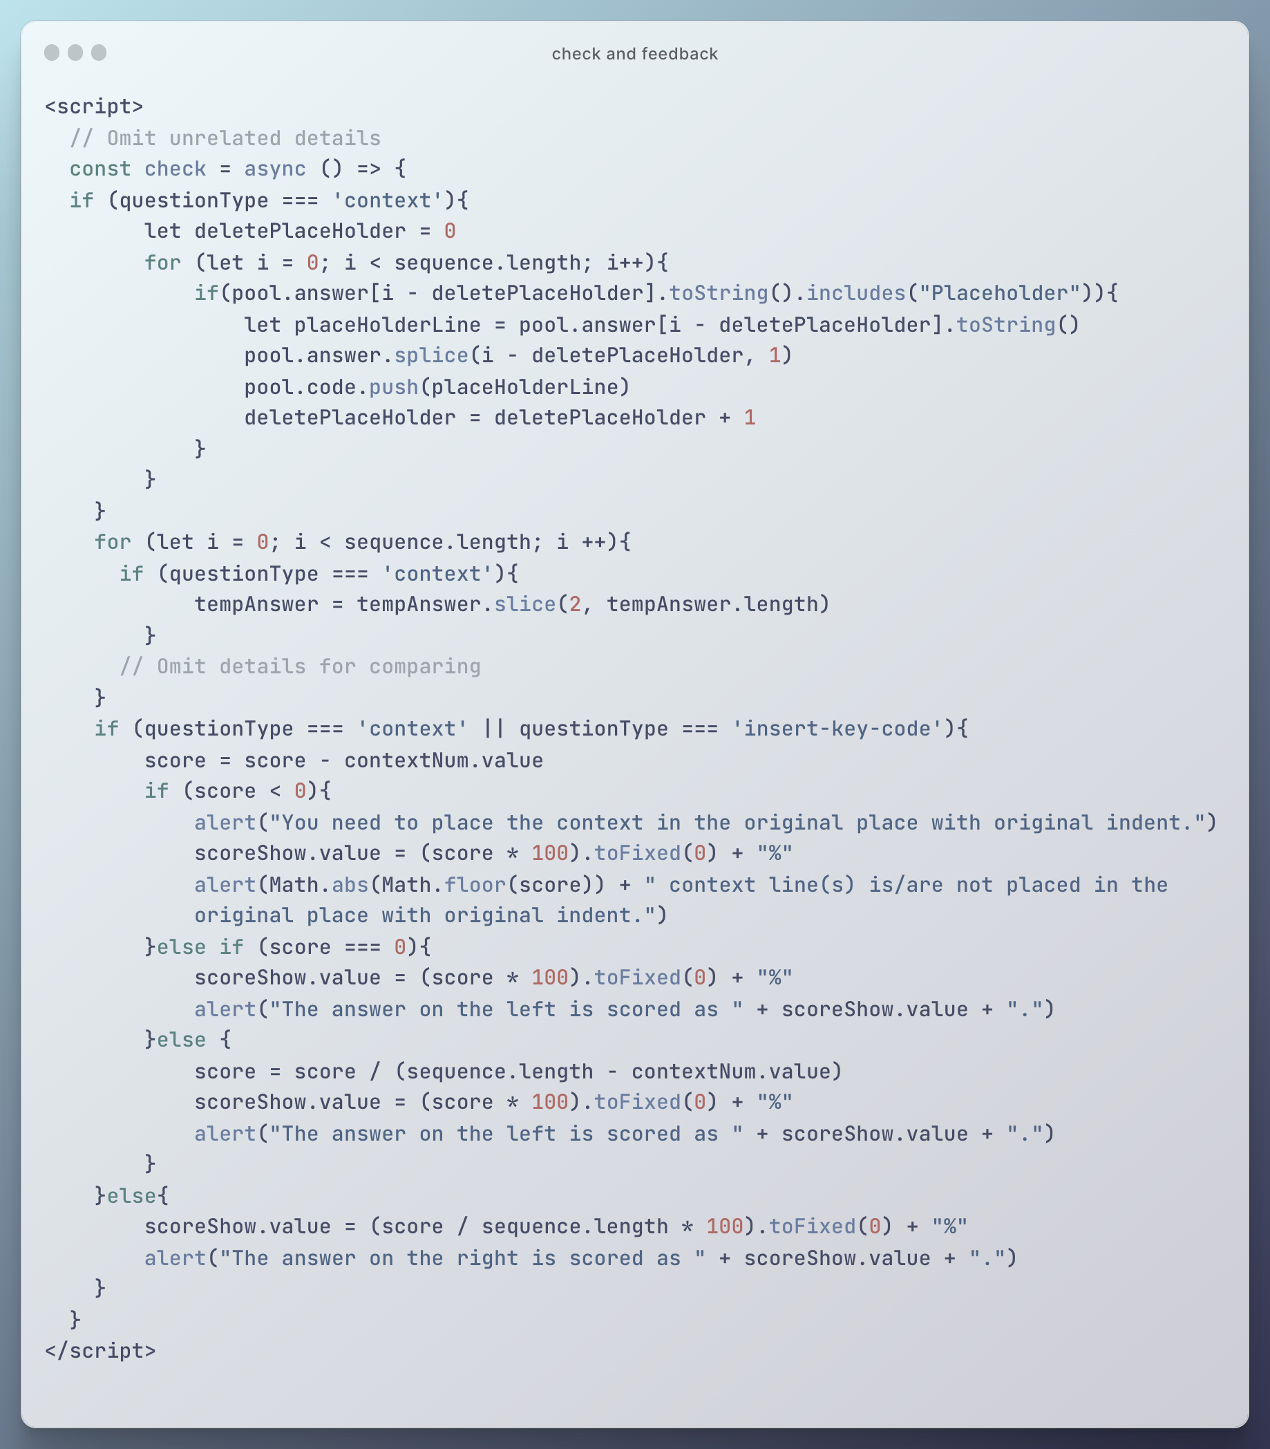

Figure 30 Check and feedback about context or insert key code

## Multiple Step

Compared with the traditional Parsons problem, the Multiple Step type of question is largely different in the following three actions: customize solution, show, and check.

### Customize solution

Similar to the previous types of questions, the add step view is hidden by default and only is visible after clicking the buttons. Lines coverage information is collected through the select input tag. And then, a new ‘Difficulty Level’ is created in the database (under the same ‘solution’ but with a different ‘level’ value), and the grouping information is recorded by the ‘BlockSeq’ in ‘Difficulty Level’, which can record the order of code in a more flexible way. The related codes are shown in the following (Figure 31 and Figure 32).

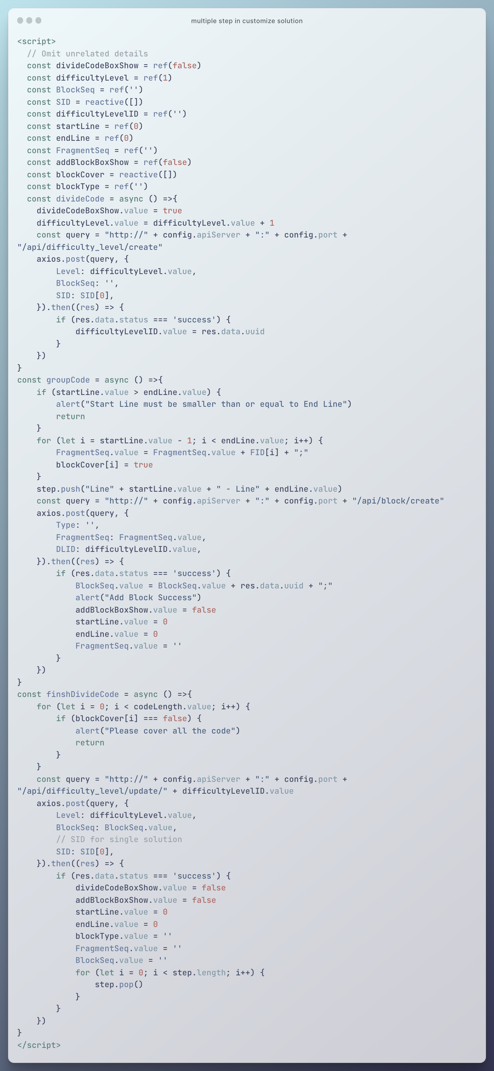

Figure 31 Multiple step in customize solution (script)

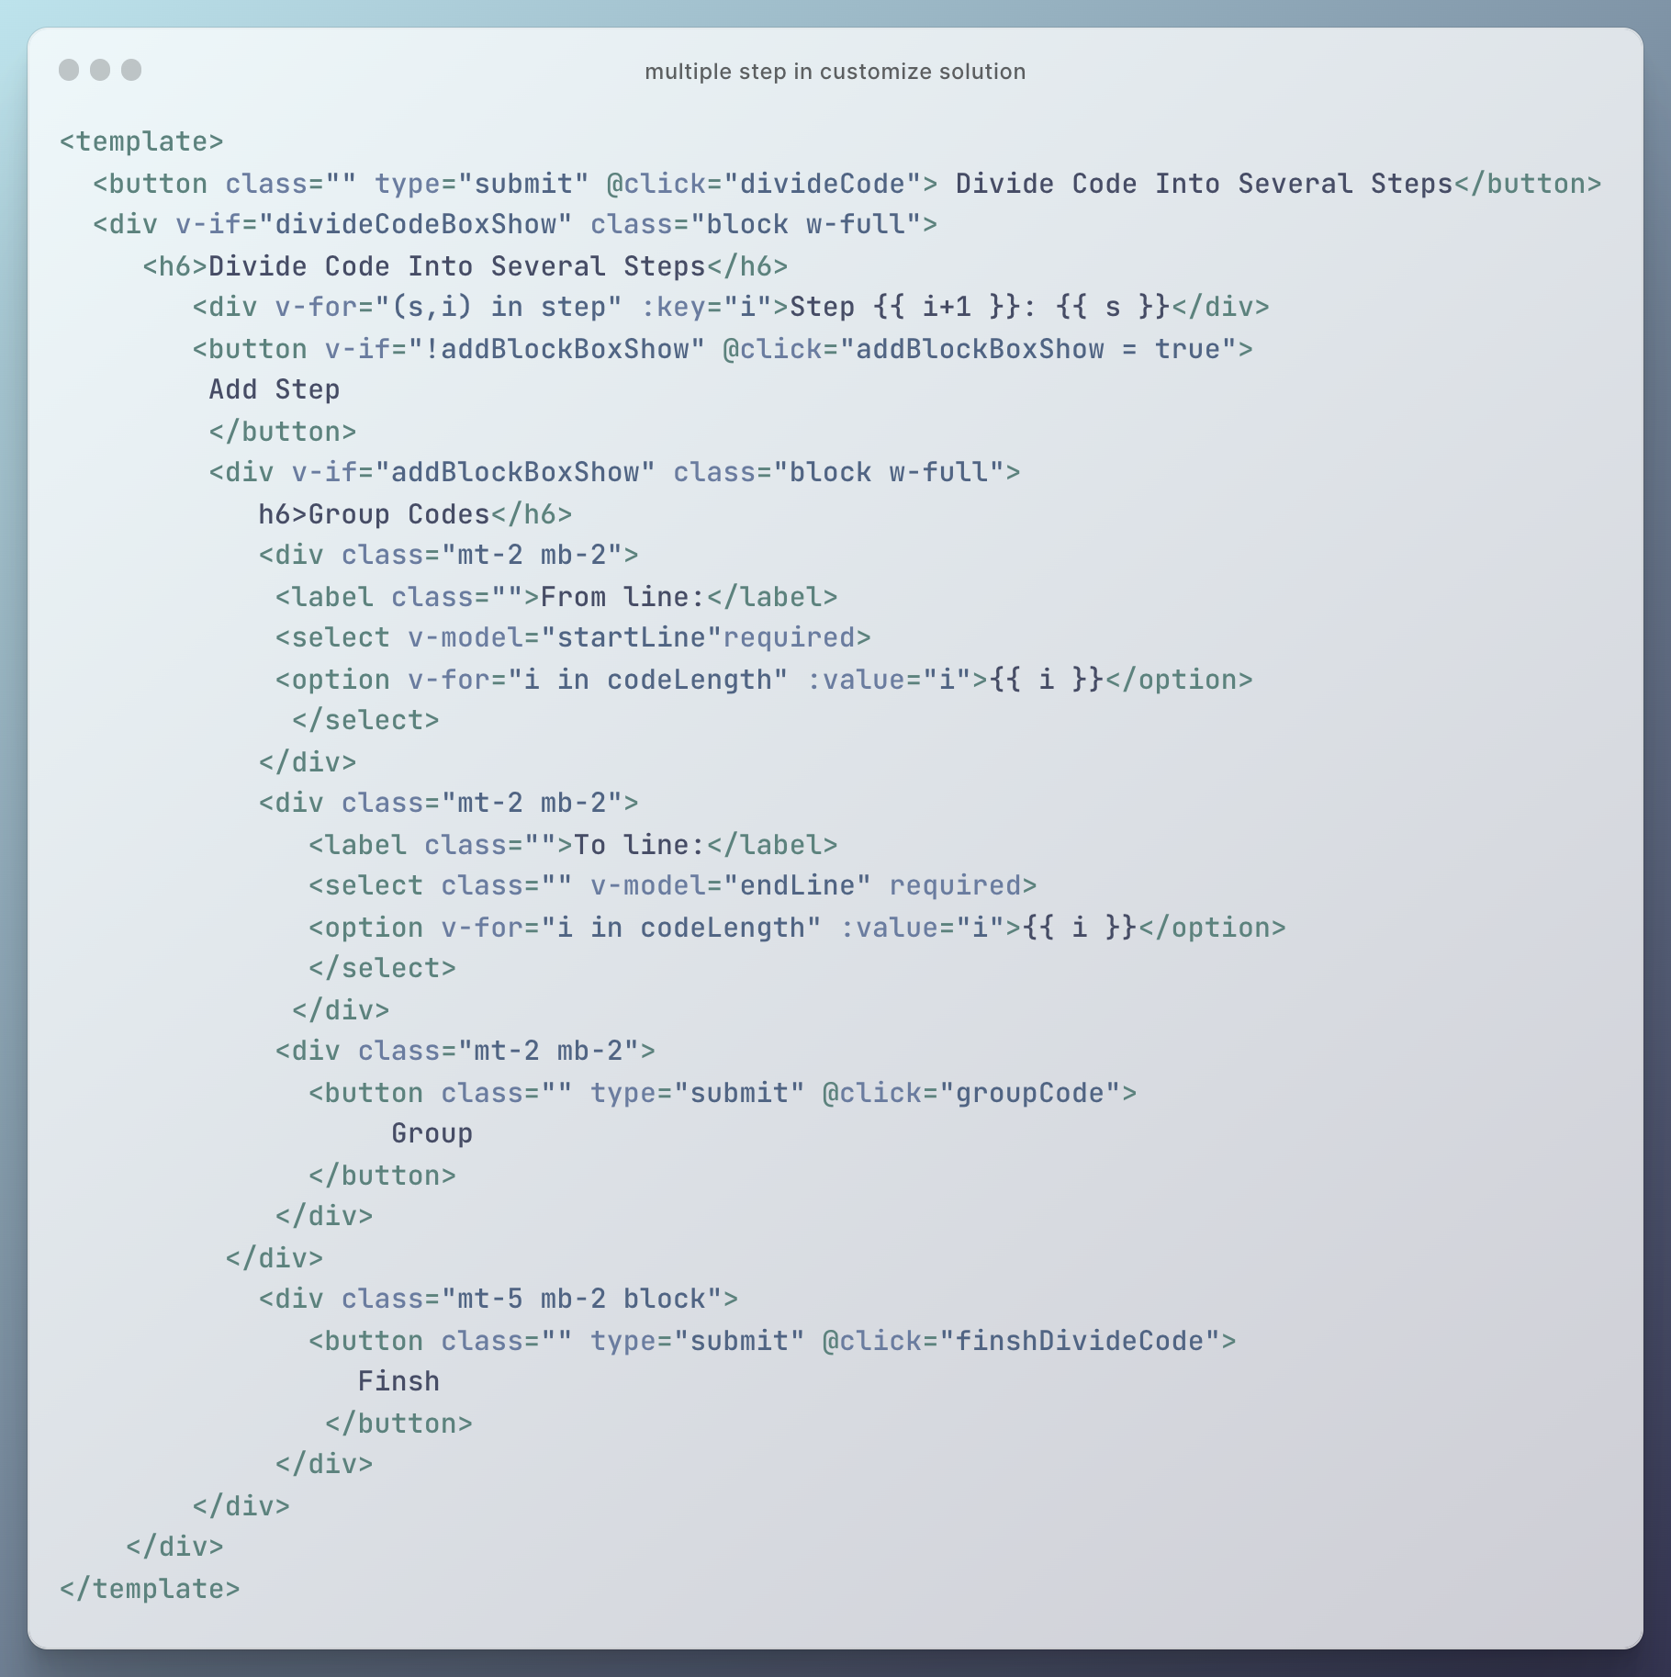

Figure 32 Multiple step in customize solution (template)

### Show and check

Different groups of codes are indicated as different steps. To make these ‘step’ words distinguishable from the code, the Unicode for ‘【’ and ‘】’ is inserted. These special words are removed before checking (Figure 33).

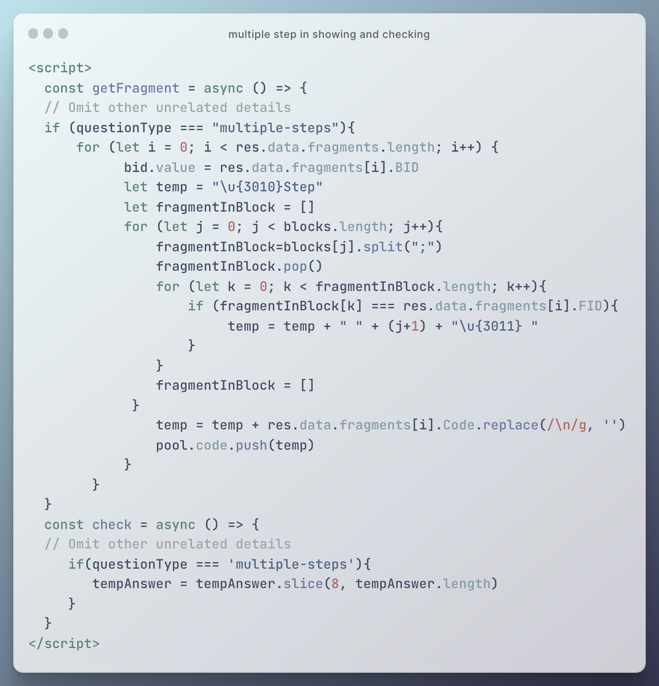

Figure 33 Multiple step in showing and checking

## Algorithm Comparison

This type of question does not make significant changes in the logic of the program. The only thing is to store the information of the second solution into another set of existing variables like ‘sequence’ and ‘sequence2’. And new draggable area is added in between the original two areas, and the items in this area are pushed into ‘pool.buffer’ when showing (Figure 34).

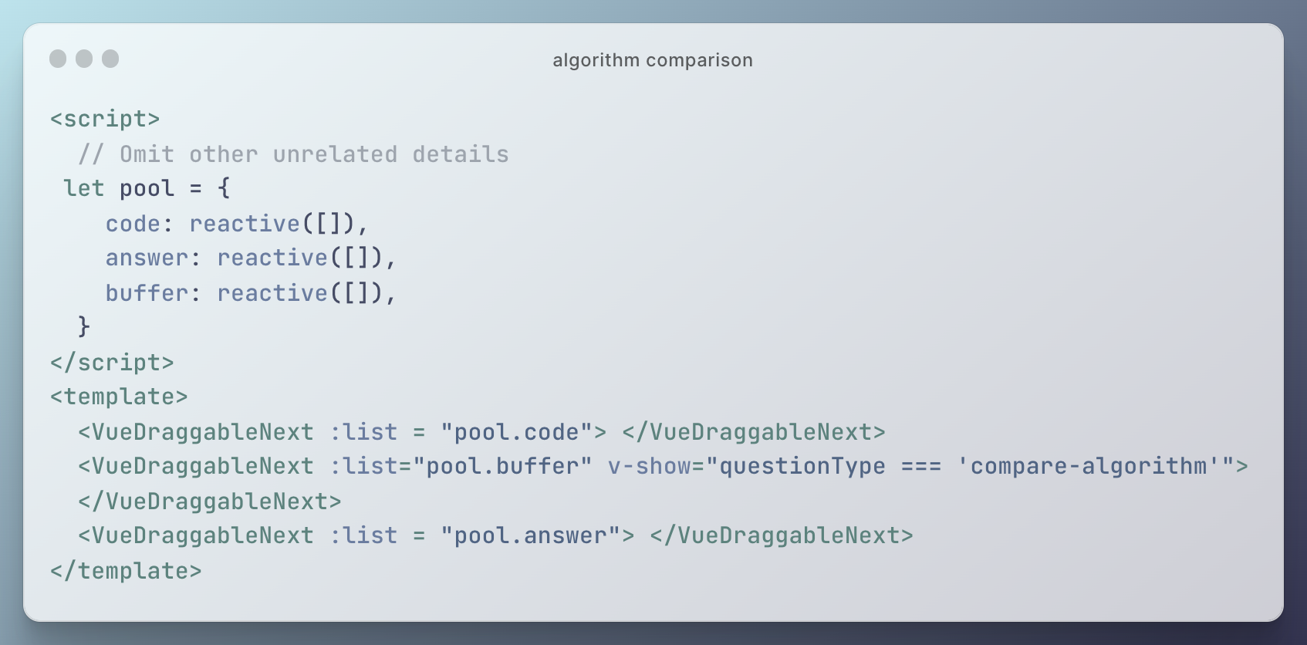

Figure 34 Algorithm comparison

## Switch Difficulty Level

Switching difficulty level can reduce the difficulty significantly. However, the implementation of this function is not easy. The first idea coming out about this function is to use the ‘Difficulty Level’ in the database to handle the different organizations of different difficulty levels. But in that design, the types of blocks and fragments are quite trivial, unclear, and not user-friendly. To handle this question, the types are summarized in ‘Question’ level, and all the action about the lower level should refer to the question types. Since the ‘Question’ is high level of ‘Difficulty Level’, it is not straightforward to store different question information in the single ‘Difficulty Level’, which belongs to one question. To solve this problem and save time, the ‘Easier Version Pointer’ is created to store the relationship between the original question and the easier one. This final design breaks the restriction of the previous design effectively. By using this design, the teachers can create a question type after customization. The new question is created in the back-end, and the same information as the original and easier one is automatically stored (Figure 35). The teacher only needs to choose the new question type and customize solution in the front-end.

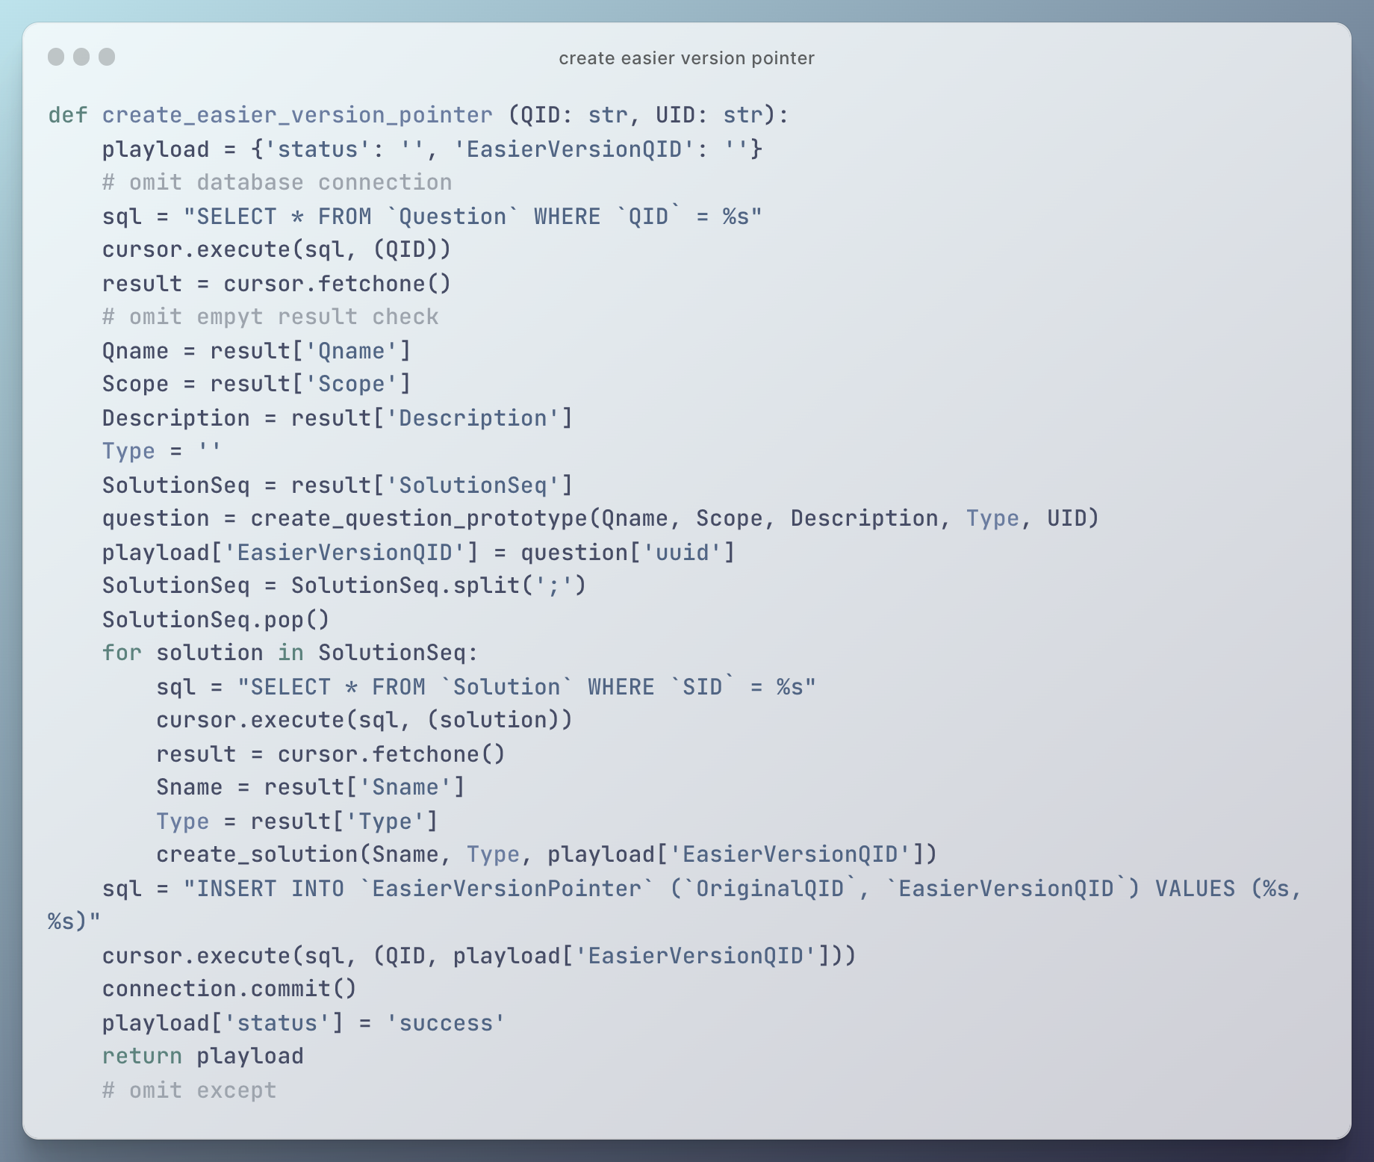

Figure 35 Create easier version pointer

# Results and Discussion

In this chapter, the outcomes of the project are illustrated by screenshots. In addition, the effectiveness of this project is assessed by comparing it with directly using traditional Parsons problem in CS2 and by opinions from questionnaire. Specifically, the results of basic activities taken by teachers and students are illustrated in sequence. And different question types are introduced based on the mentioned basic process. Other additional details are introduced finally. Besides, the value of this project is assessed by comparing the expanded Parsons problem with traditional Parsons problem in object-oriented programming, recursion, and comparison. Moreover, opinions about this Parsons problem are collected from students to improve the project.

## Results of Basic Process: Present Home Page

When users first enter this web application, they can see the home page of this project (Figure 36). There are three major parts shown on this home page. Specifically, basic information of different questions is listed in card view in the core area of home page. By reading these question information cards, users can get to know the question names with descriptions and select one question to view details. The navigation bar is shown on the top of the question list to allow the users to take some basic actions, including login, going to personal center, and creating a new question (only for teachers). The scope filter is shown on the right of the question list. Users can use it to filter questions shown on the homepage (Figure 37).

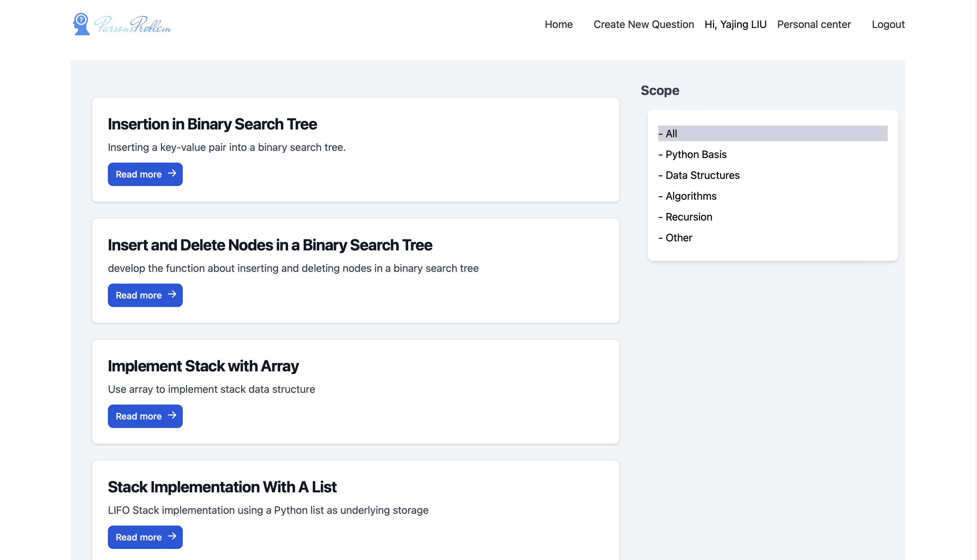

Figure 36 Home page

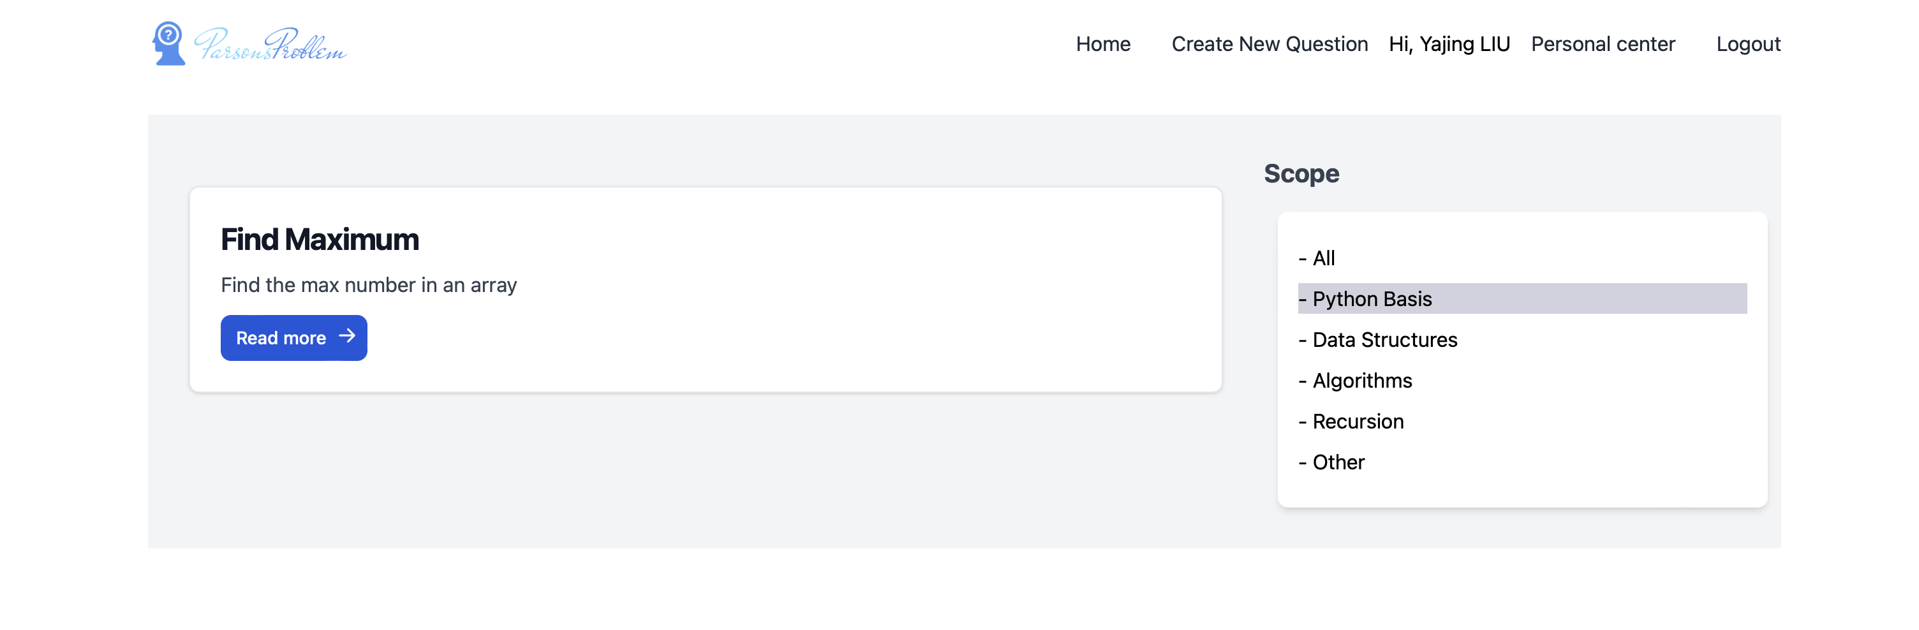

Figure 37 Example for filtering python basis question

## Results of Basic Process: Register and Login

Users can enter the login page (Figure 38) by pressing the button ‘login’ in the navigation bar on home page. After users input the email address and password, the information is sent to back-end and compared with the records in the database. It is worth noting that the passwords are converted into hash forms for security reasons (Figure 39). If they are new users without an account, they can press the link ‘Not have an account’ and go to register page (Figure 40). After register or login successfully, the information of users is stored in the front-end for further use. And the navigation bar is changed according to the user’s type (Figure 41).



Figure 38 Login page



Figure 39 Hashed password stored in database

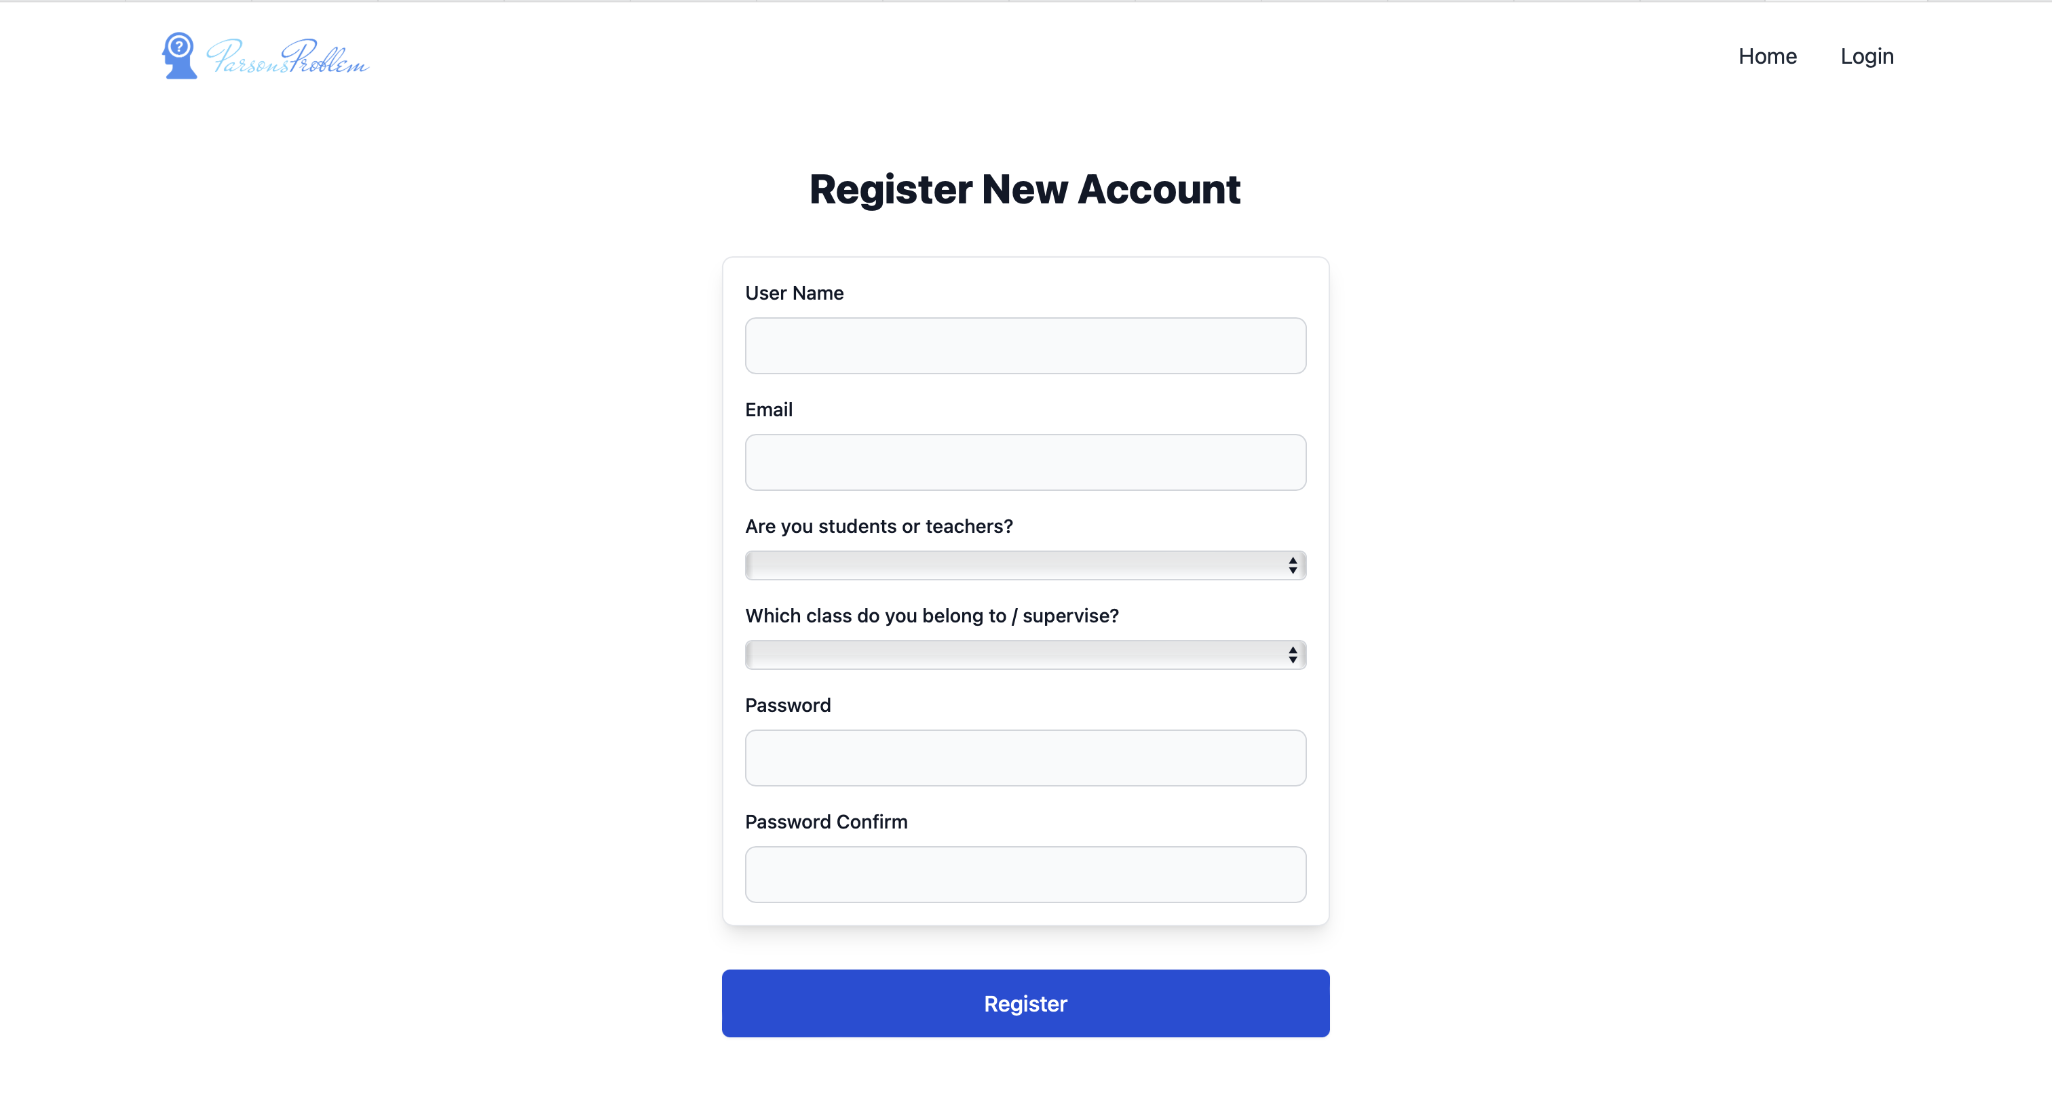

Figure 40 Register page

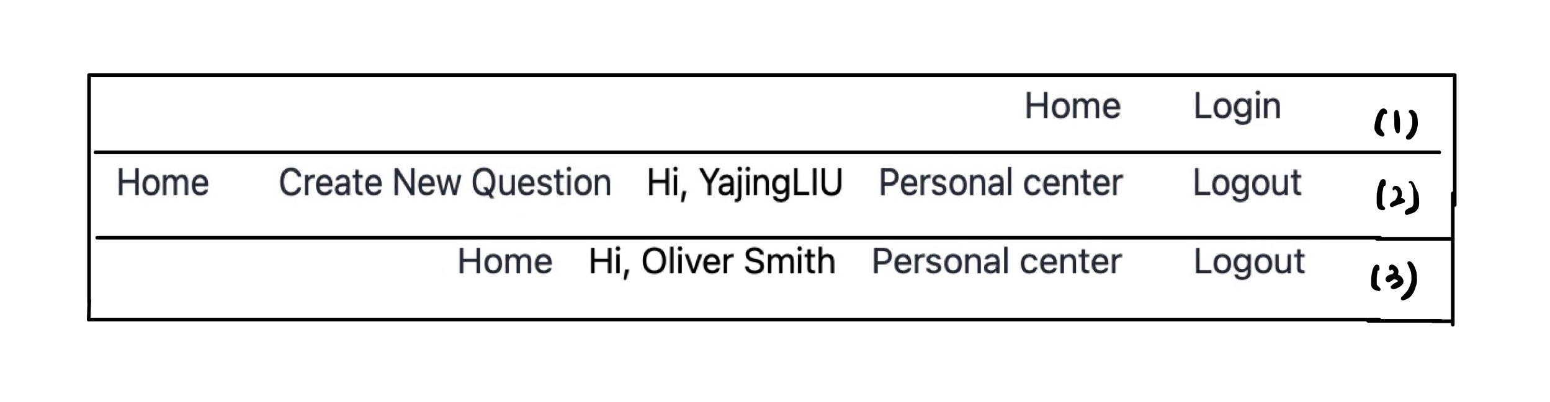

Figure 41 Different navigation bar for visitors (1), teachers (2) and students (3)

## Results of Basic Process: Create Question

Teachers can create new questions by clicking the link ‘Create New Question’ in the navigation bar. There are several steps to create a question – inputting basic question information, choosing question type, uploading solution, customizing solution.

Inputting basic information of question is shown in Figure 42. On this page, teachers should input the name, scope, and description of question.

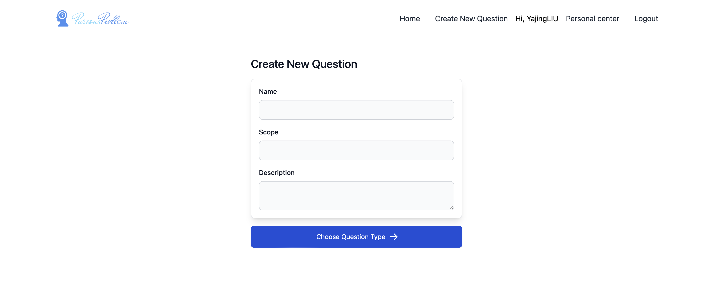

Figure 42 Create new question page

After inputting the mentioned information, teachers should choose the question types (Figure 43). On this page, gif animation and detailed descriptions are used to give intuitive explanations in differences among different question types. Gif images show the conceptual picture, and teachers can get some basic idea about how they work. And the description focuses on comparing the characteristics of different question types.

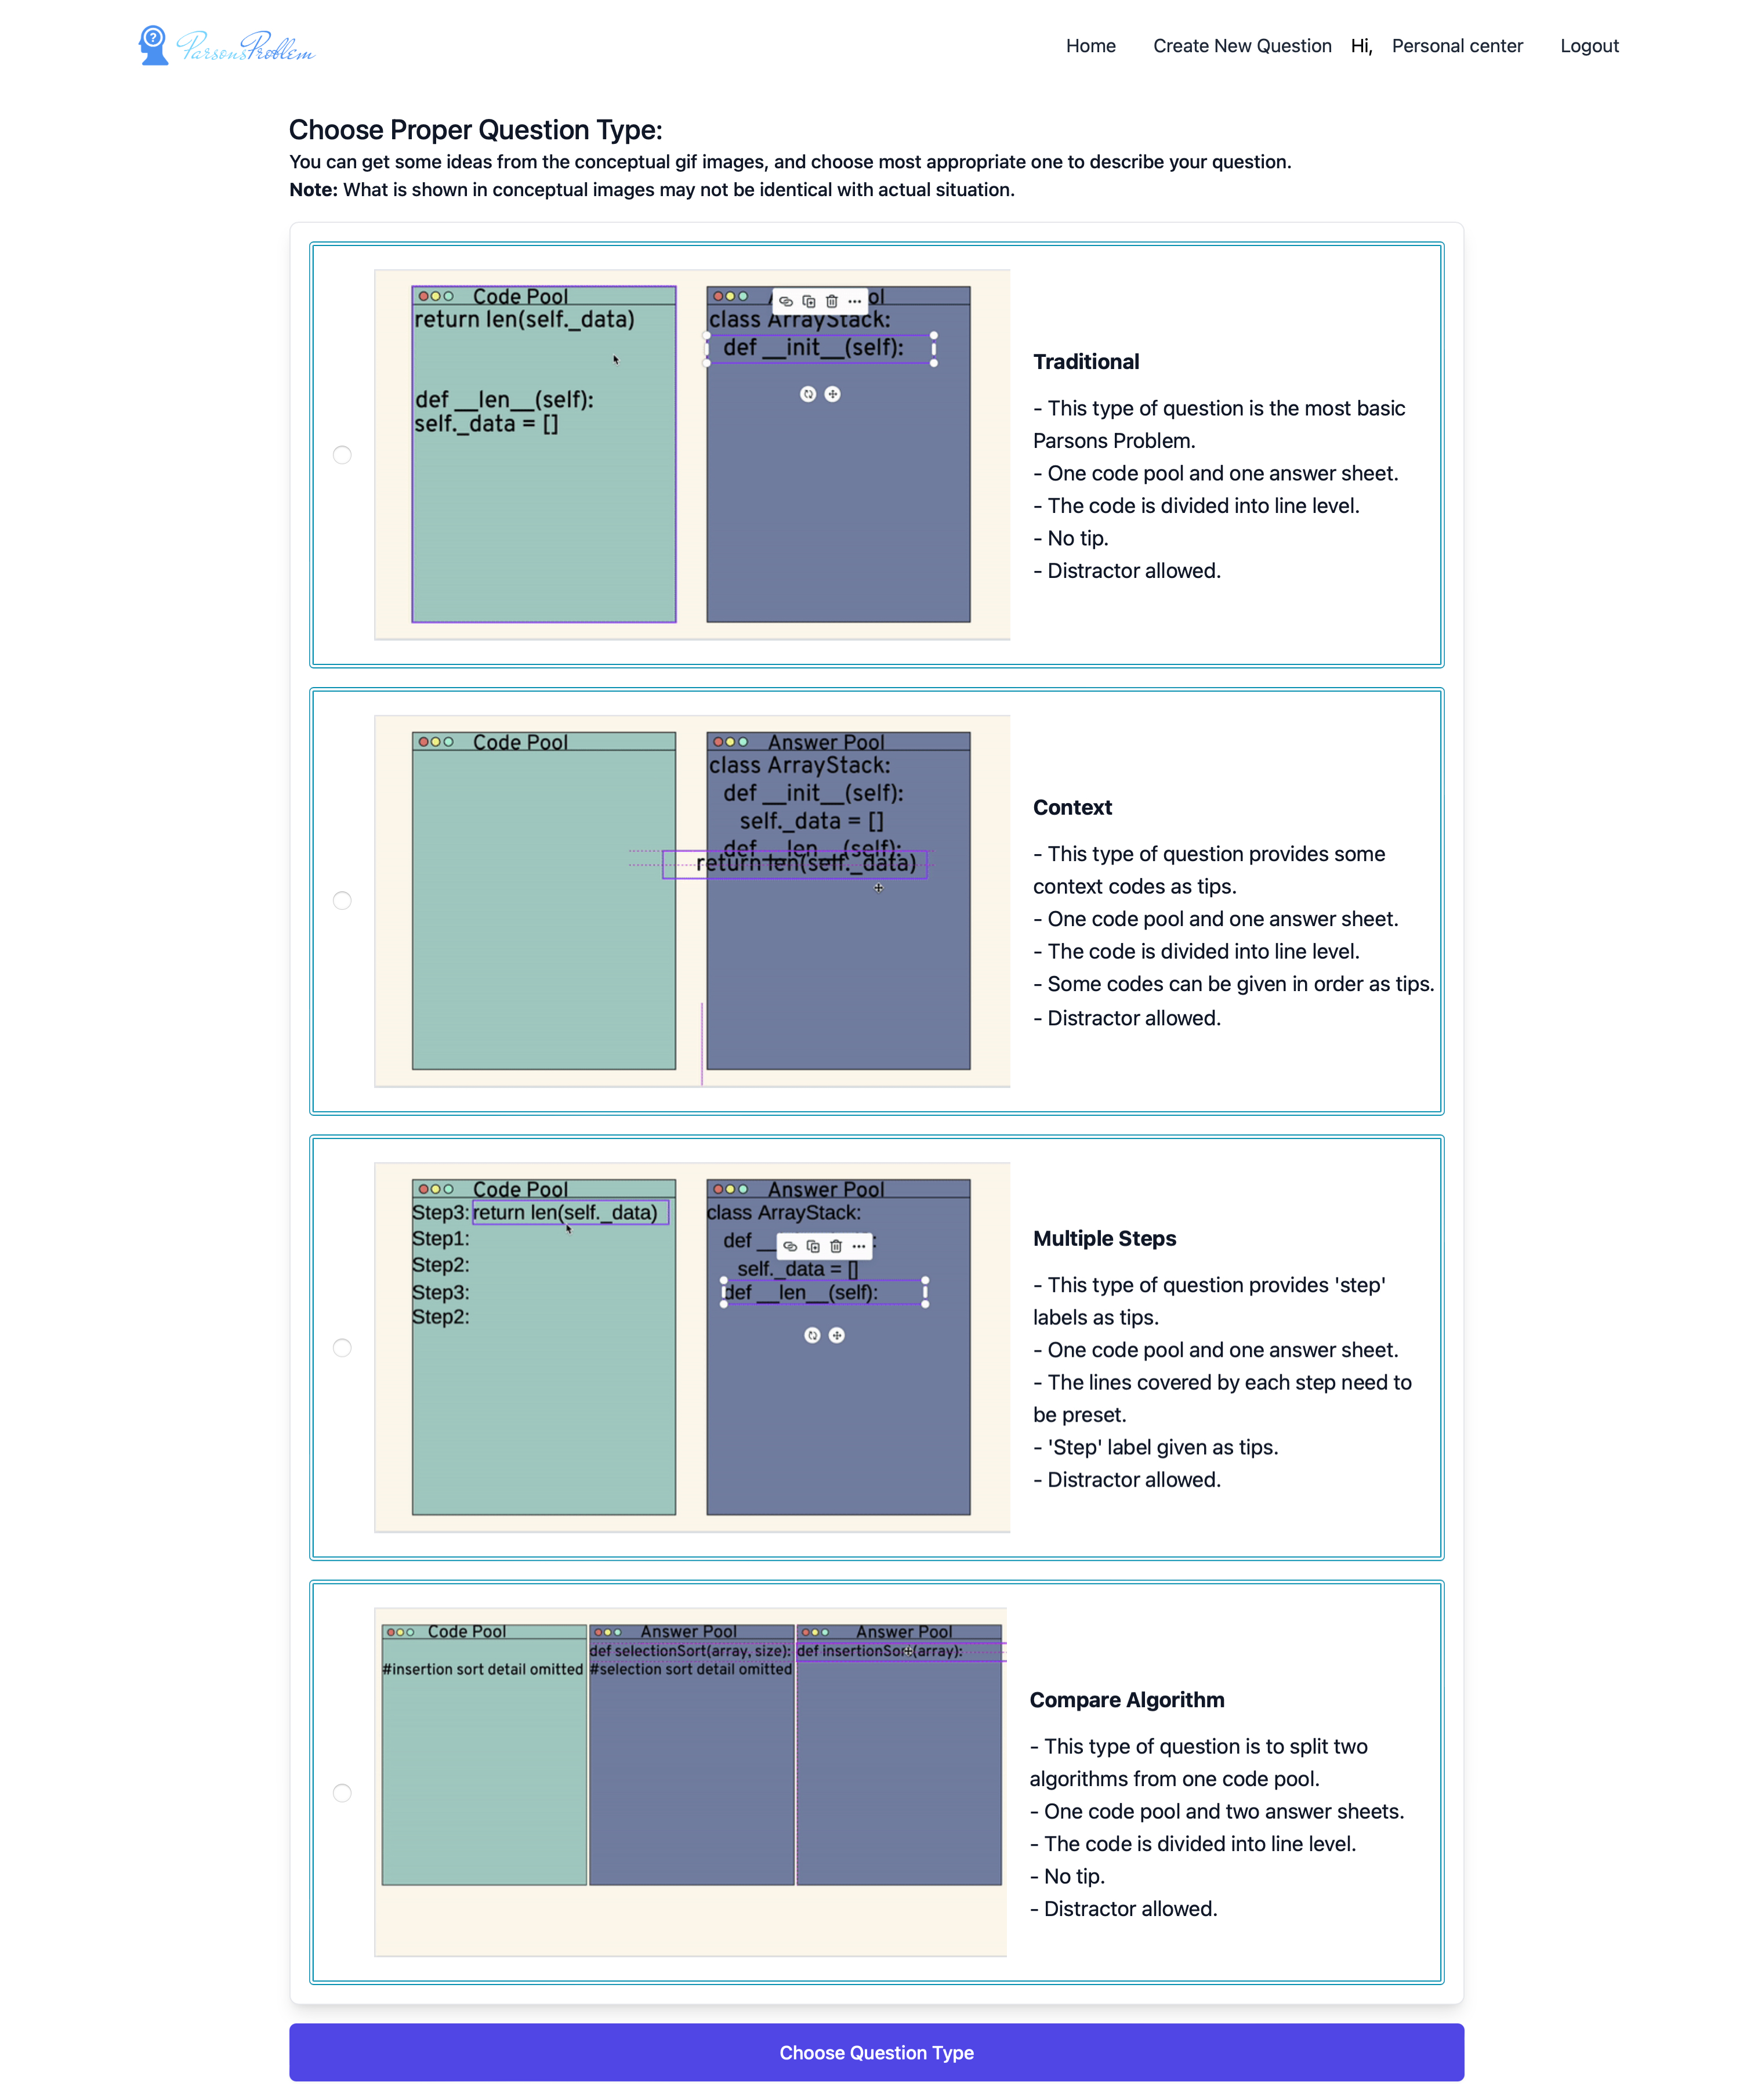

Figure 43 Choose question type page

The following step is to upload solution file (Figure 44). In this step, the prepared python solution file is uploaded into the system. This file is cut into code fragments line by line in the back end and stored in the database.



Figure 44 Upload solution page

In the final step, teachers can customize the solution according to their needs (Figure 45). Specifically, they can refer to the original codes in the uploaded Python file and take several actions, including setting distractors, marking special code fragments, grouping multiple code fragments into one block, and creating easier version. More details will be illustrated when introducing different types of question.

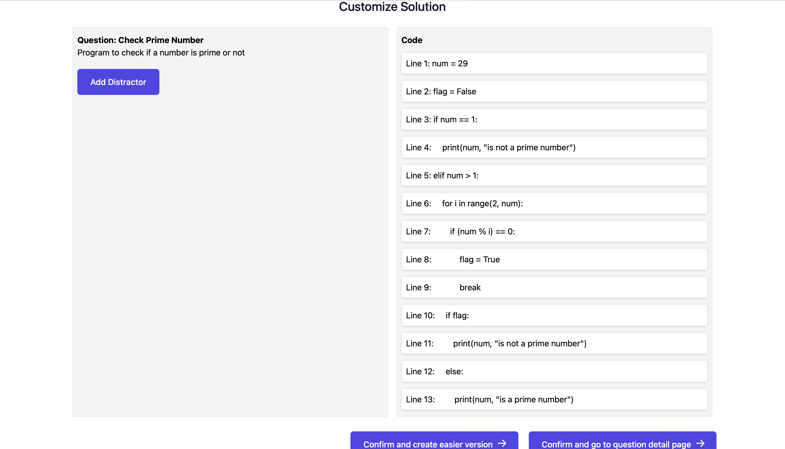

Figure 45 Customize solution page

## Results of Basic Process: View Exercise Detail and Do Exercise

Students can do exercises in the exercise detail page (Figure 46) after selecting a question from home page. Besides teachers can also preview this page after creating a new question. Students can reorder the jumbled codes by dragging and dropping the code fragments from the left code pool to the right answer sheet (Figure 47). Subsequently, they can push arrow buttons shown in the lines in the answer sheet to set the proper indent of codes. After finishing, they can press the check button to get feedback. In the feedback, the score (completeness of predefined solution reconstruction) and textual indication are shown in an alert (Figure 48). In addition, the codes are marked as different background color (green for totally correct, yellow for the right code but wrong indent, and red for wrong code) to give students further instruction (Figure 49). Students need to repeat taking exercises until they achieve 100% correct. And each score is recorded in the database once checking is done.

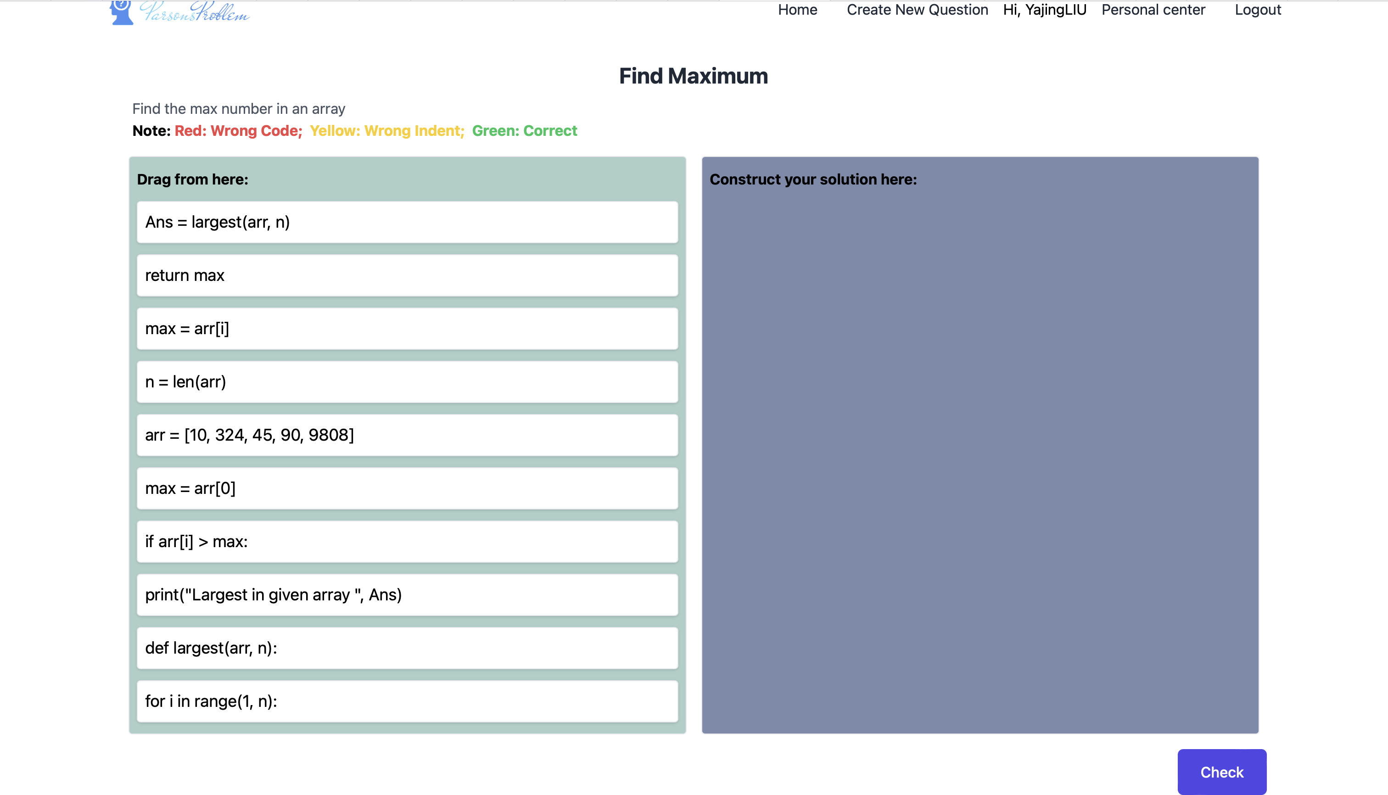

Figure 46 Question detail page

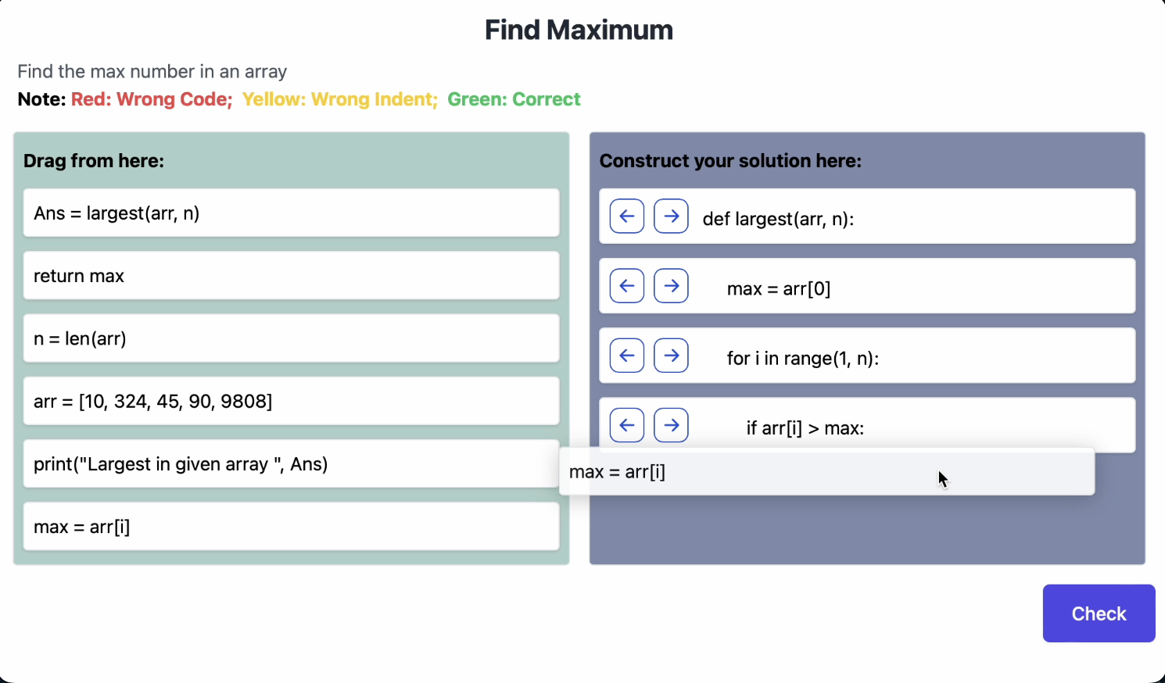

Figure 47 Drag and drop

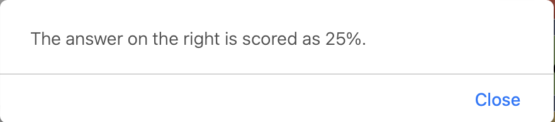

Figure 48 Feedback alert

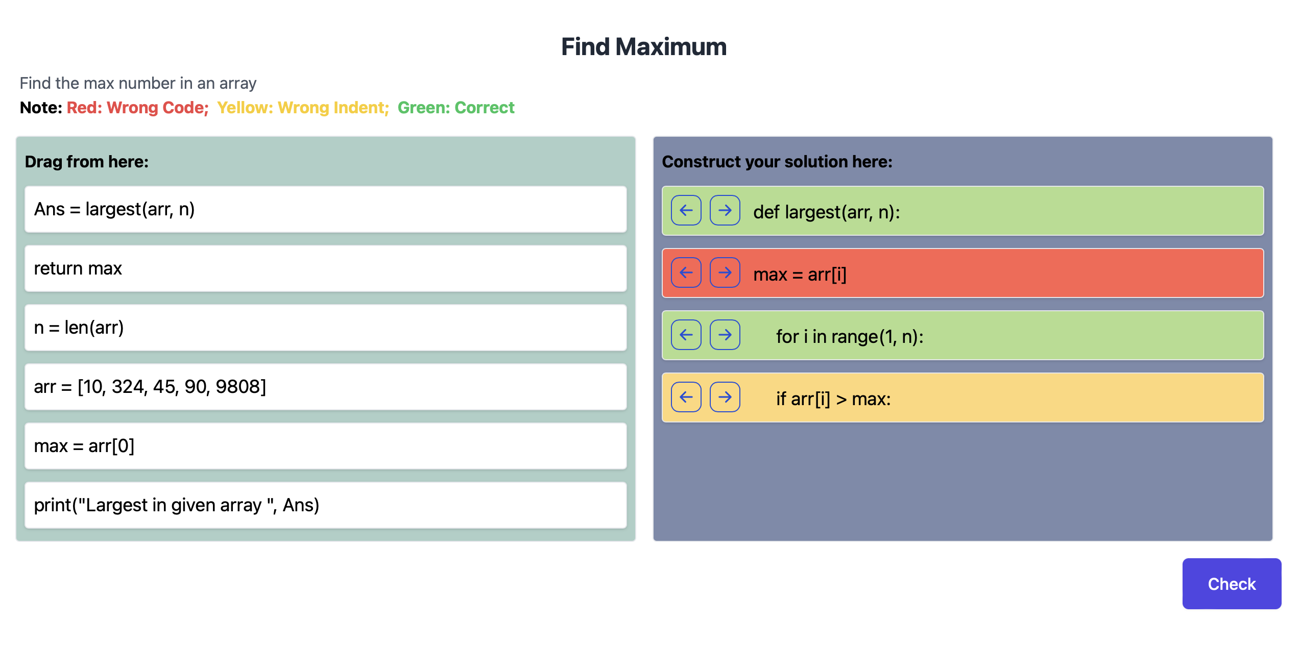

Figure 49 Codes with different background colors

## Results of Basic Process: View Records

Students and teachers can both see the personal center page. But the pages for students and teachers are quite different. Specifically, students can only view and interact with their own records of past performance on exercise and their profiles, while teachers can view and interact their with own profiles, view the students’ record statistics, manage question and manage class.

The personal center is shown in Figure 50. On this page, students can view their personal information. If they want to edit their name or email, they can click the ‘pen’ button shown on the right of their information, and then they can see the information changed to editable input box (Figure 51). After they finish editing, they can press an enter to update the changes. In addition, they can also view the exercise information they did before. If they are not satisfied with the score of some questions, they can click the ‘try again’ button to jump to the exercise detail page of the question and do the exercise again.

The teachers’ personal center is shown in Figure 52. On this page, teachers can not only edit their profiles like students, but they can also view the records of all students, manage questions and manage classes as well. To be more specific, teachers can view the average score of all the records of student from different class under ‘view students’ exercise records’ tab. Besides, they can manage the questions under ‘manage questions’ tab (Figure 53). They can click the create new question button to jump to the create new question page. They can also jump to edit question page to edit question name, question scope, and question description of the existing questions (Figure 54). They can also delete the question by click the delete button shown with every question. Finally, they can view and manage the classes under the ‘manage classes’ tab (Figure 56). Teachers can create new classes by clicking the create new classes button (Figure 57). Teachers can also edit (Figure 58) and delete the existing class (Figure 59).

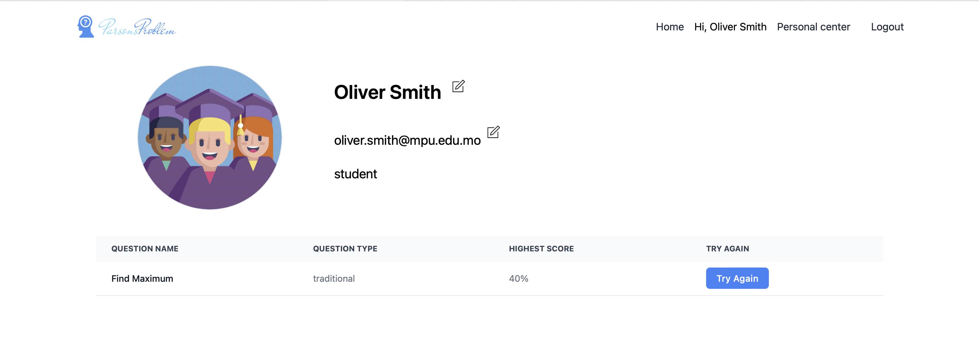

Figure 50 Students’ personal center

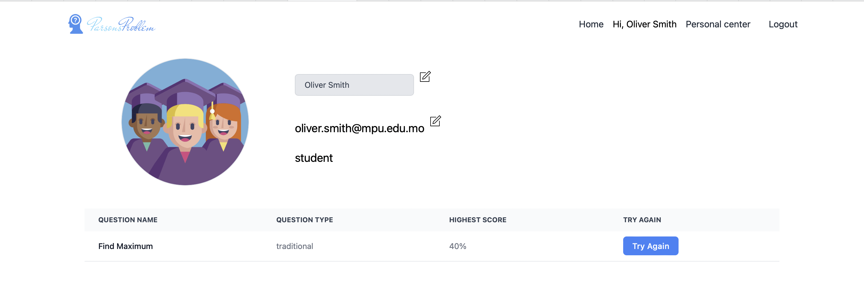

Figure 51 Edit user’s name



Figure 52 Teachers’ personal center: view students’ exercise records

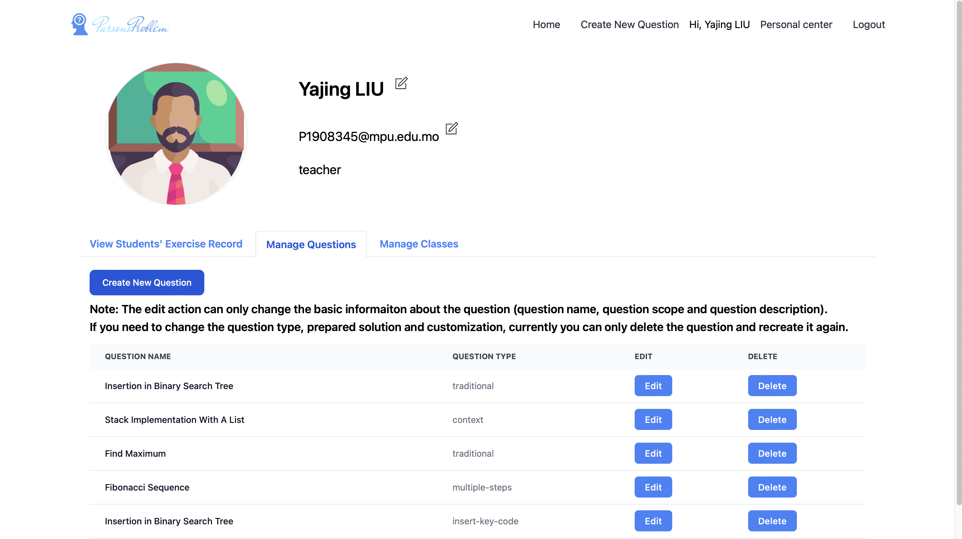

Figure 53 Teachers' personal center: manage question

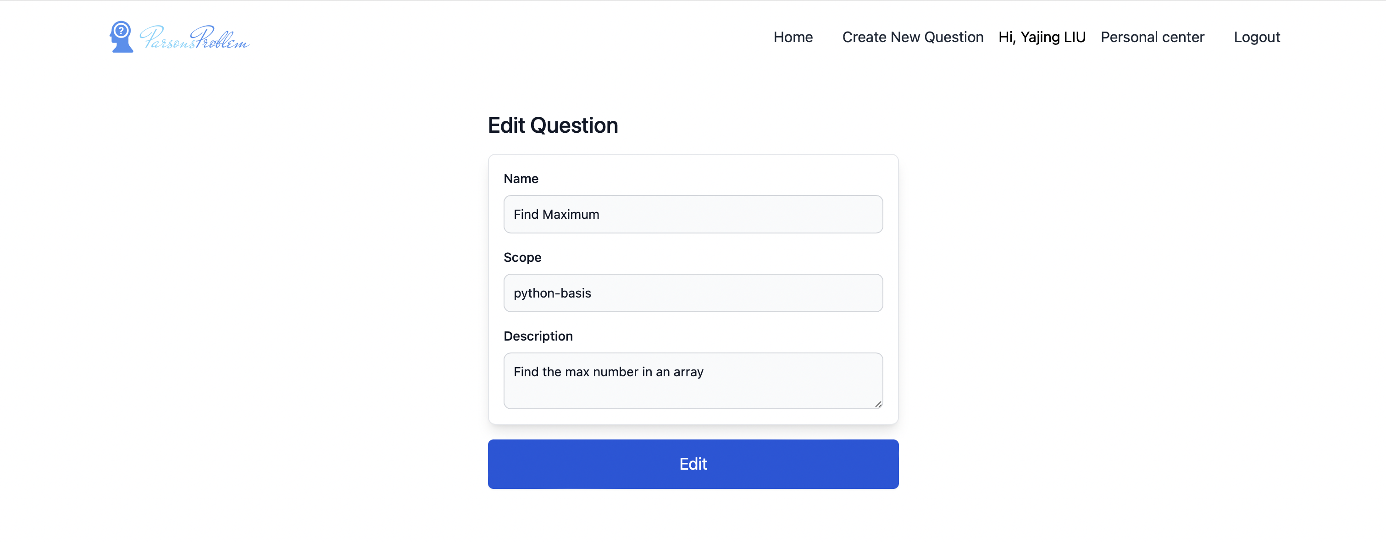

Figure 54 Edit question

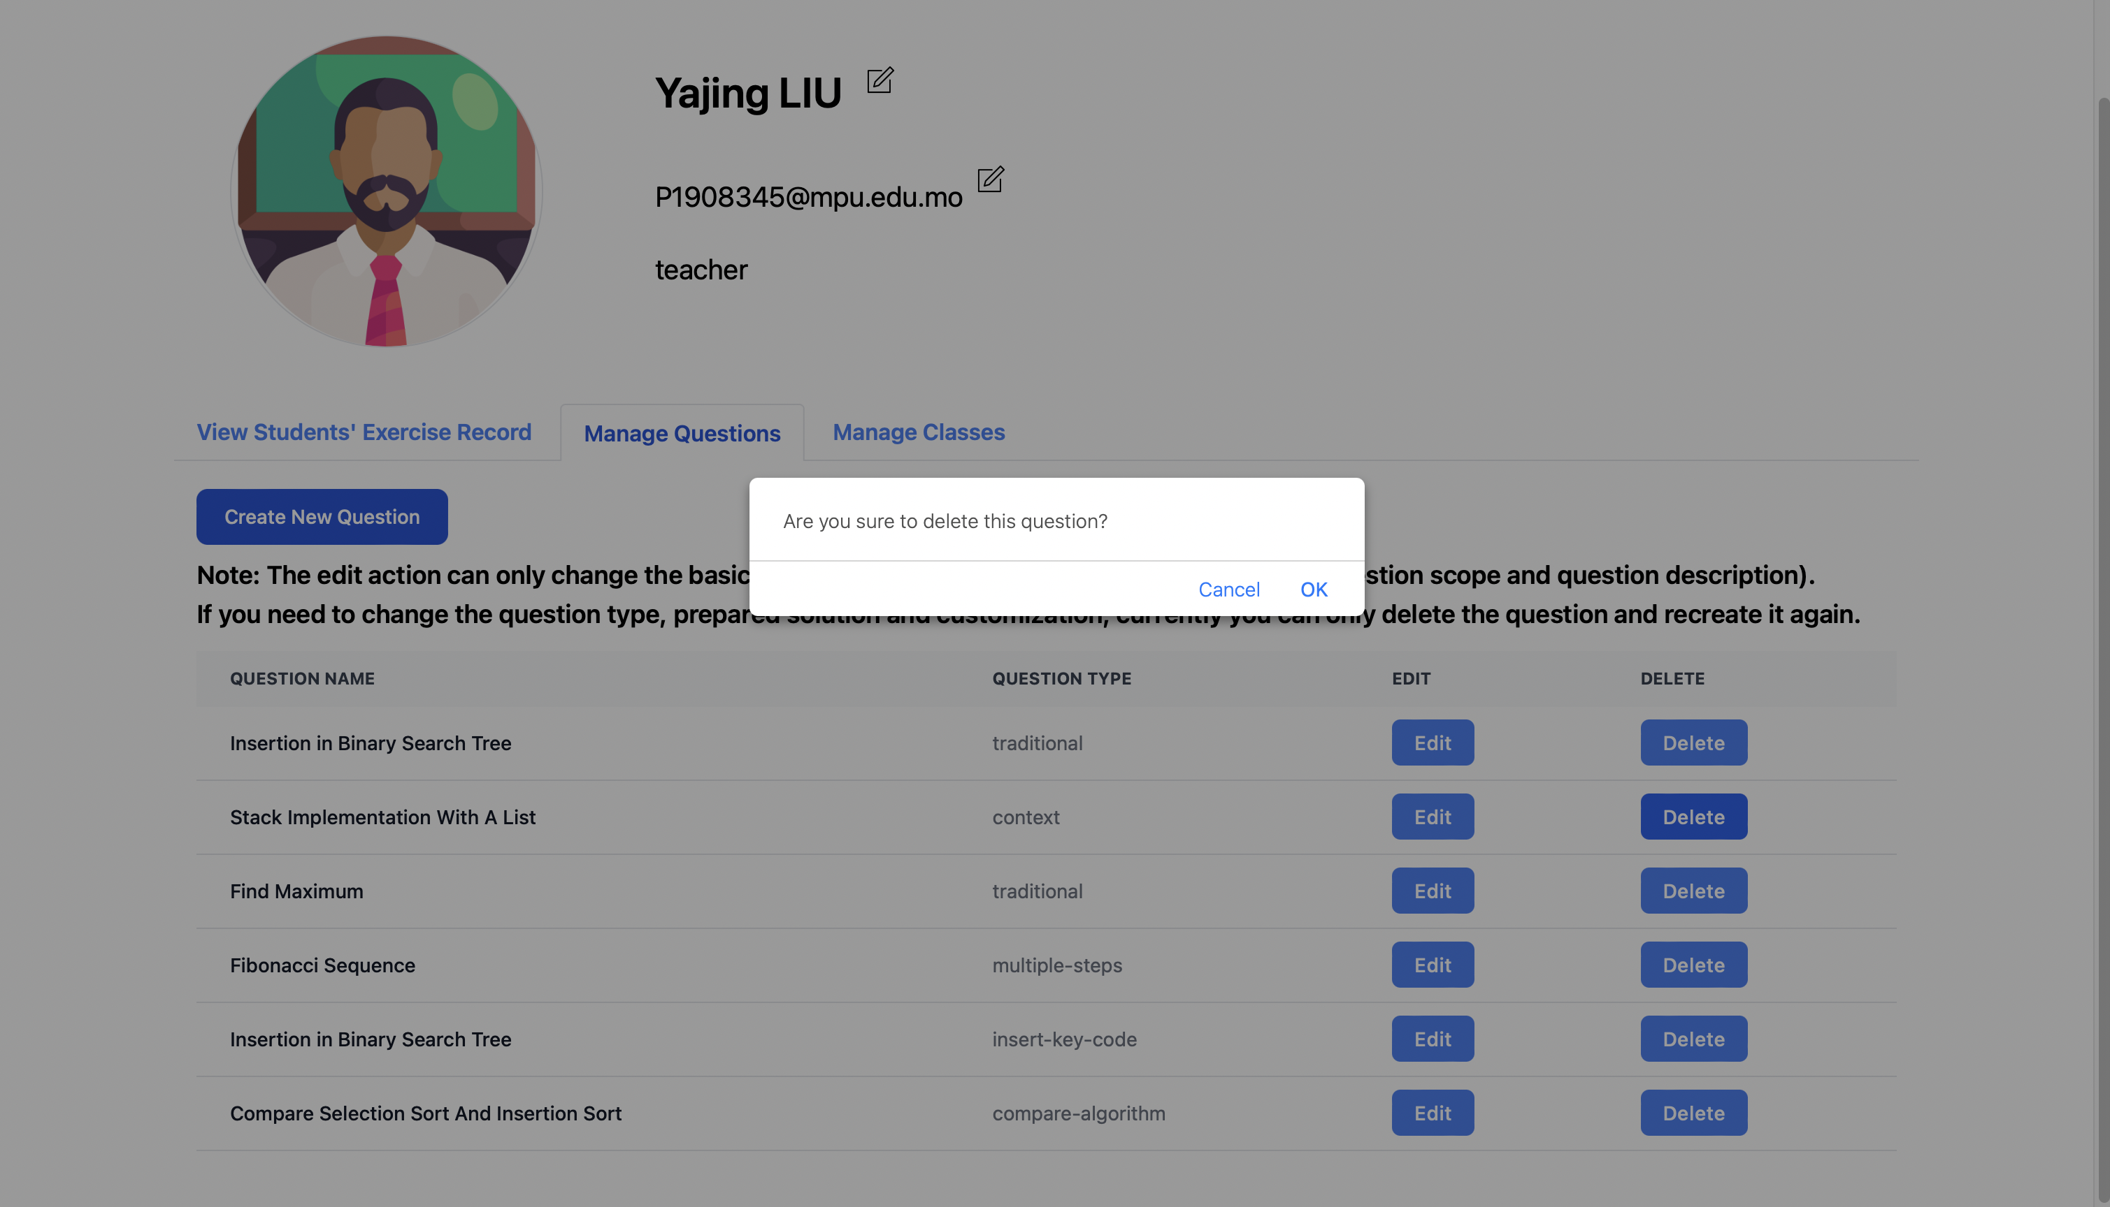

Figure 55 Delete question

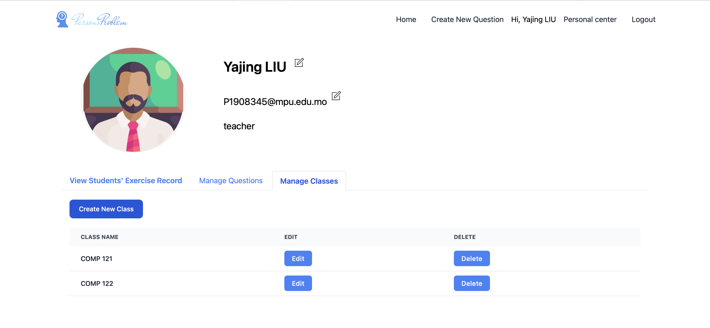

Figure 56 Teachers' personal center: manage classes



Figure 57 Create class

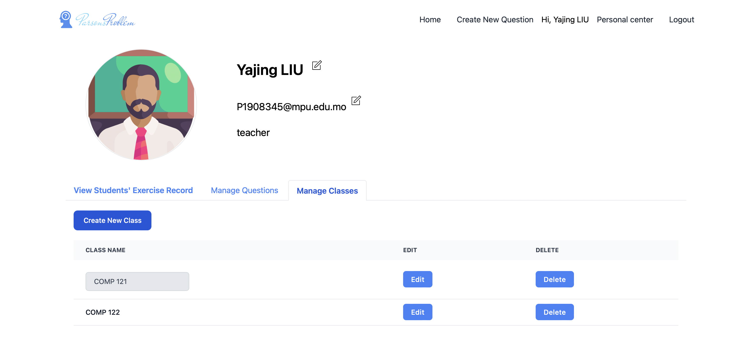

Figure 58 Edit class

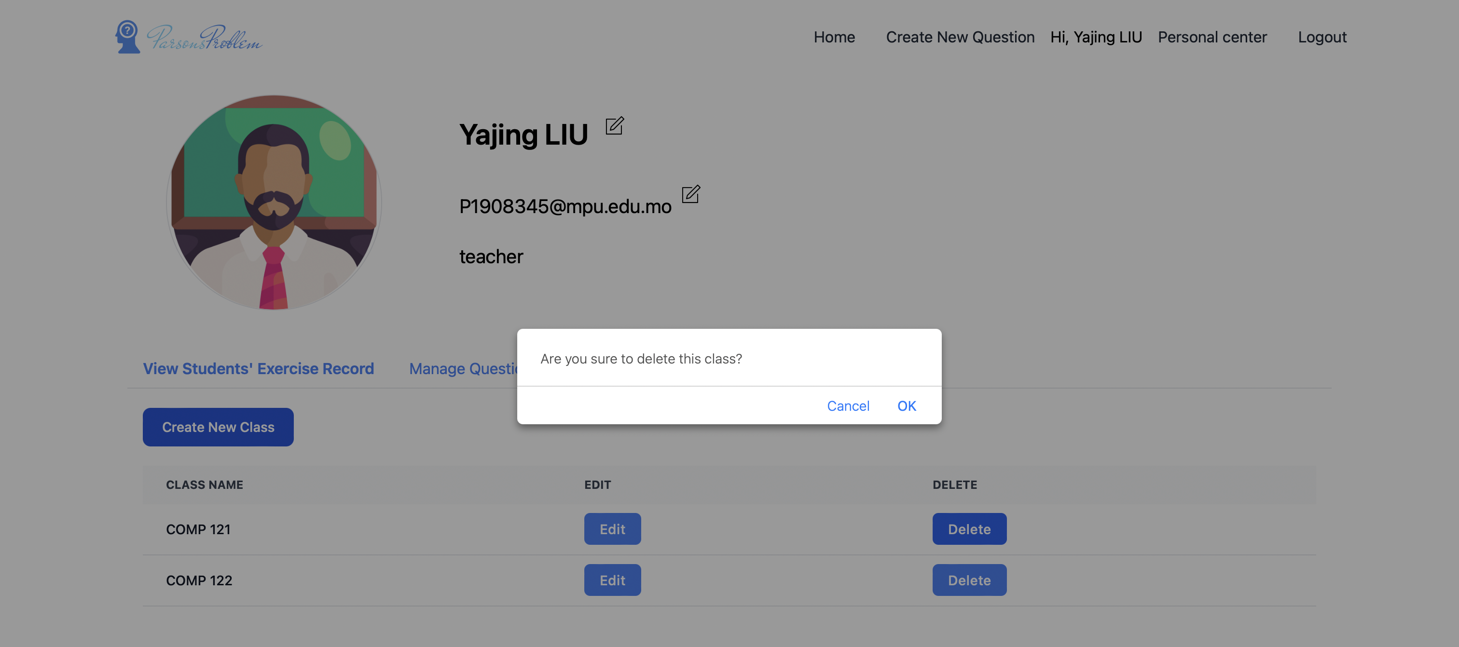

Figure 59 Delete class

## Results of Different Question Types: Traditional

This is the most basic question type of Parsons problem. It is used as an example to show the workflow mentioned before. To compare with the following question types, the significant page - customize solution page (Figure 60) and question detail page (Figure 61) are shown below.



Figure 60 Traditional: customize solution page



Figure 61 Traditional: exercise detail page

## Results of Different Question Types: Contextual Clues

This part shows the Parsons problem with partially ordered codes as tips. There are two types of questions – context and insert key code. For both types of questions, teachers need to mark context or key code in customize solutions, and then students can view in question detail page.

For the context type of question, teachers need to mark context code to let students view the context information on exercise detail page. In the customize solution page, compared with customize solution page of traditional Parsons problem (Figure 60), the buttons ‘pin’ and ‘unpin’ are added in the front of every line of code in reference area. And teachers can click these buttons to change the code fragment types (pin used as context and unpin used as not context). As Figure 62 shown, the lines with pin marks (line 1, 2, 3, 4, 6, 8) are context, while others are not context. As for the exercise detail page, the context type of questions can provide partially ordered code with placeholders in the initialization phase to reduce the difficulty of the problem (Figure 63). And after clicking the checking button, all the placeholders will be put in the left code pool.

The context type of question is quite advantageous for students to learn codes in CS2. Specifically, the context type of question is an important way to handle the difficulty. It can reduce students’ cognitive load by providing some ordered codes as information and by reducing the codes needed to reorder. In addition, this type of question can also be useful to alleviate the checking errors caused by not unique correct answer. For example, as the code shown in Figure 63, the method headers are pinned, which means that students can only follow the fixed order of methods and cannot build other correct answers by changing the positions of methods. It prevents students from wasting time guessing the unique standard answers and makes them focus on the question itself. Moreover, it can be used to provide some background information, like the methods called in this question. For example, in the question insert nodes in binary search tree shown in Figure 64, the node class can be provided as background information, students do not need to worry about how to build node class, and they can focus on inserting method itself.

By contrast, for the insert key code type of question, the key codes are marked as star on the customize solution page (Figure 65). As for the exercise detail page, most of the codes are shown in the answer sheet, and no placeholder is provided. Students only need to insert fewer key codes (the most confusing part) in the proper positions, which reduces the difficulty of the problem significantly (Figure 66). This type of question is relatively simple, and it can be only used as an easier version of the same question. It is only provided to students when they have no idea about the original question (More details will be discussed in the part on switching difficulty level in chapter 5.11).

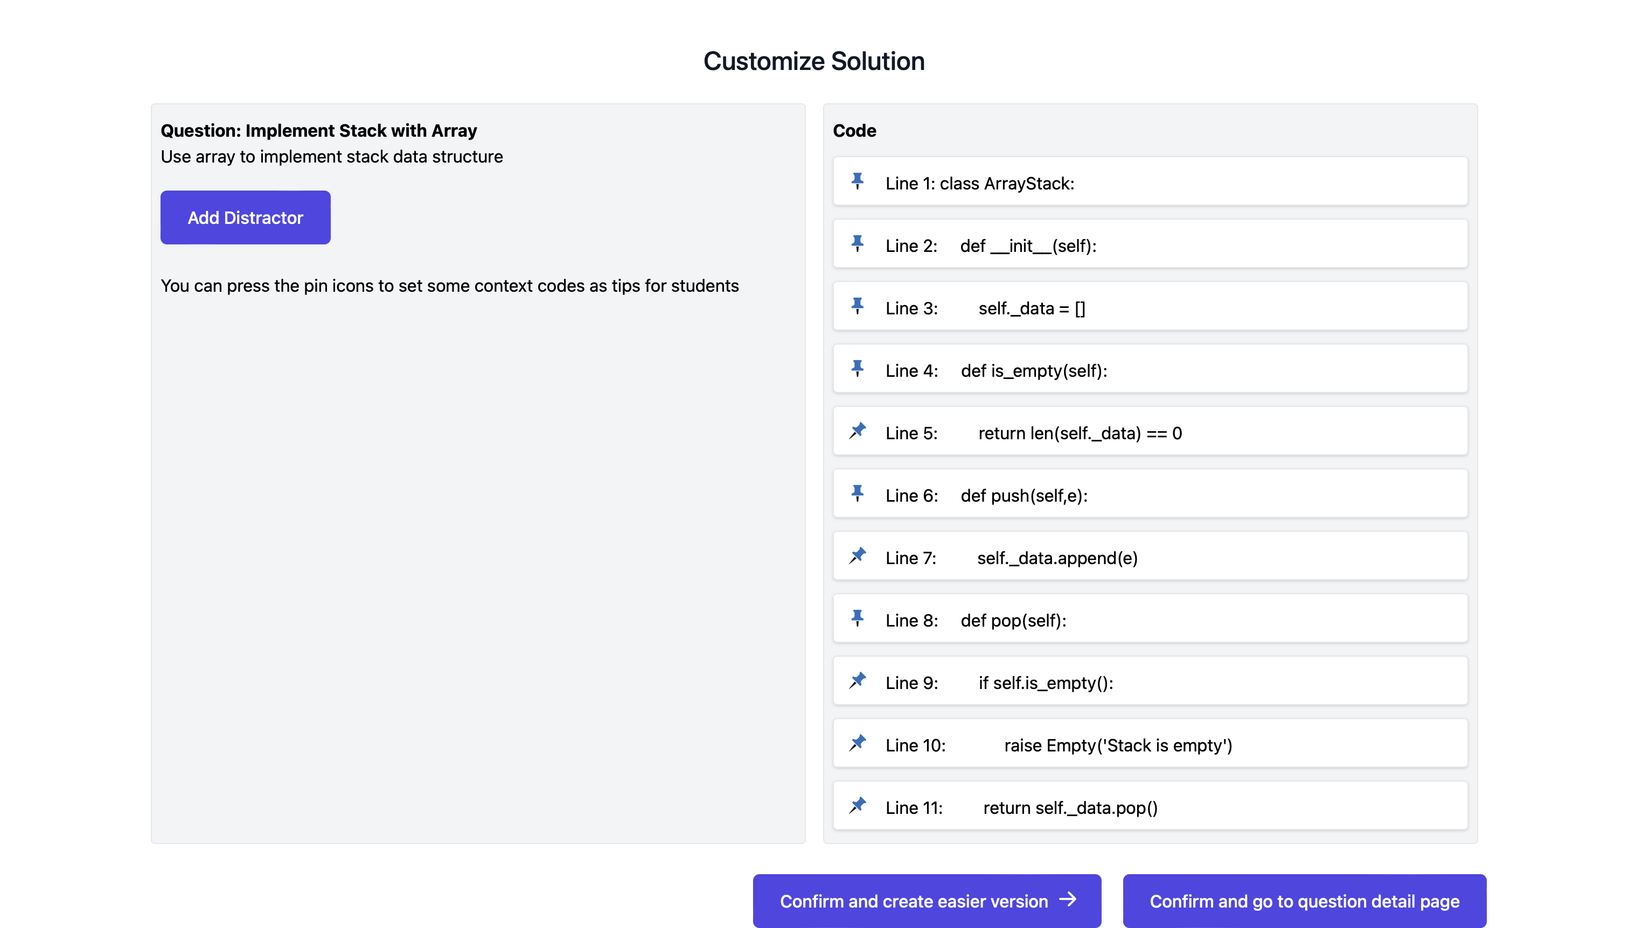

Figure 62 Context: customize solution page

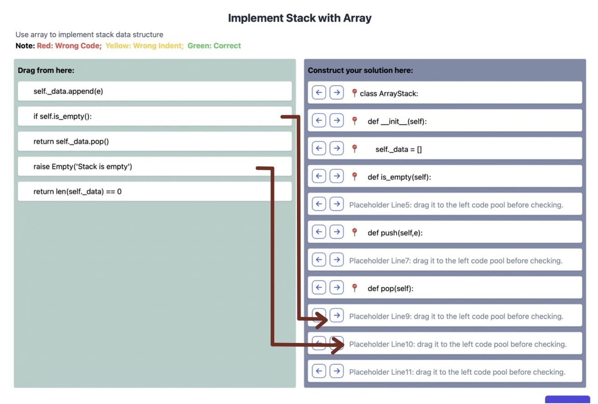

Figure 63 Context: exercise detail page

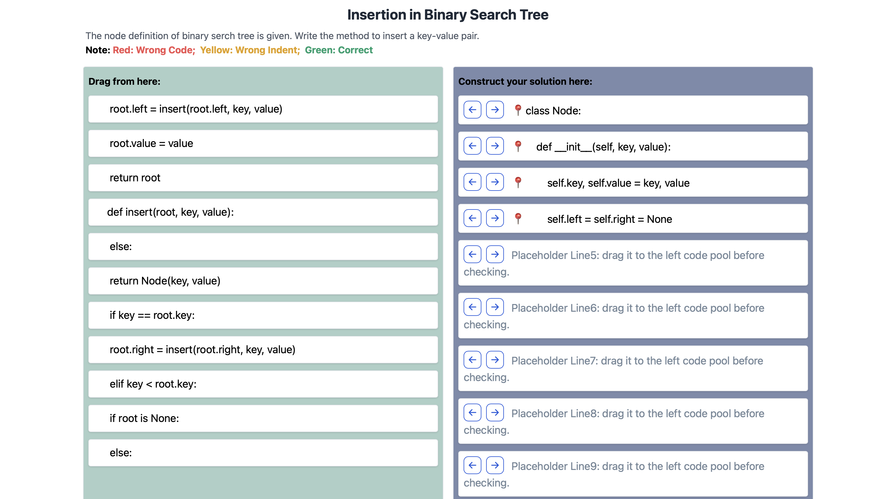

Figure 64 Insertion in binary search tree

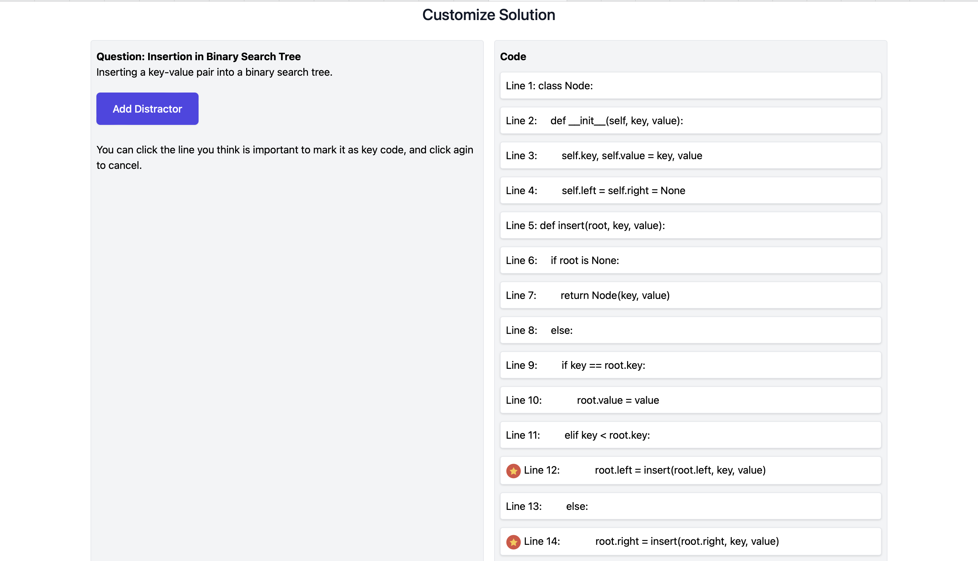

Figure 65 Insert key code: customize solution

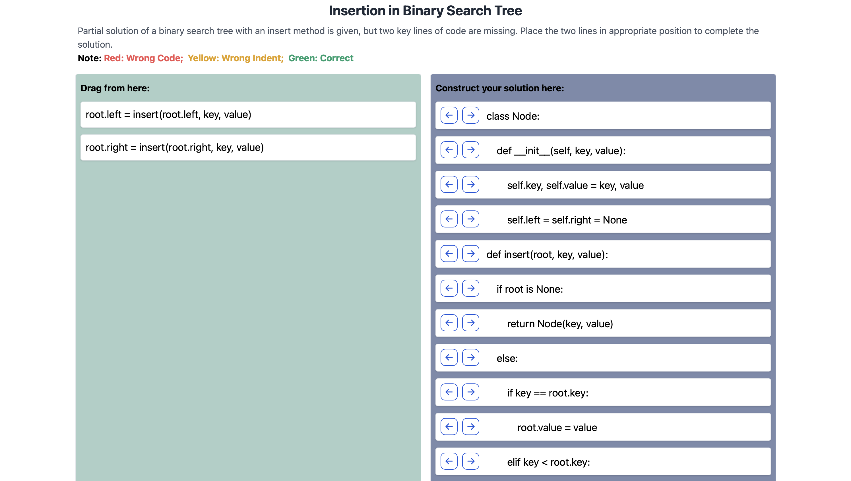

Figure 66 Insert key code: exercise detail page

## Results of Different Question Types: Multiple Step

This question type is to break complex problems into several consecutive steps. Firstly, in the customize solution (Figure 67), teachers set step information by making multiple lines of code belong to a single step (Figure 68). The step information is stored in the database once every line in the original code is covered. After teachers set the step information, the step number can be shown as tips for students on question detail page (Figure 69).

This type of question is applicable for students to learn Data Structures and Algorithms. To be more specific, there are a lot of long and complex codes in CS2. If these codes are given to students directly, students may feel depressed about finishing the question, and they may directly give up. By cutting the codes into several steps, it can allow students do every small steps separately, which can improve students’ engagement. For example, the exercise shown in Figure 70 is about inserting and deleting nodes in a binary search tree. Although there are 38 lines in the codes, the codes are split into four different steps (class Node, method insert, method minValueNode, method deleteNode), giving students some hints.

Another application of this method is to use in the recursion problem, as shown in Figure 69. It is built from the base case firstly. Then it lets students build other subproblems by using the base case. The next step is to let students sum up the previous two steps and define the proper parameters used in the method header. The final step is to build the original recursion problem. The set of these steps is consistent with the idea of mathematical induction, gives students general ideas of how to solve recursive problems, and helps students develop good habits when solving recursion problems.

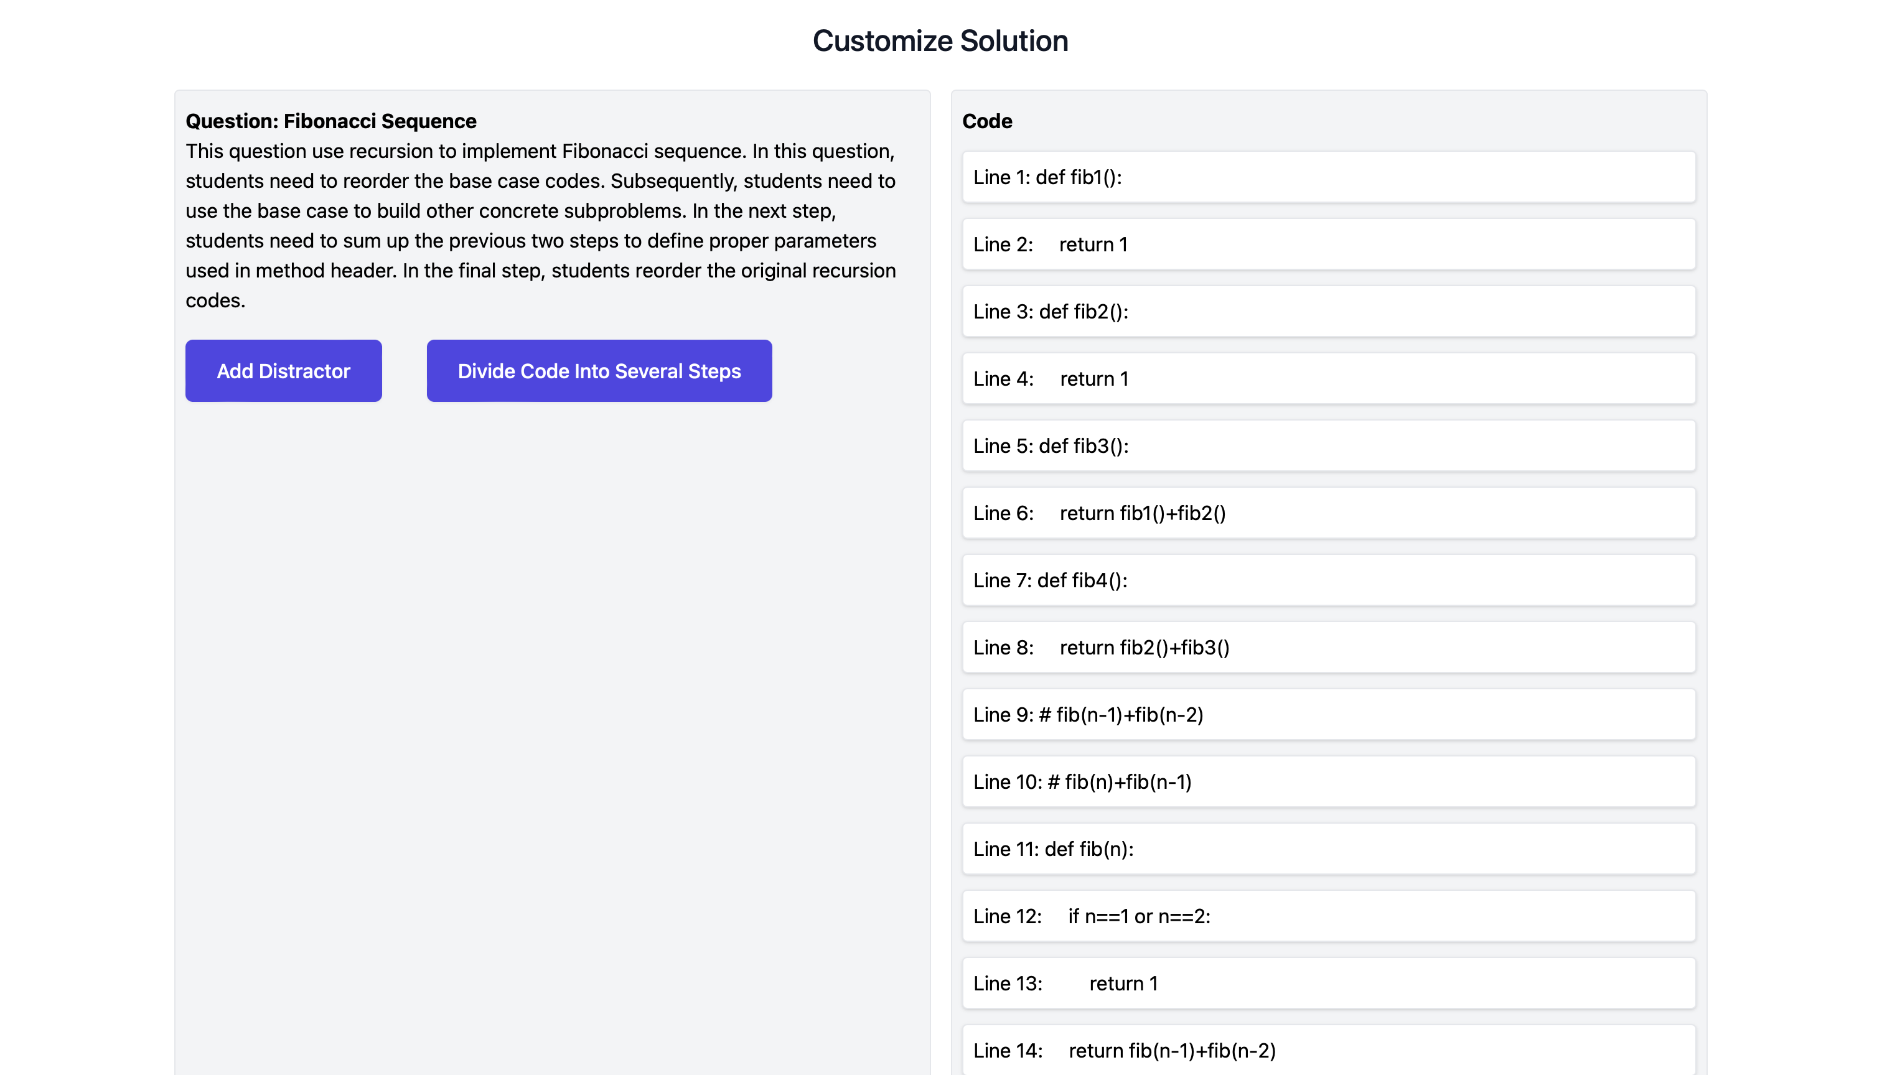

Figure 67 Multiple step: customize solution

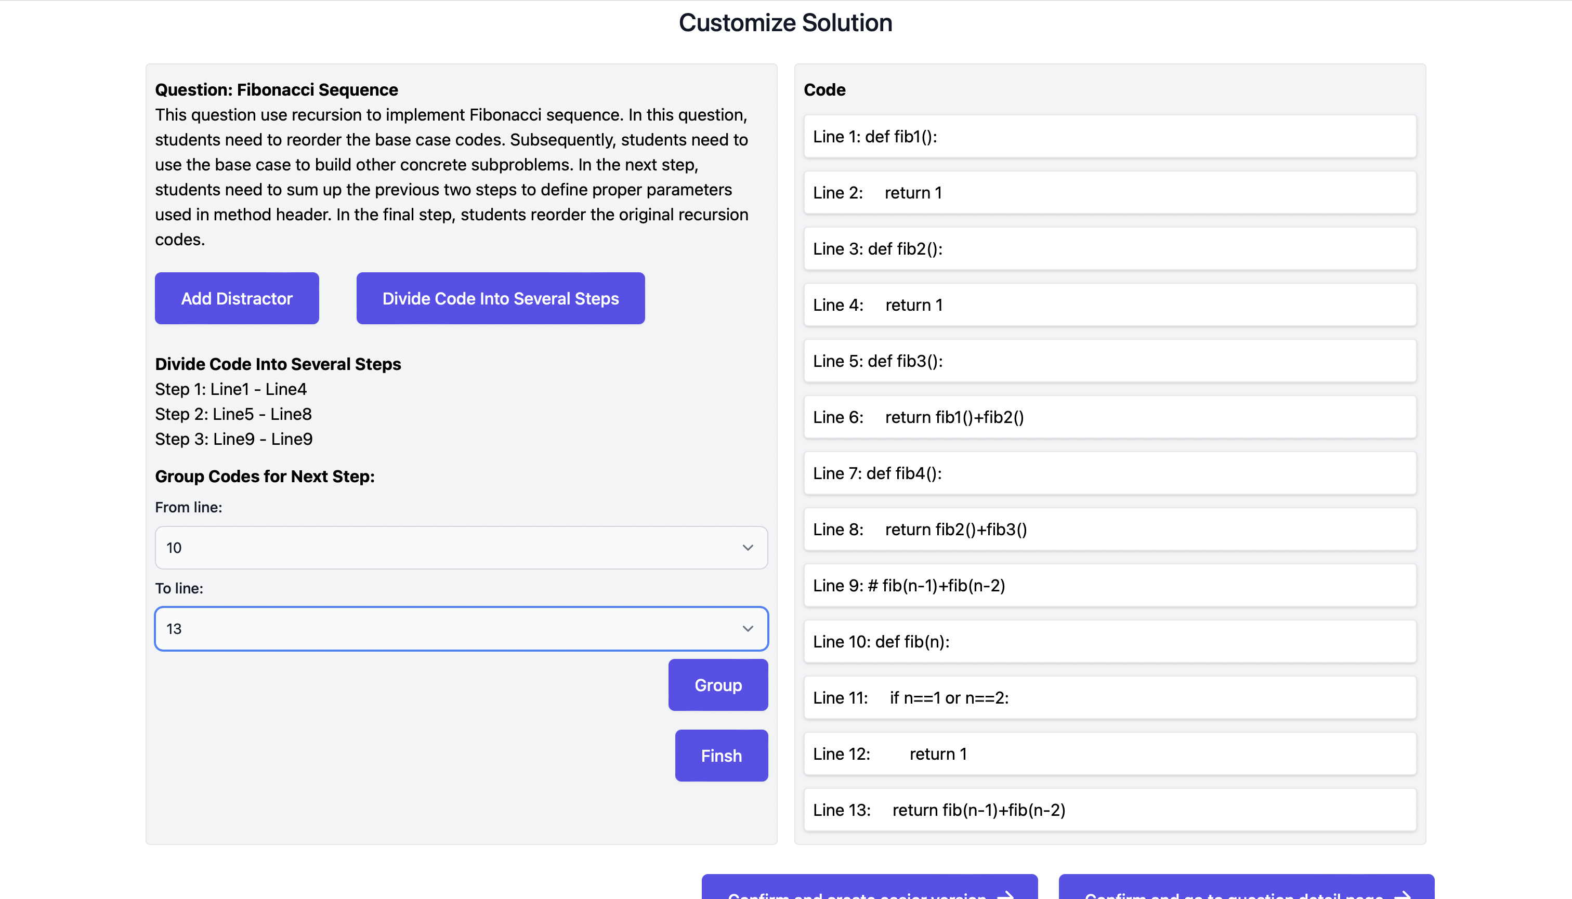

Figure 68 Multiple step: divide into steps

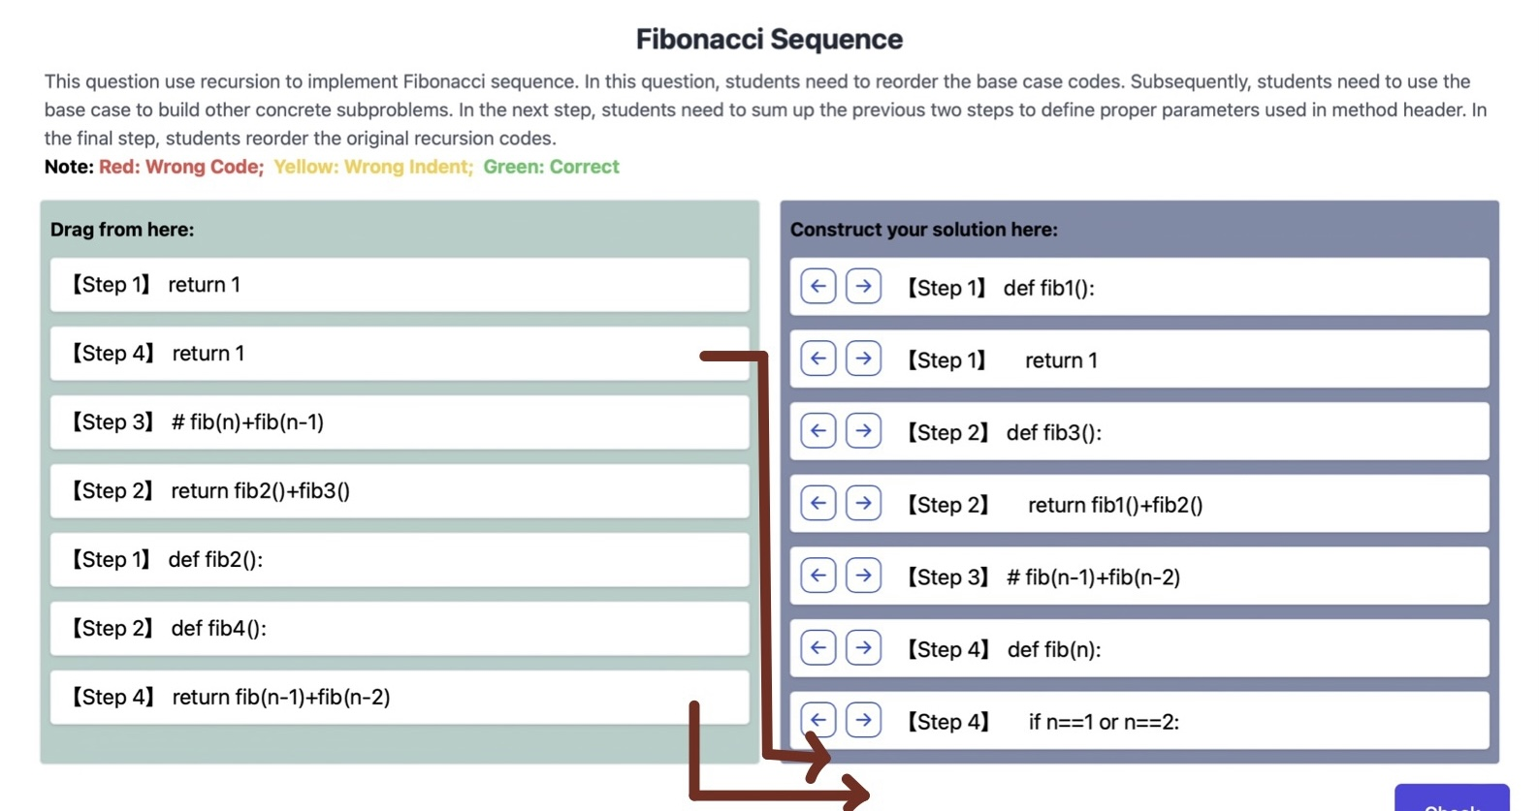

Figure 69 Multiple step: exercise detail page

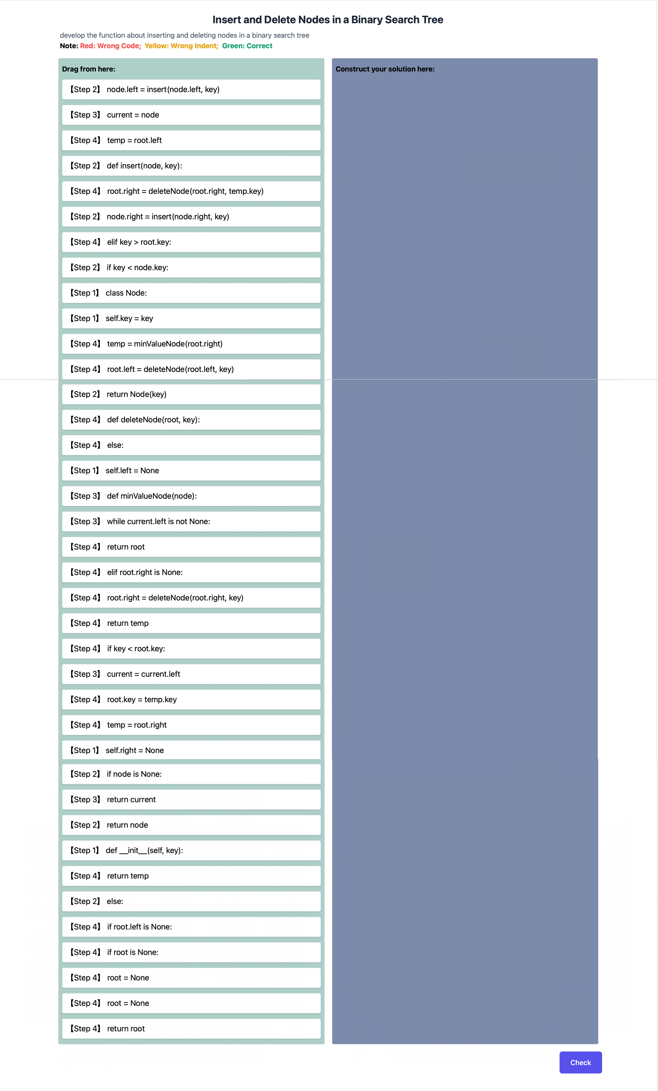

Figure 70 Example: insert and delete nodes in binary search tree

## Results of Different Question Types: Algorithm Comparison

Compared with traditional question type, the algorithm comparison can show two solutions simultaneously on the customize solution page (Figure 71). And in the question detail page, there are two answer sheets to hold these two solutions separately (Figure 72). Students need to split two algorithms mixed in the left code pool to middle and right answer sheets.

This type of question has wide application in CS2. There are plenty of similar or related codes under the same categories, for example, different algorithms with the common mission (like the example of two sorting algorithms shown in Figure 72.), different implementation ways of the same data structures (like array-based stack or linked-list-based stack), some related methods in data structures (like pop and push for stack, pop or push for array-based-stack and array-based-queue, insert node and delete node in a tree). It is useful to help students to differentiate similar or related codes, consolidate their memory, and reduce the chance students write the codes mostly because of blurry memory.

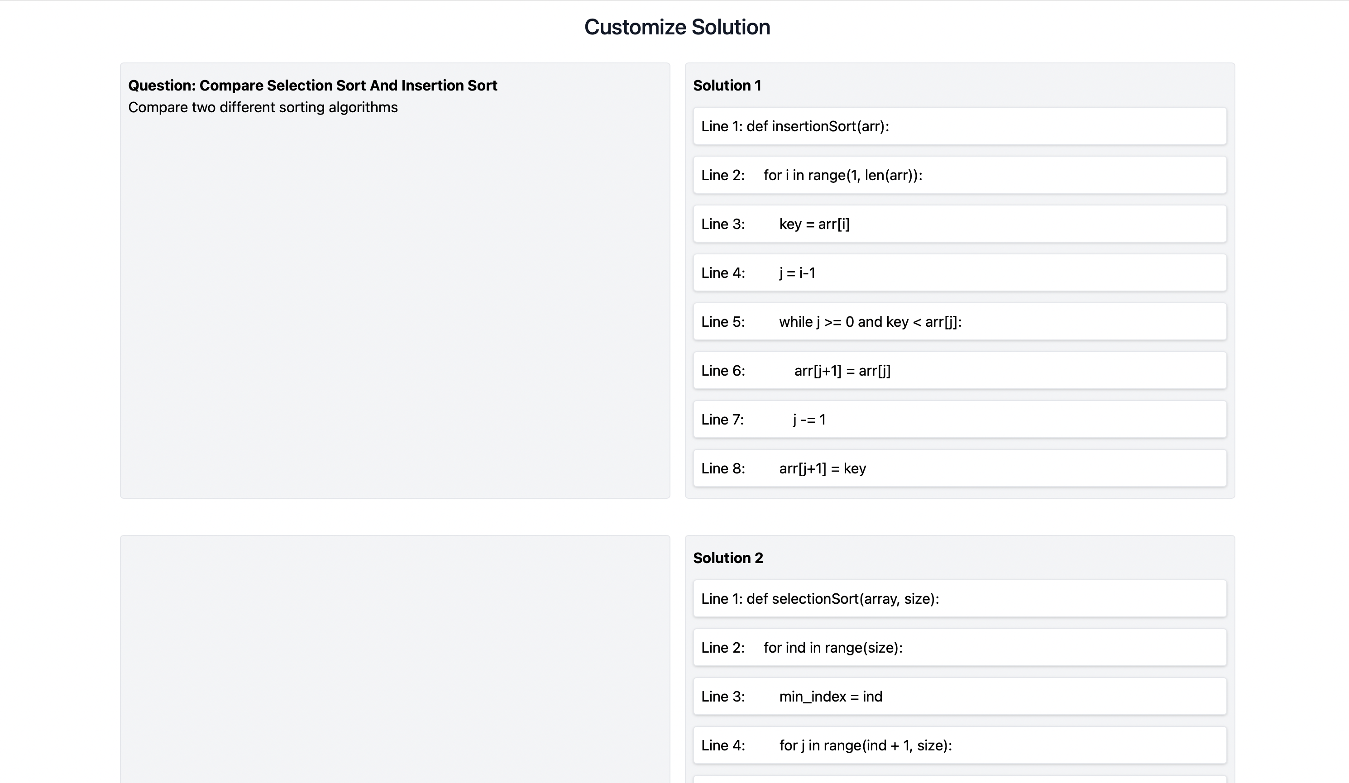

Figure 71 Algorithm comparison: customize solution page

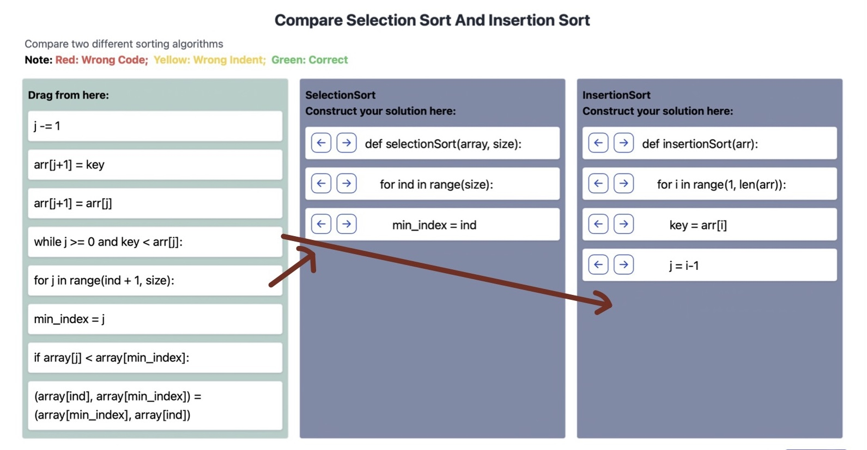

Figure 72 Algorithm comparison: exercise detail page

## Results of Other Function: Distractor

For some types of questions (traditional, context, insert key code), it is allowed to add distractors to let students learn to distinguish some common errors. The distractor is set in the customize solution page. The teacher presses the upper-left button ‘Add Distractor’ to show the hidden distractor information collecting box, inputs all the information, and presses the lower-right button ‘Add Distractor’ to confirm. Taking the example shown in Figure 73, the correct answer is ‘break’, and the set distractor is ‘continue’. A message (in a purple drawing box) is also added to show why the distractor is wrong. After the teacher finishes the customization, students can view the exercise detail page of this question. A partially finished exercise of this question is shown in Figure 74. As the figure shows, both correct code and distractor are shown in the code pool. If the correct code is used to build the solution, the feedback will only show the score (Figure 75). If the distractor is selected, the set message in customize solution stage will also be shown in the feedback (Figure 76).

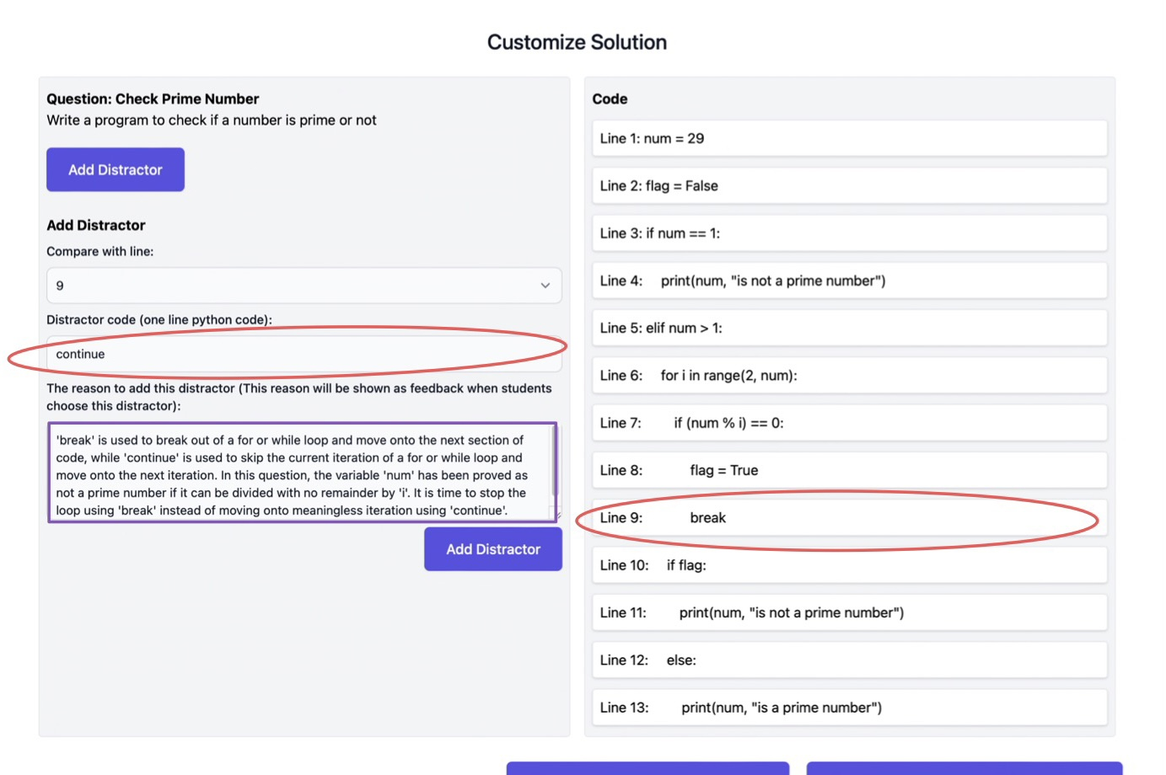

Figure 73 Distractor: customize solution page

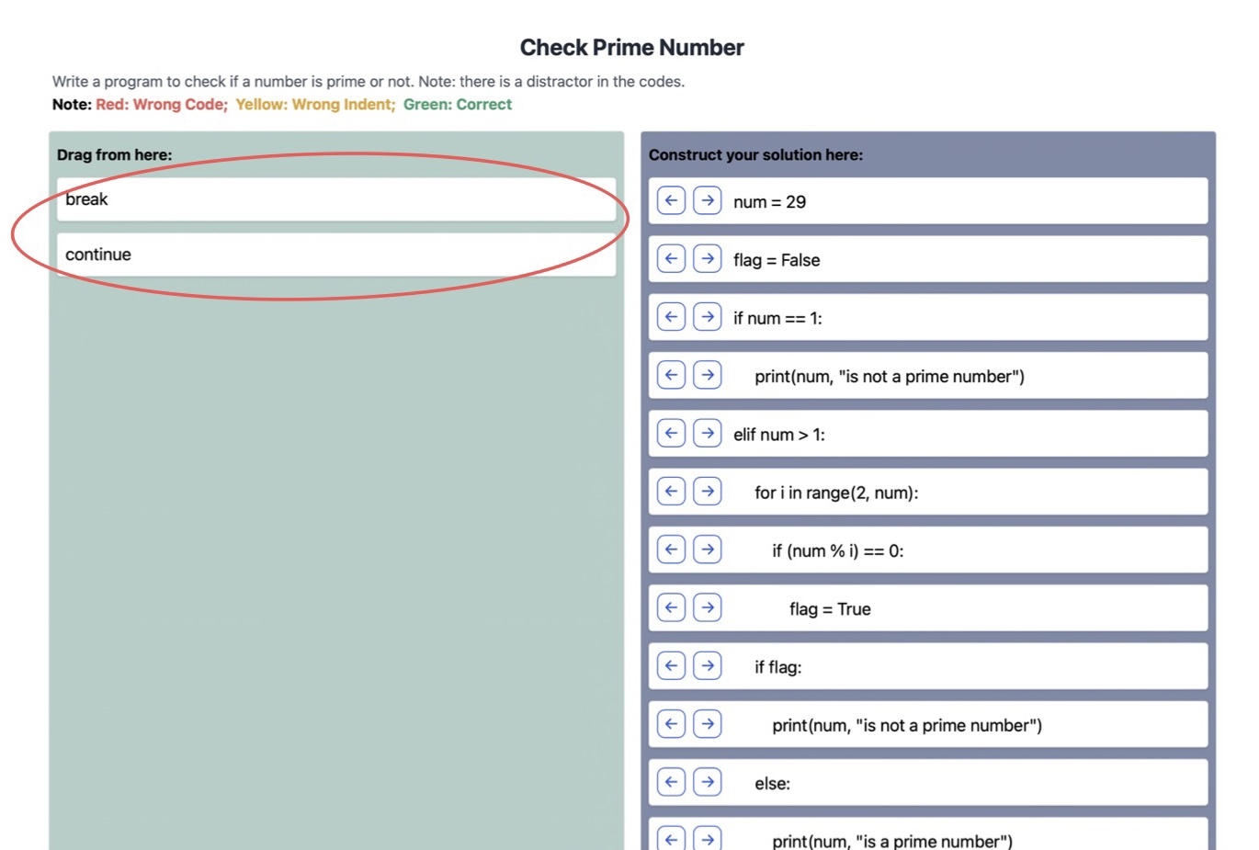

Figure 74 Distractor: exercise detail page

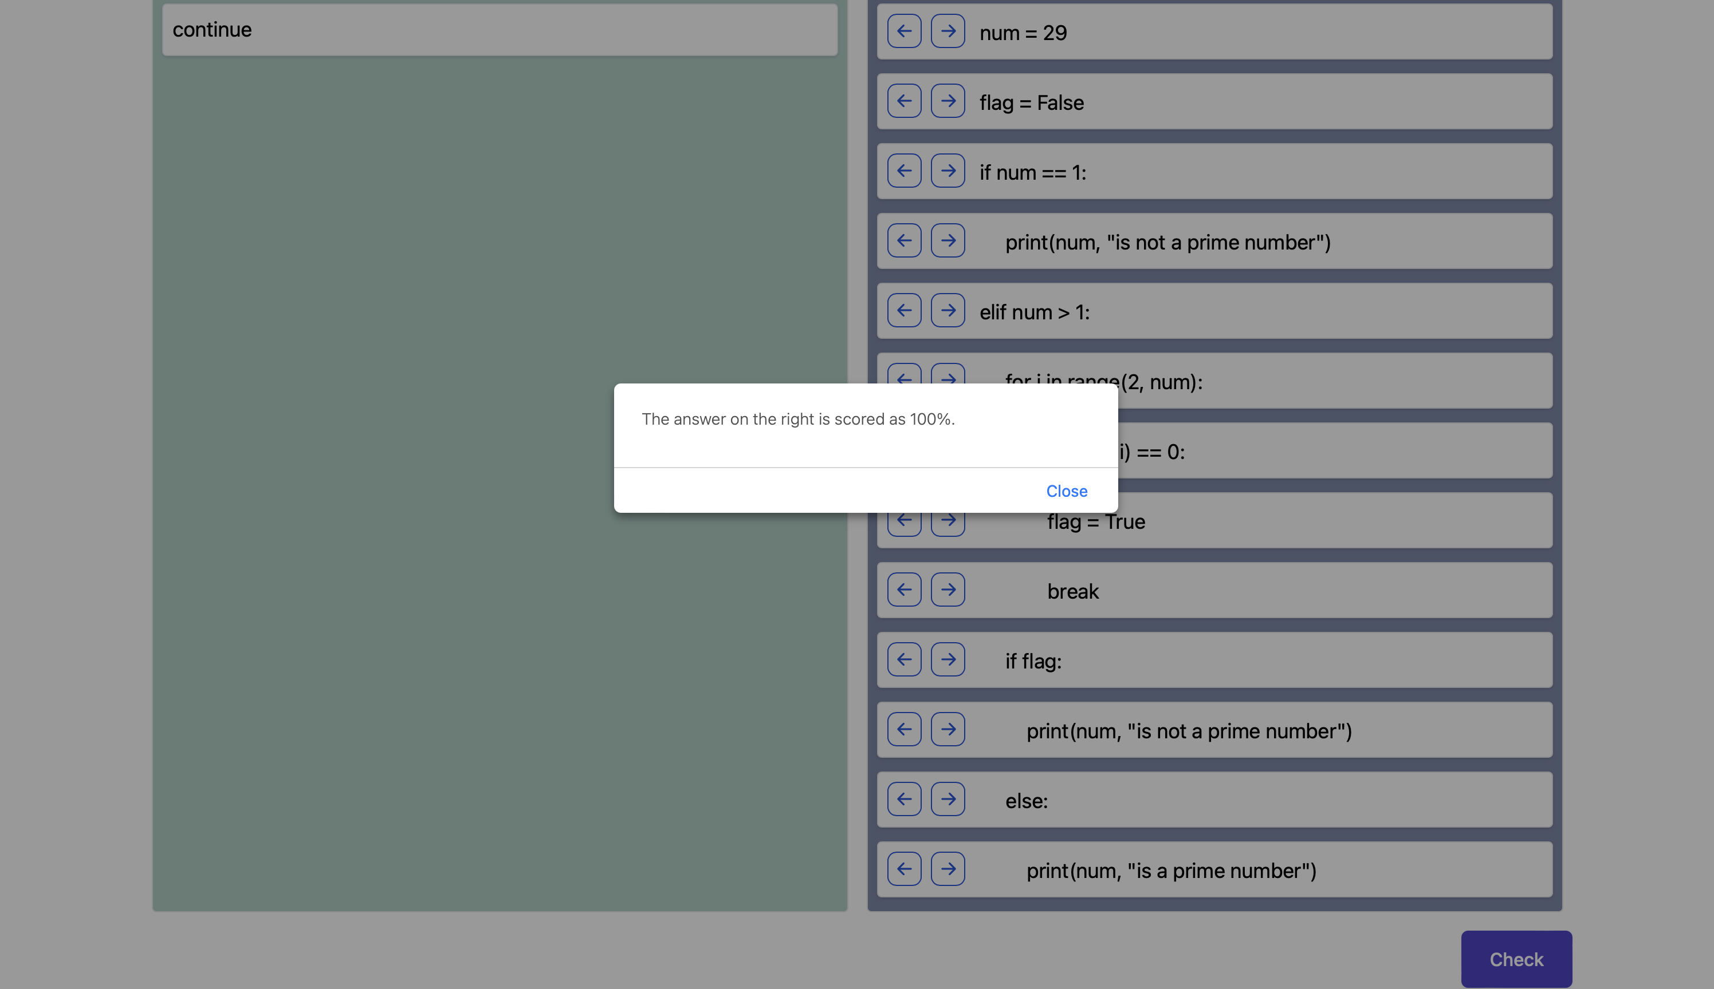

Figure 75 Feedback for correct code

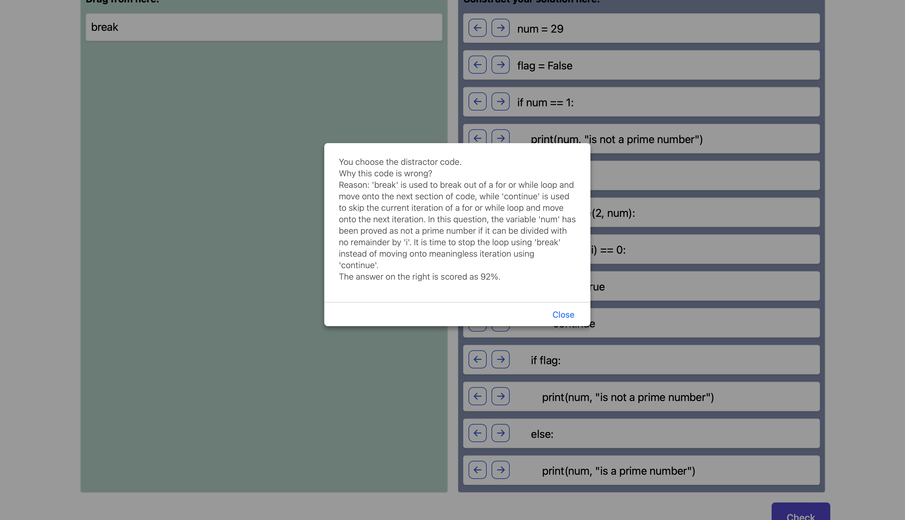

Figure 76 Feedback for distractor

## Results of Other Function: Switch Difficulty Level

For the traditional Parsons problem, students can get some ideas about how to improve their answers by viewing the background color feedback after checking. However, what if students totally have no ideas? In this situation, it is hard for students to get help only through feedbacks. But, in this project, a new function – switch difficulty level – can be used in this situation to provide further hints.

This function is to provide easier version of the original question by using some question types with more hints (context, insert key code, multiple step). To achieve this function, teachers need to predefine easier version in advance, and then students can use it later.

Specifically, teachers click the confirm and create easier version button in the customize solution page shown in Figure 77. After clicking the button, a new question is created at the back end according to the information from the original question with the original prepared solution. In the next step, teachers need to choose the question type of this easier version of the question (Figure 78). Since the traditional and algorithm comparison types of questions are more challenging and are not suited to become a ‘easier-version’, these two types of questions will be hidden. Teachers can choose one of the remaining types as the type of easier version. If teachers want to see the description and gif animation of every type, they can click the link ‘forget the details of every type’ to jump to the choosing question type page (Figure 79). After choosing the question type of easier version, teachers can customize solution of easier version (Figure 80) finally. It is similar to the customize solution with the original one. The only difference is that no other easier version is allowed.

After the teacher sets the easier version, the students can jump to the easier version by pressing ‘Not have ideas? Click here to get easier version’ button (Figure 81). And then, they can view and do the exercise of easier version. After they finish the exercise of easier version, they can go back to the original version by pressing the button ‘Go back to the original version’.

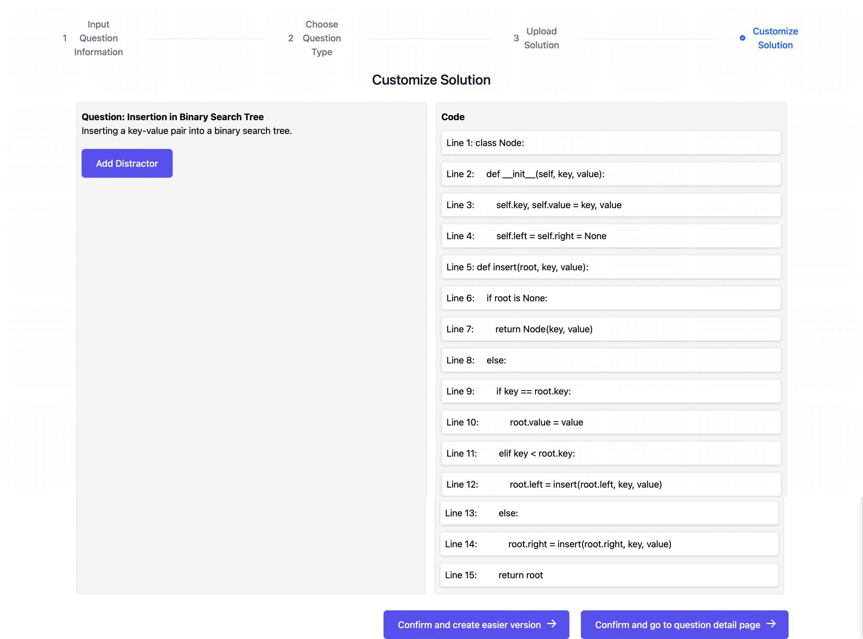

Figure 77 Switch question type: customize solution page

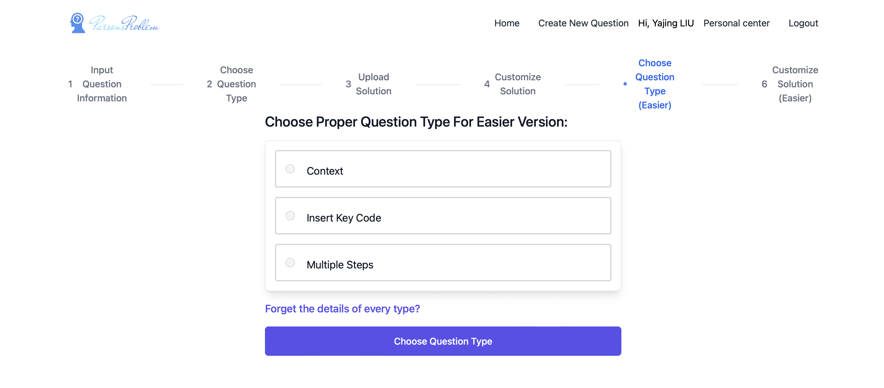

Figure 78 Switch question type: choose question type for easier version

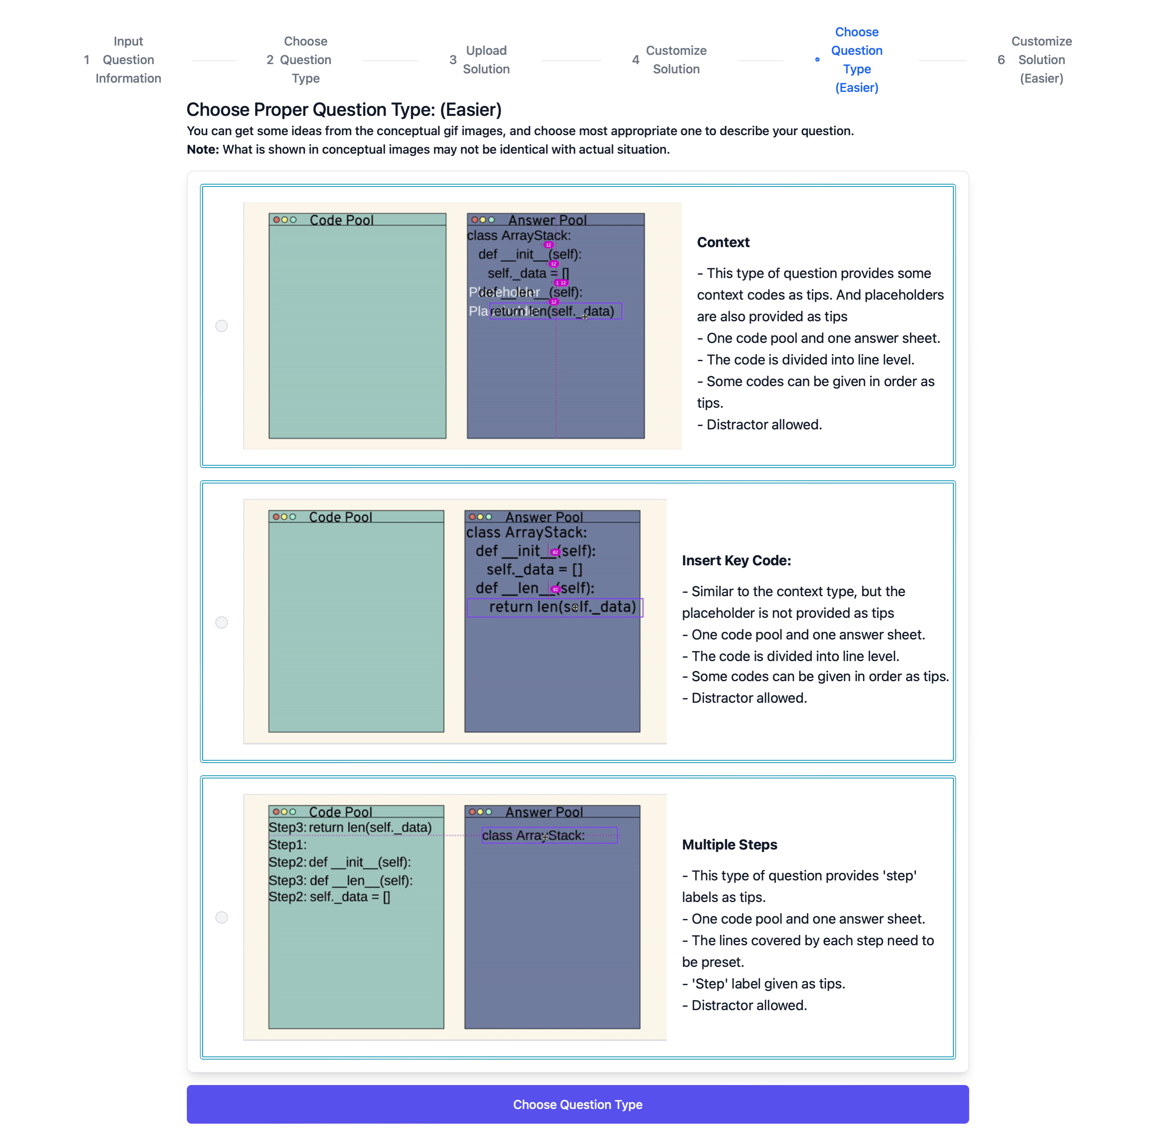

Figure 79 Switch difficulty level: choose question type for easier version (with more description)

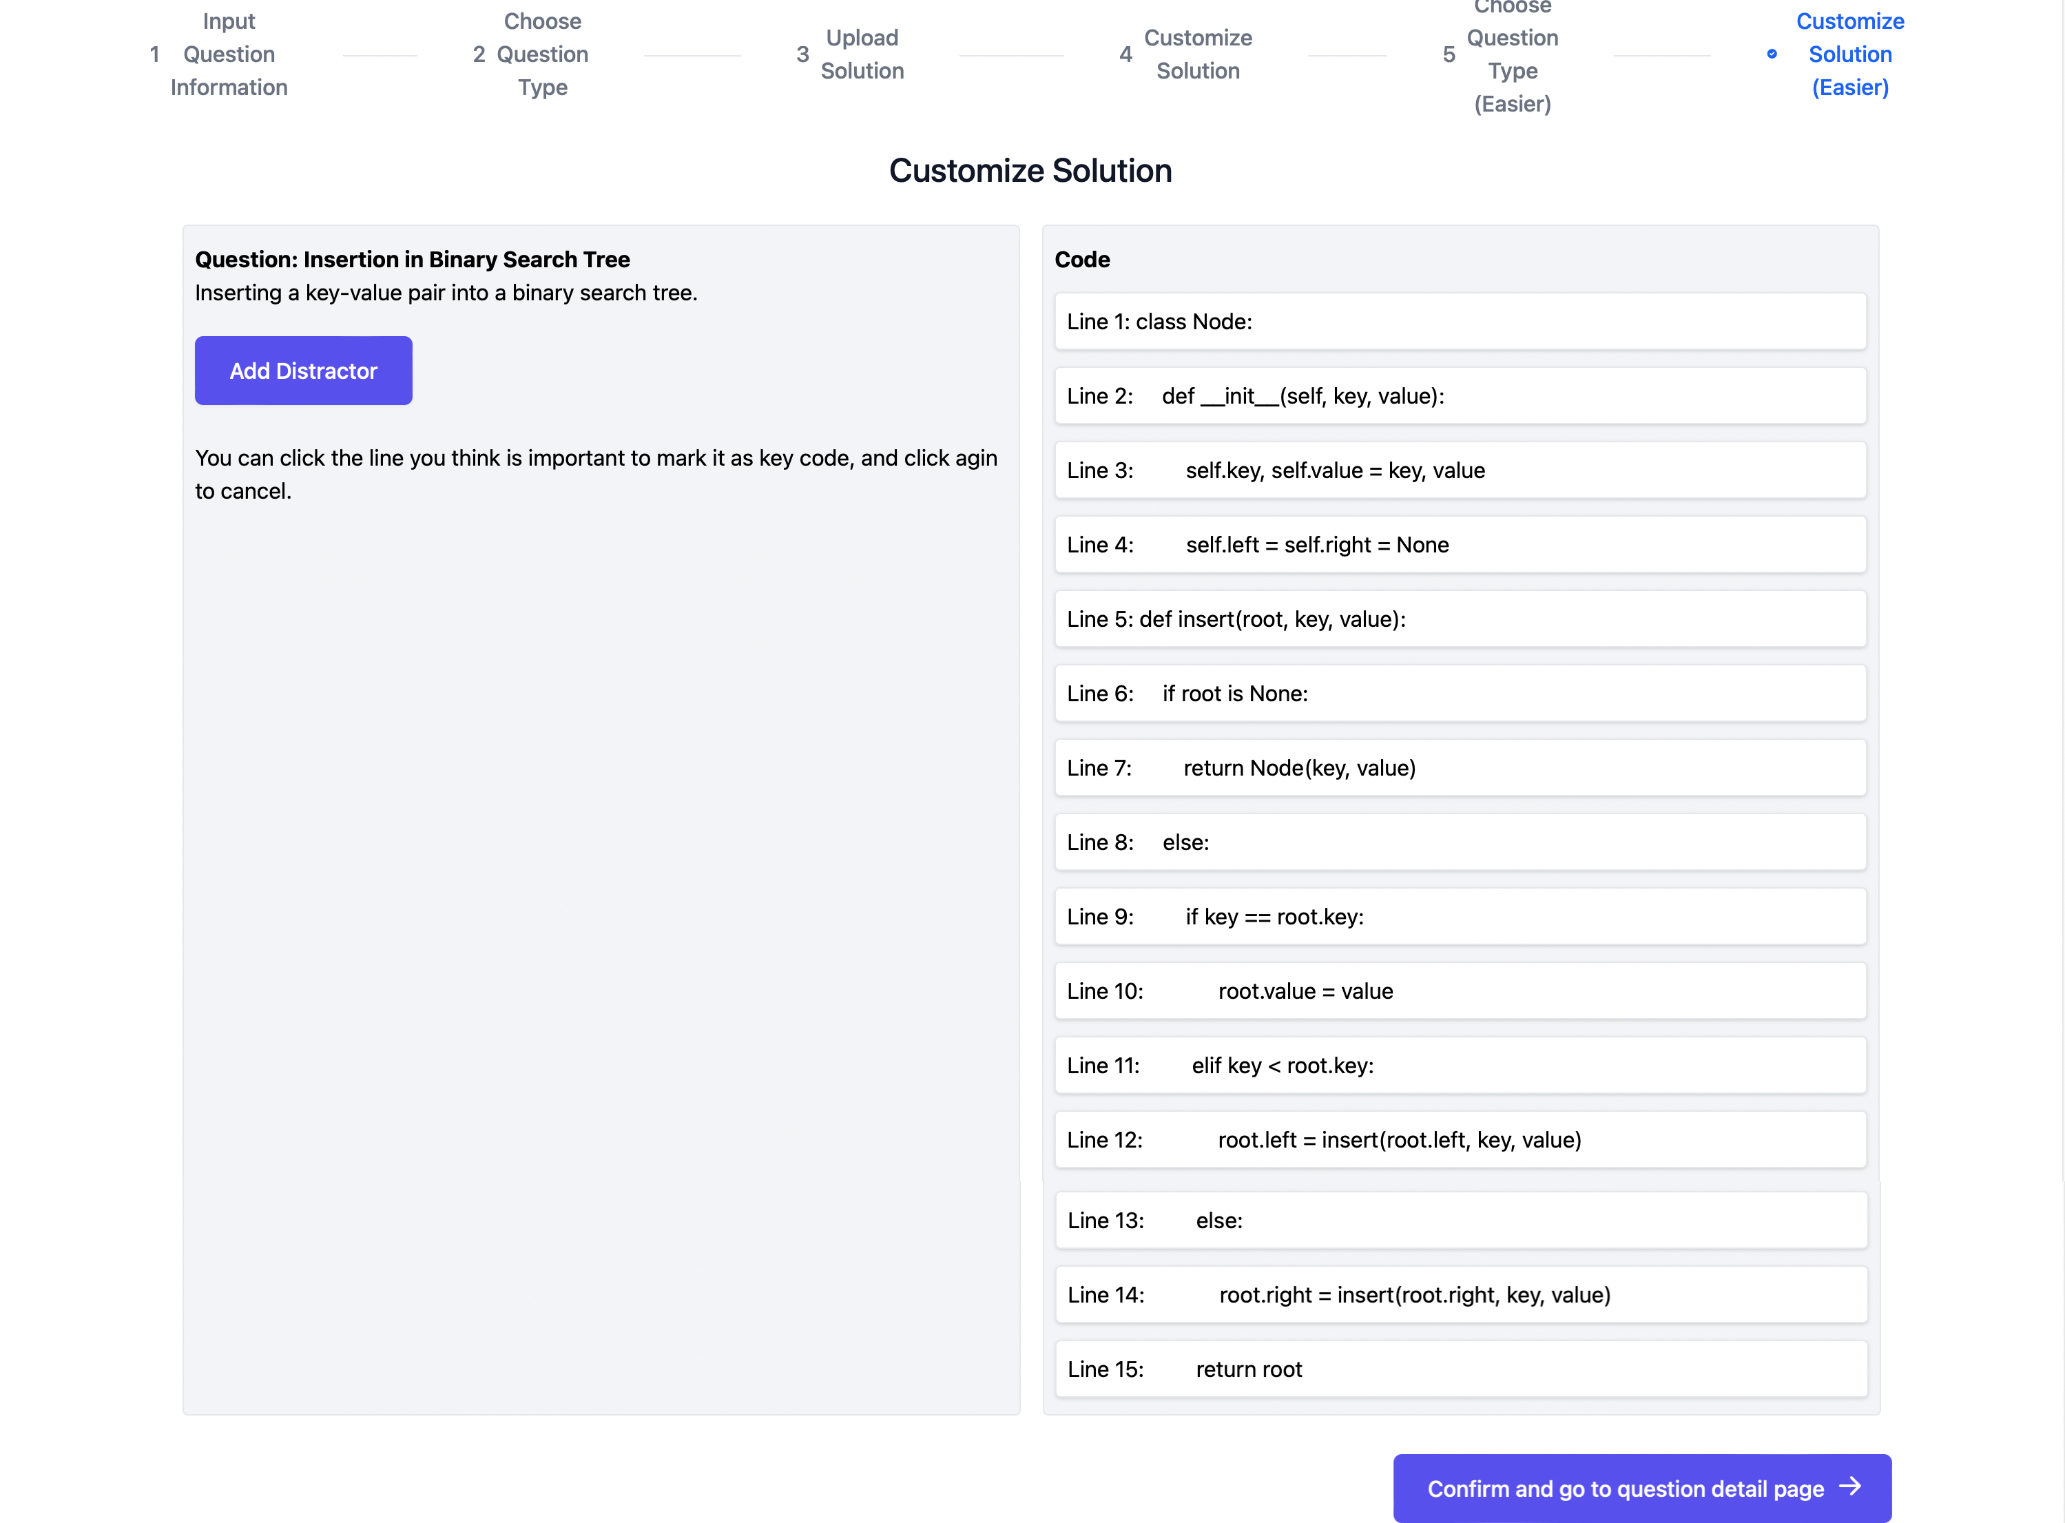

Figure 80 Switch difficulty level: customize solution for easier version

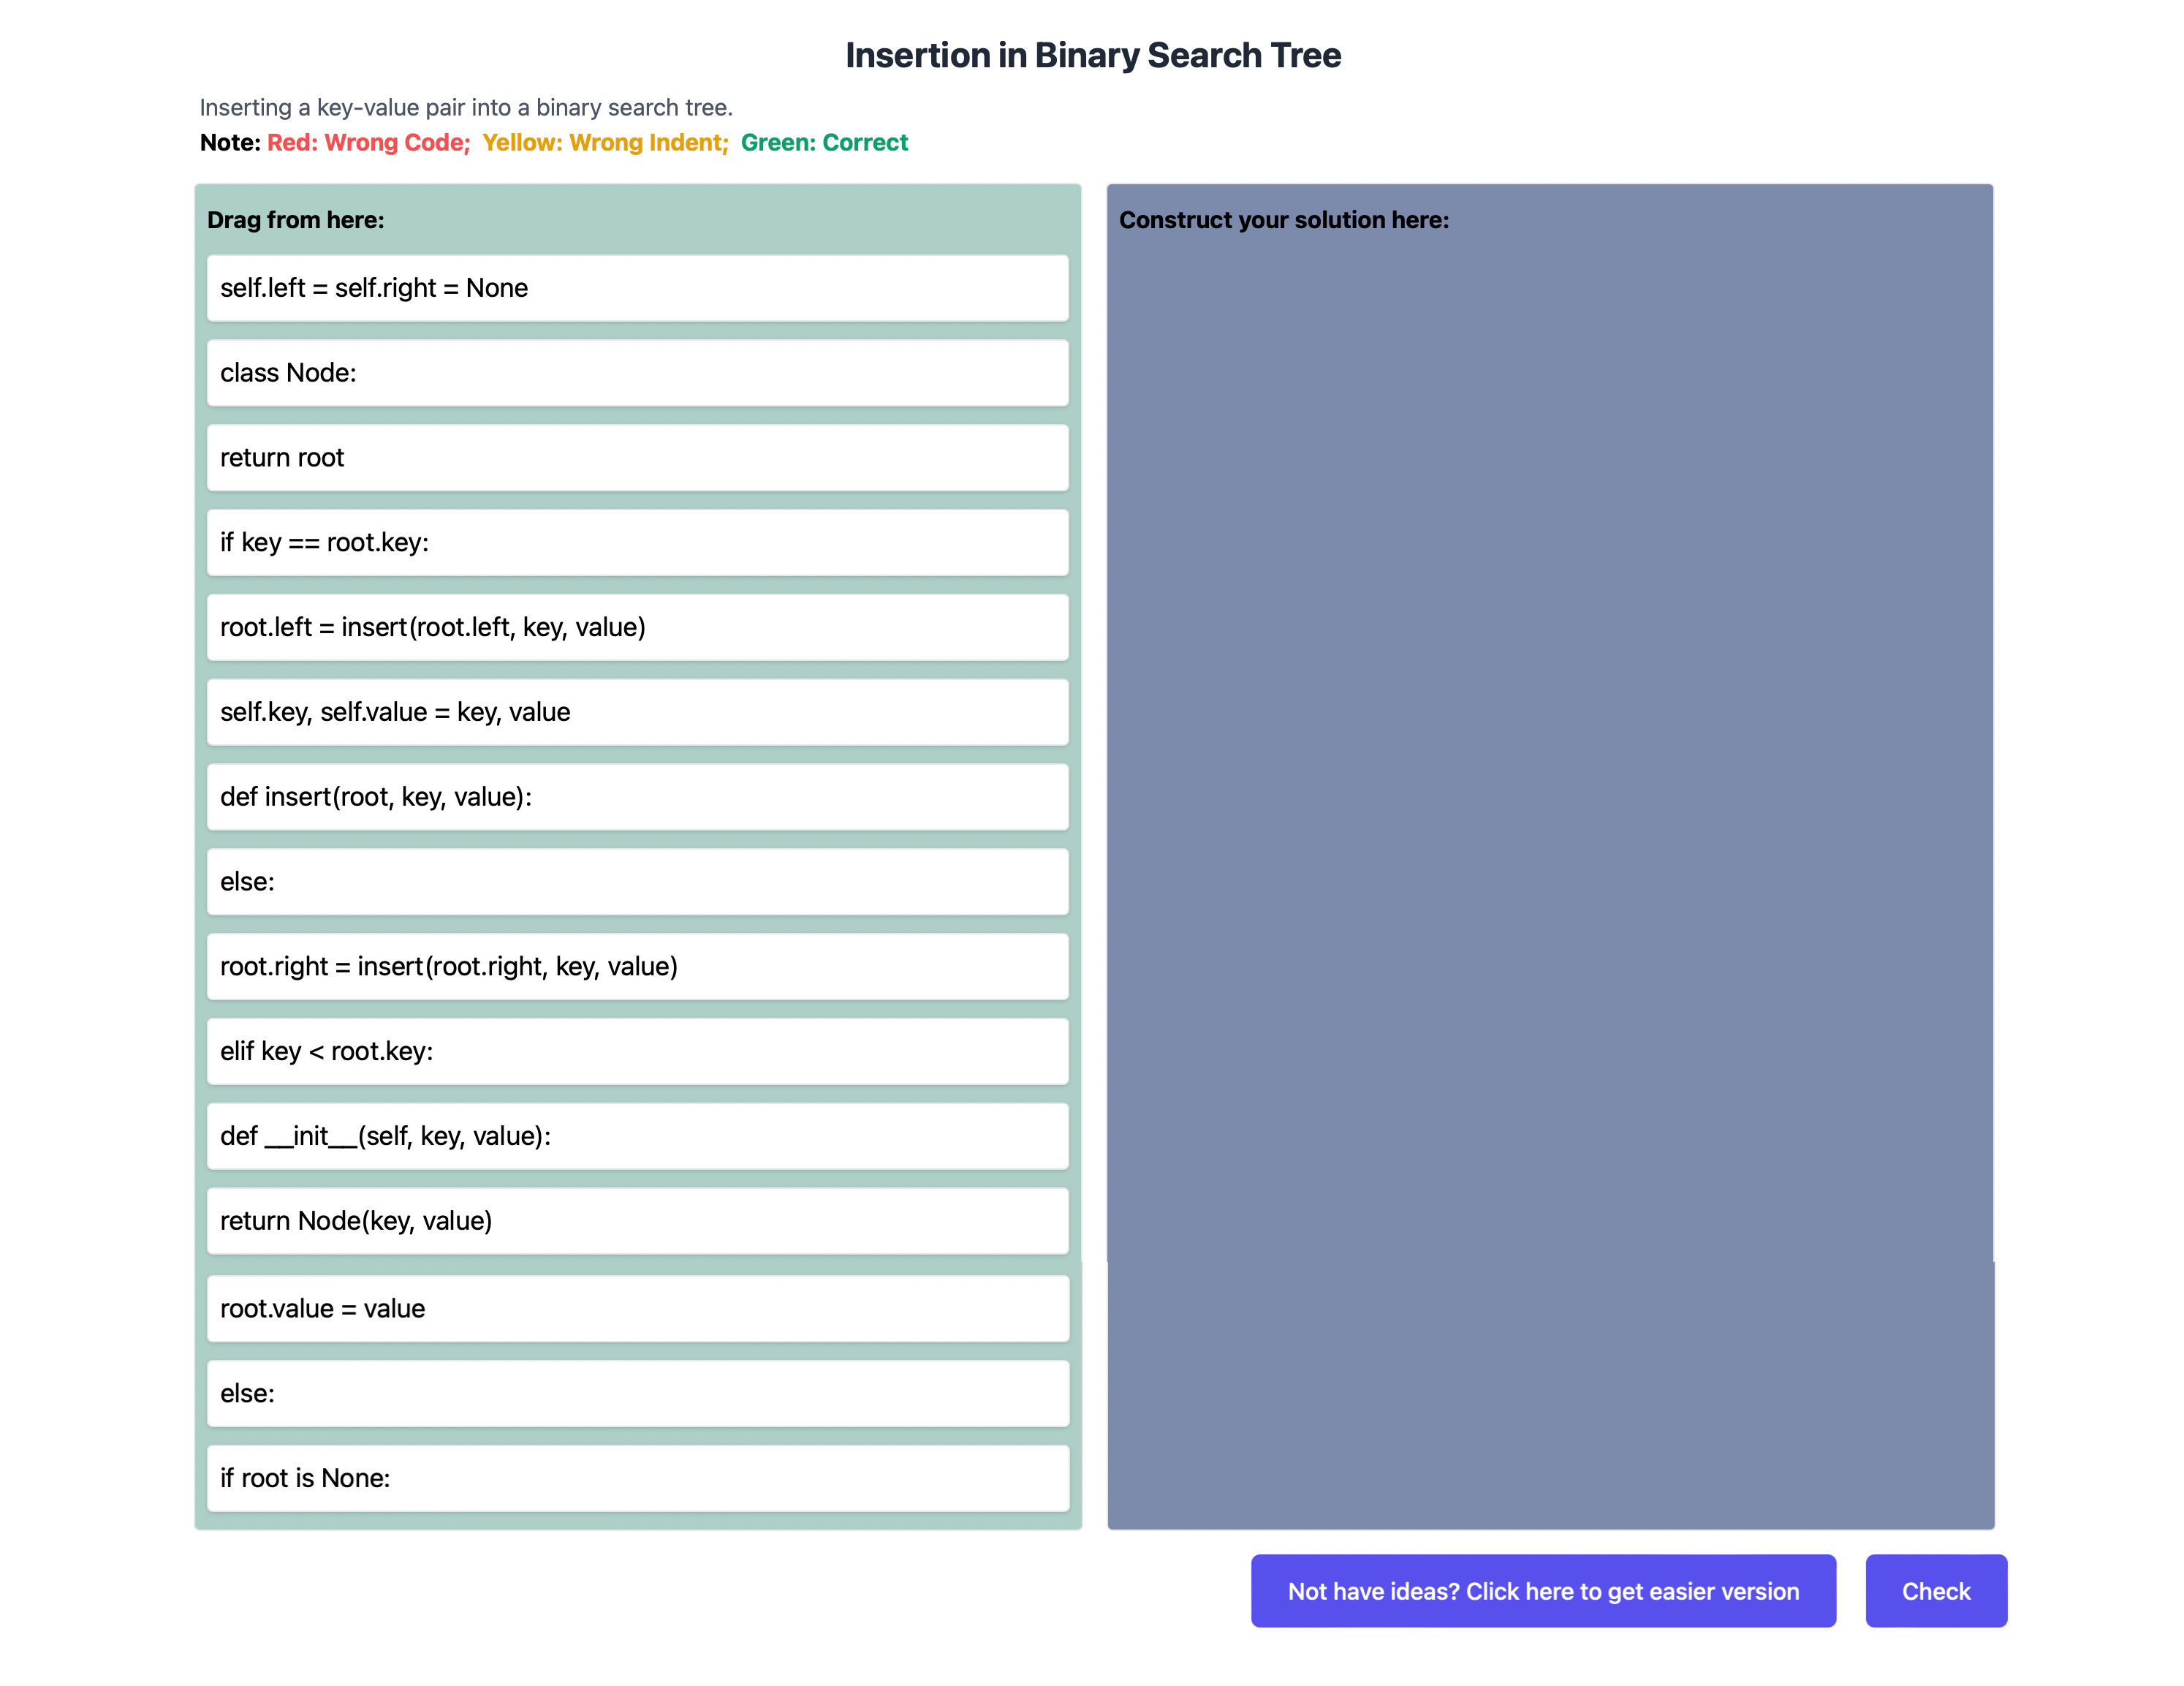

Figure 81 Switch difficulty level: exercise detail page of original question

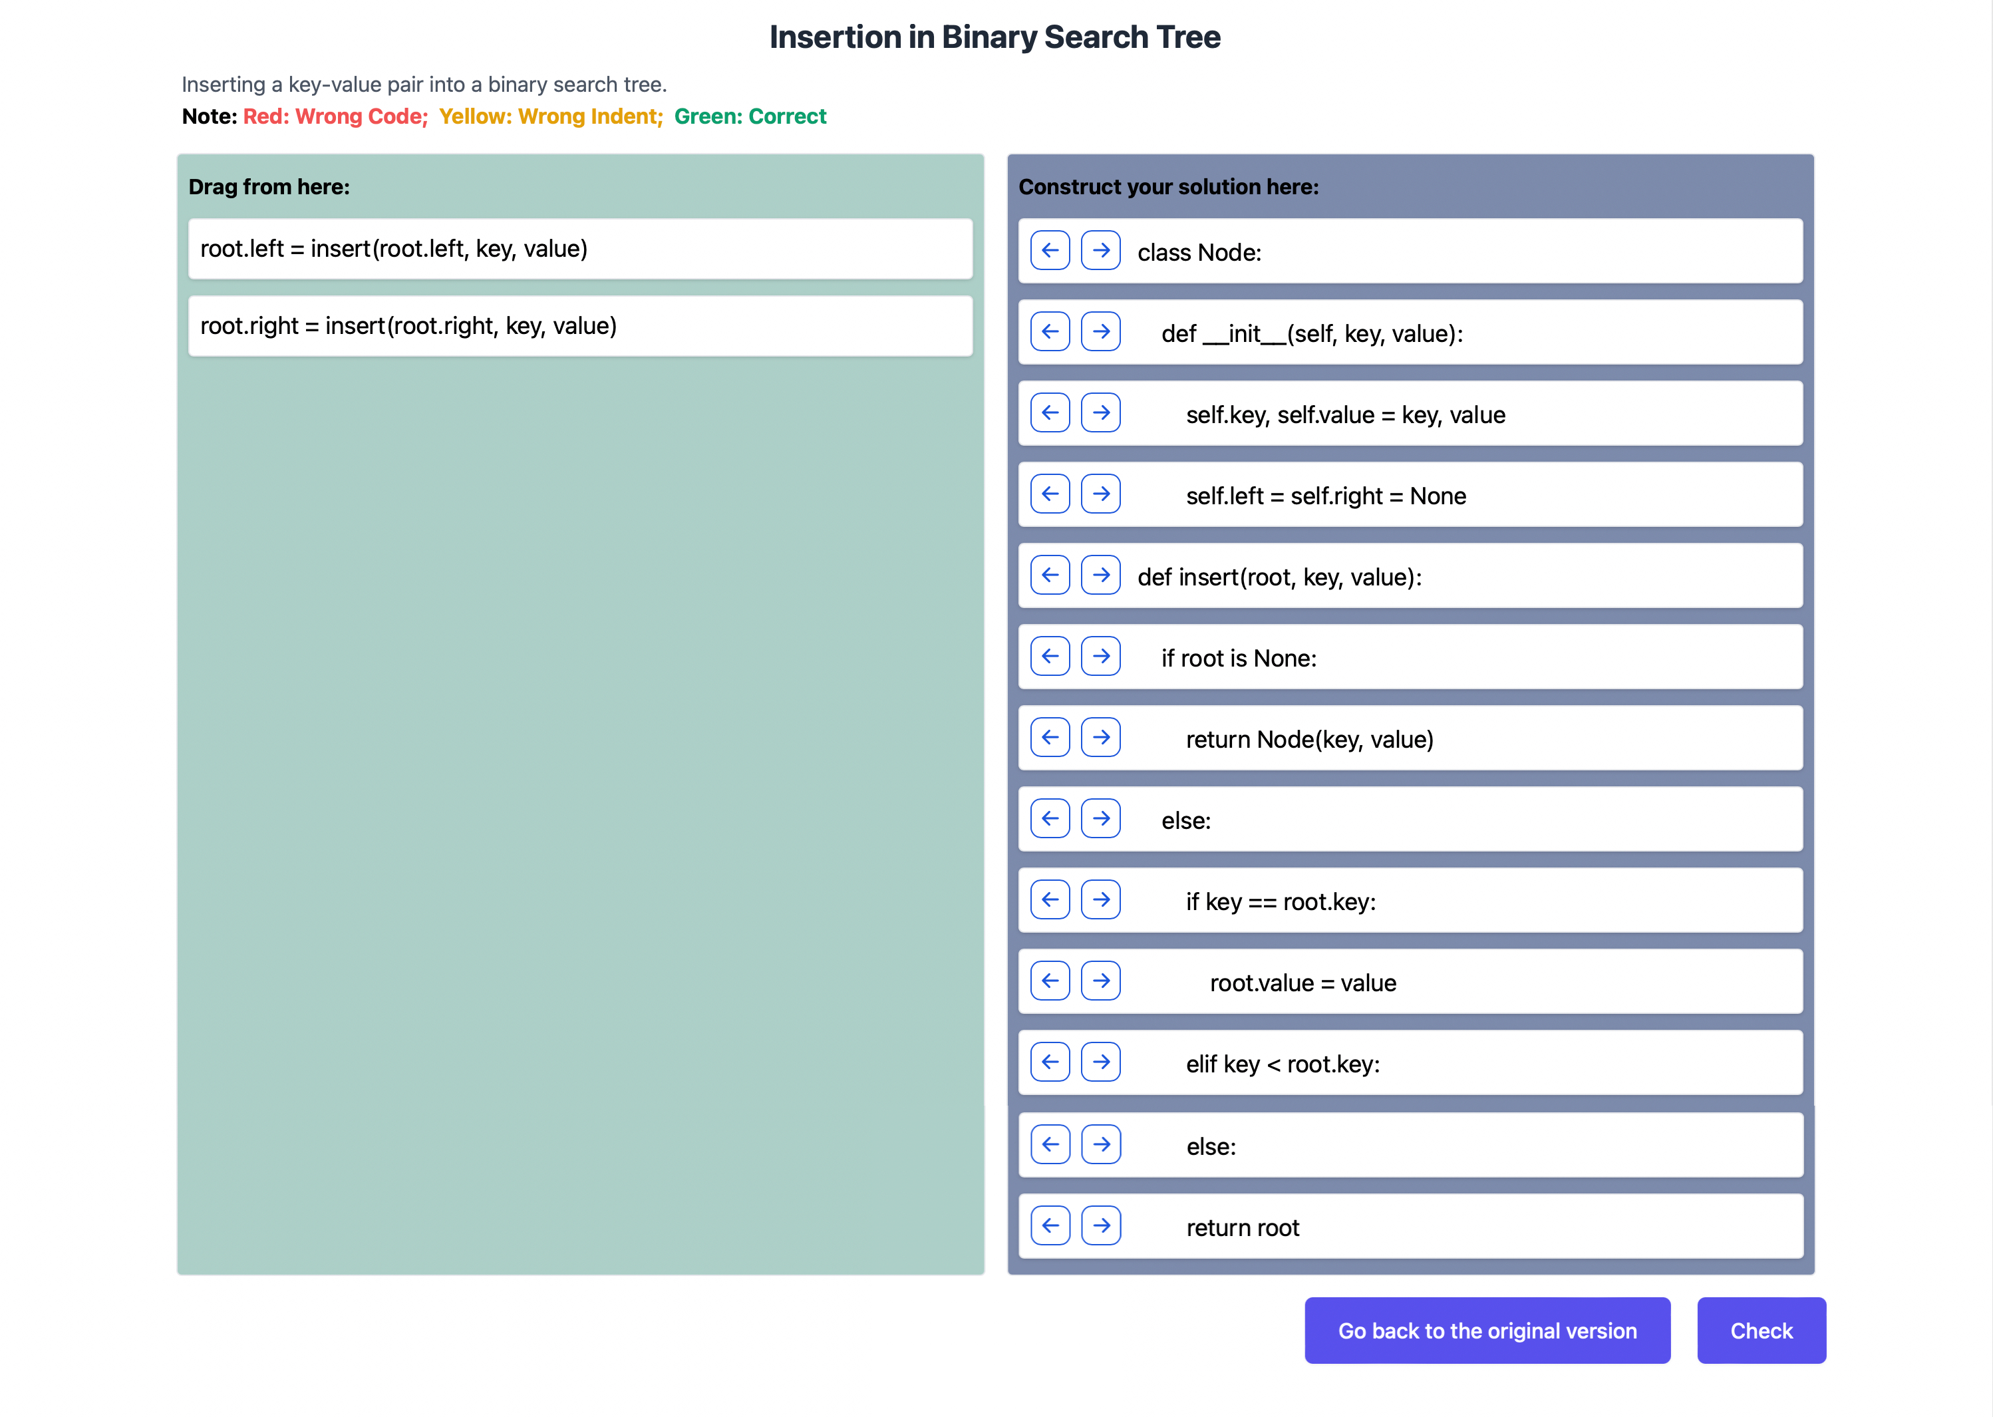

Figure 82 Switch difficulty level: exercise detail page for easier version

## Compare with the Traditional Parsons Problem

In this section, the effectiveness of the extended Parsons problem is illustrated by comparing with the traditional Parsons problem in the following three aspects – object-oriented programming, recursion, and comparison.

### Object-oriented programming

According to the discussion of chapter 3.1.1, changing the order of methods in a class may cause multiple correct answers. However, since the answers are checked by comparing them with the unique standard answer, some answers can be marked as wrong answer although they are totally correct. For example, in the question ‘implement stack with array’ shown in Figure 83 and Figure 84, the method ‘push’ and the method ‘is_empty’ are switched their position. Although both answers are correct, the second one is marked as wrong because of differentiating from the standard answers. The existence of multiple correct answers wastes students a lot of time guessing the standard answers instead of focusing on the exercise itself. Thus, in this project, the application of context is expanded to handle this situation. The context can not only be used to provide background information for students, they also can be used to give a fixed order of methods by pining the method headers (Figure 85). In this case, students can have a unique answer with the fixed order of methods.

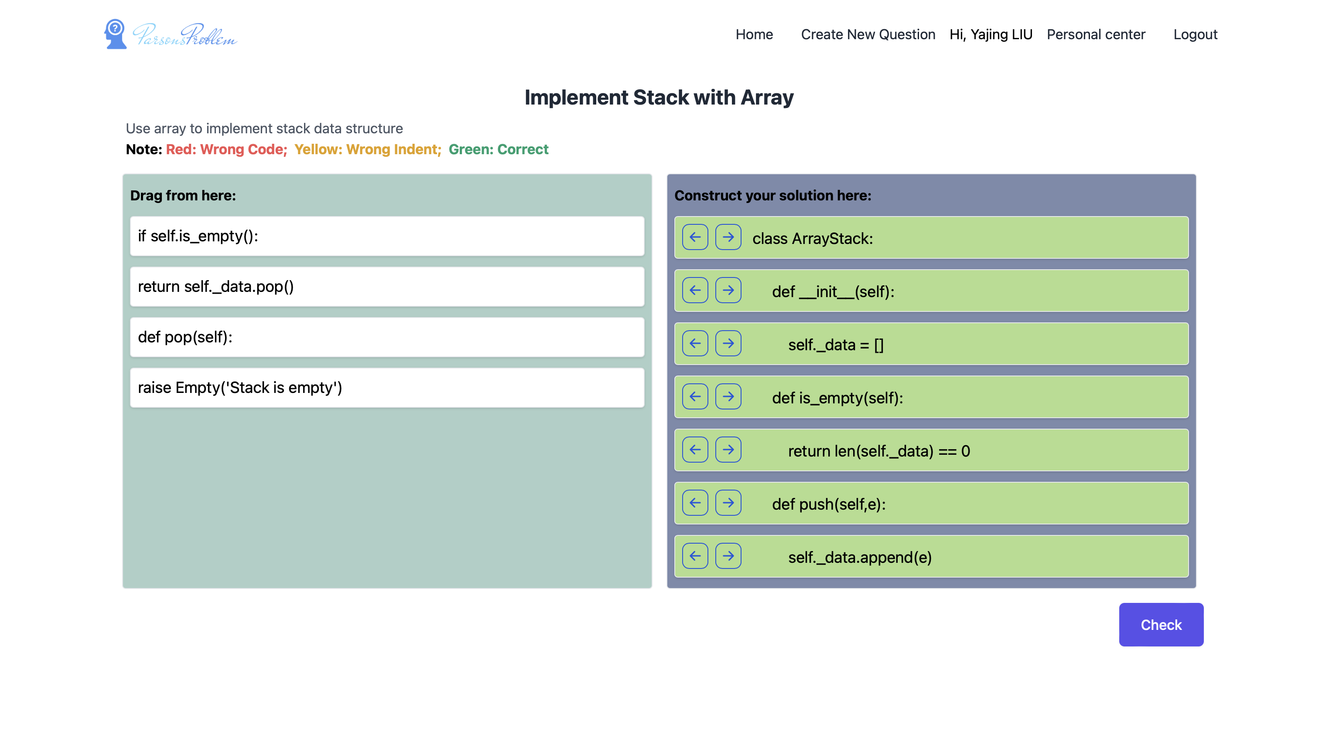

Figure 83 Example: multiple correct answers caused by changing method positions (1)

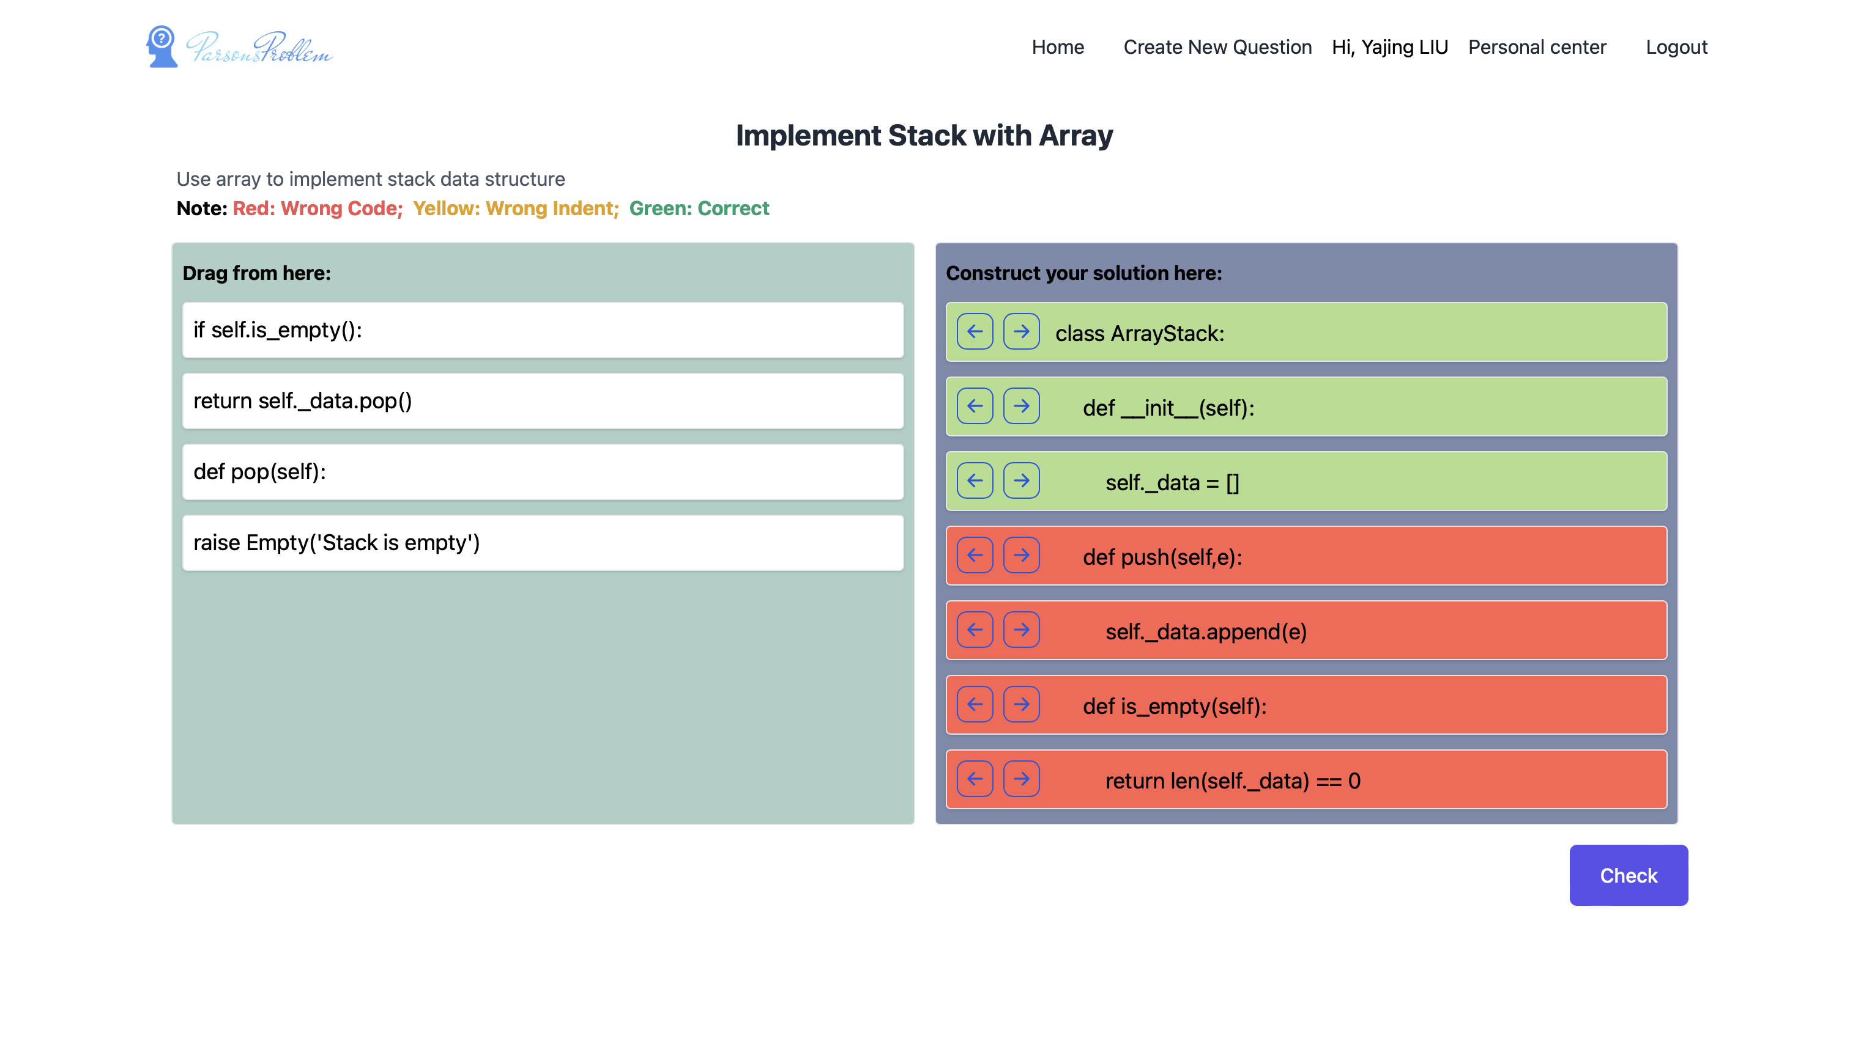

Figure 84 Example: multiple correct answers caused by changing method positions (2)

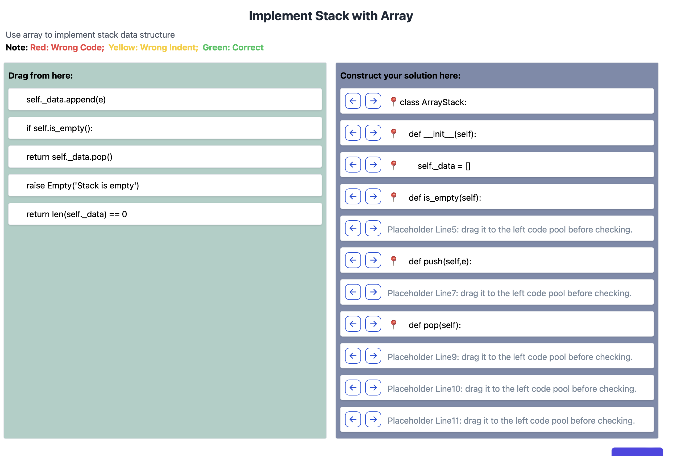

Figure 85 Example: pin the method headers to have fix order of methods

### Recursion

As the discussion in the chapter 3.1.3, it is difficult for students to get some ideas only by reading the codes like traditional Parsons problem. Taking the Tower of Hanoi shown in Figure 86 as an example, although the codes are quite short, it is still not simple for students to understand the codes even for reordering them. Thus, in this project, the recursion problem is divided into several steps to let students build from the base case to original recursion problem (Figure 87). It can not only give students more hints but also help students to get a common idea of solving recursion problem and help them solve complex recursion problem like Tower of Hanoi by themselves in the future.

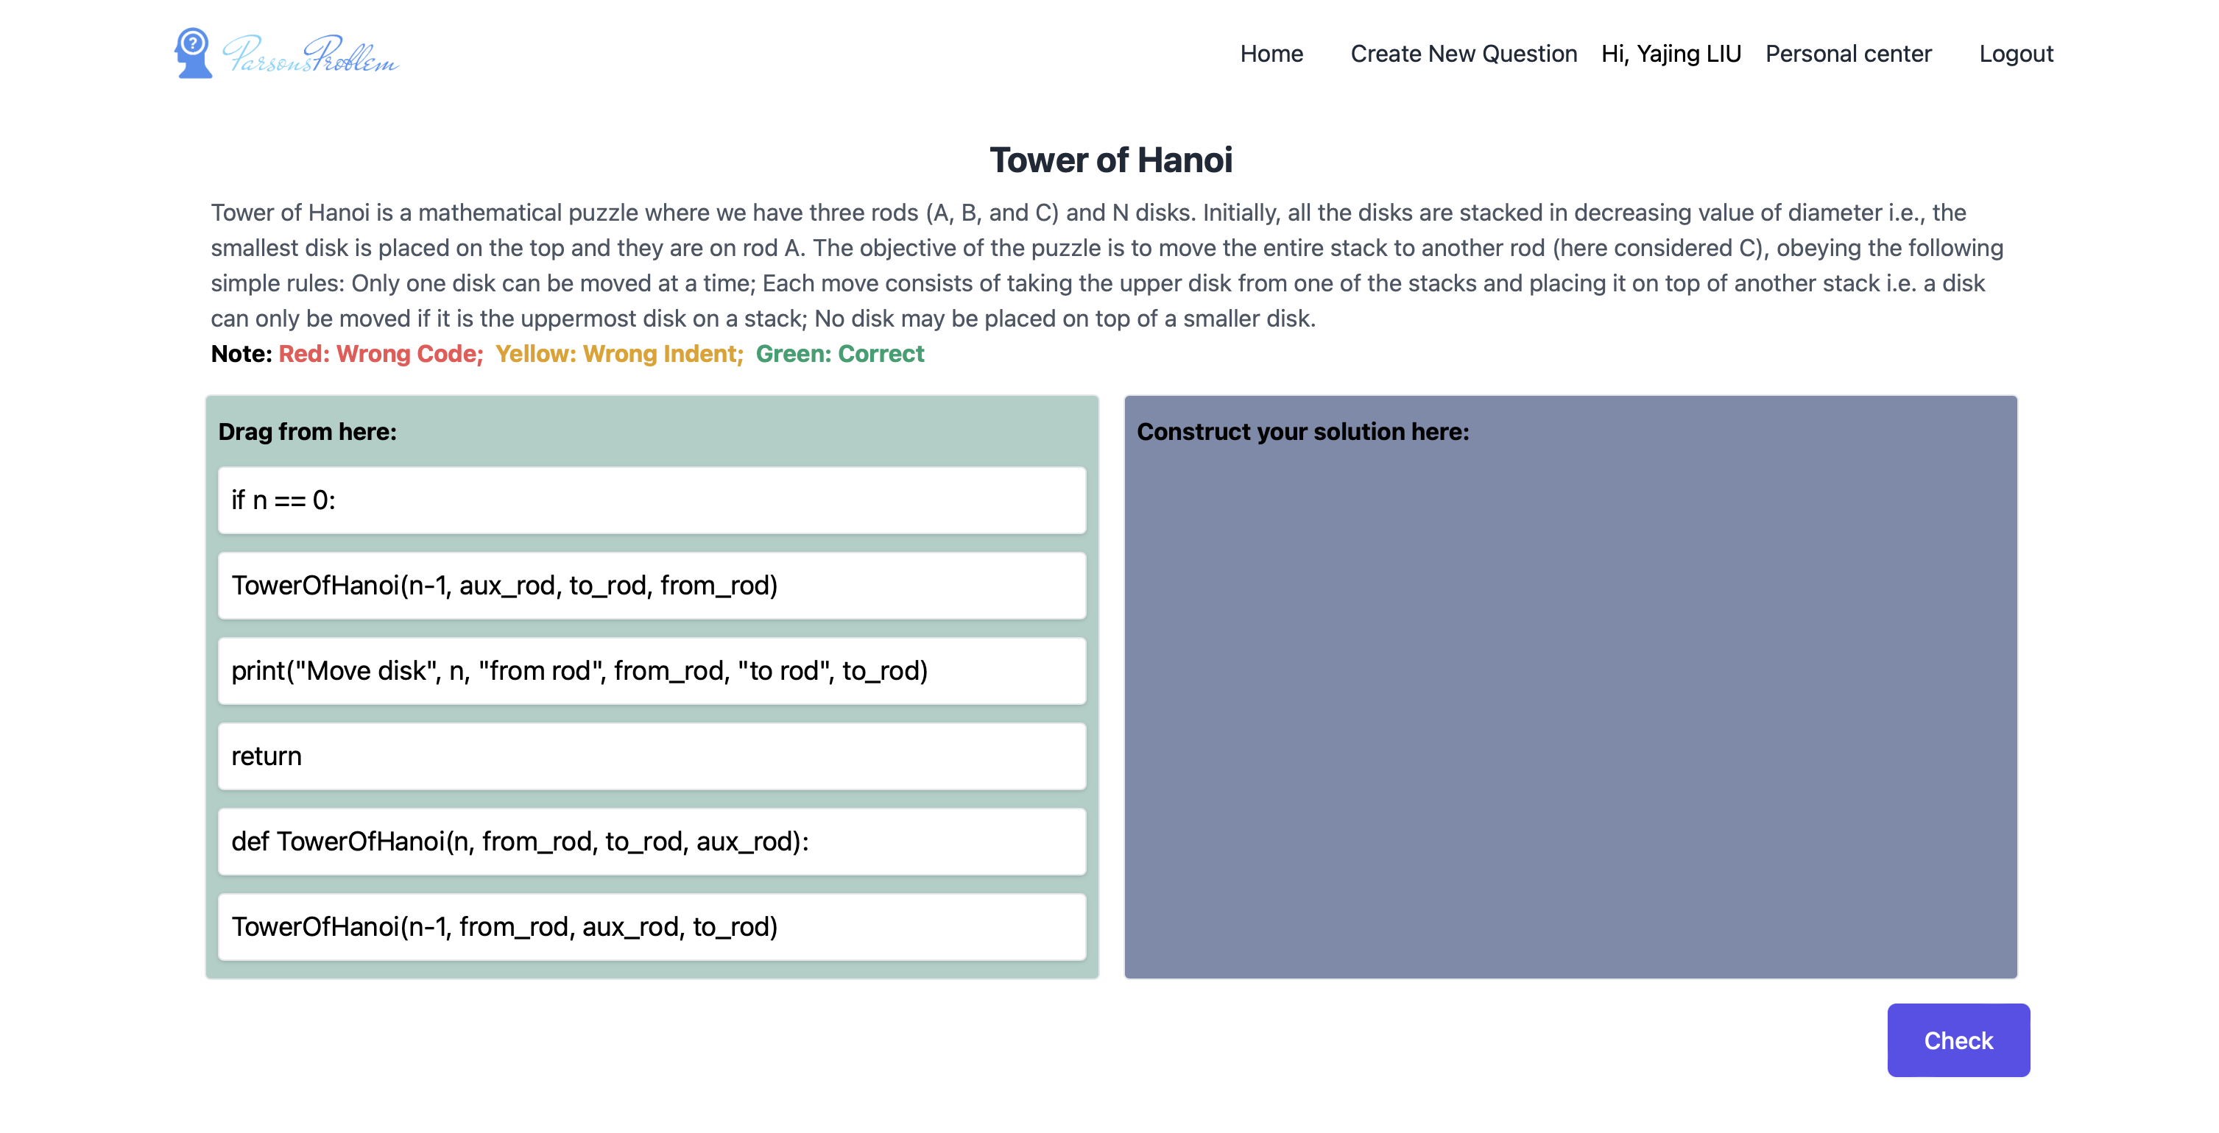

Figure 86 Tower of Hanoi



Figure 87 Divide recursion problems into several steps

### Comparison

As the discussion in chapter 3.1.4, there are a lot of similar or related codes in CS2. Although it is acceptable to use traditional Parsons problem individually for each code (for example, the selection sorting in Figure 88 and the insertion sorting in Figure 89), it would be more beneficial to help students compare these similar codes and consolidate the differences and similarities between them. In this way, students can distinguish between them and have a better understanding of the concepts. Thus, this project lets students divide the codes from one code pool to consolidate the difference between similar codes (Figure 90).

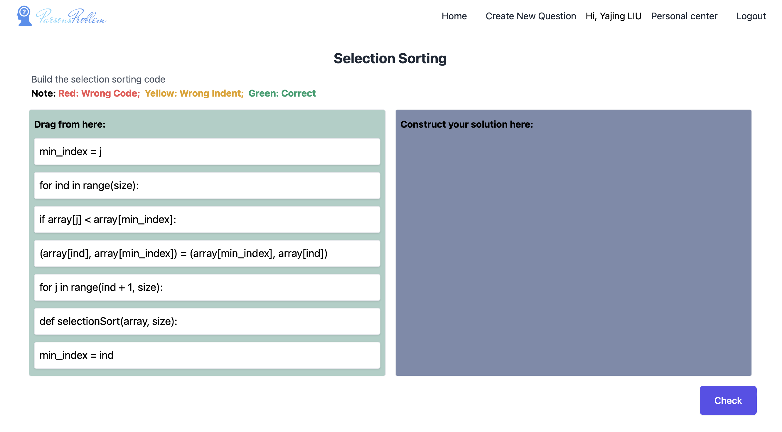

Figure 88 Selection sorting

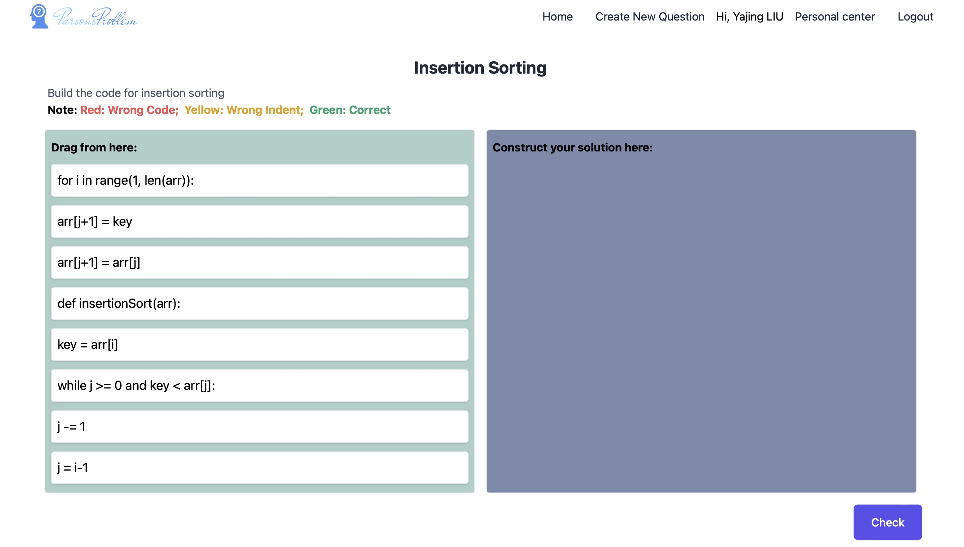

Figure 89 Insertion sorting



Figure 90 Compare selection sort and insertion sort

## Opinions from the Questionnaire Survey

To evaluate the effectiveness of this project, the questionnaires were provided to nine students from different grades who majored in computer science. Their opinions are summarized as follows.

In general, most of the interviewees think this project is advantageous to study Data Structures and Algorithms. From their point of view, they think it is easier than the traditional code writing way, and it is more friendly for beginners to learn this course helping them familiar with the knowledge. In addition, they also think it is more interesting and more fun to use this project than the traditional code writing way to study the course, which can simulate the desire of students to learn the knowledge. As for different parts of this project, they have different opinions.

### Reorder codes by dragging and dropping

Five interviewees think that the question form reordering codes by dragging and dropping is beneficial for students to learn Data Structures and Algorithms. From their perspective, it is more intuitive and easier for students to build solving ideas from the given code options instead of writing from nothing. It is especially useful for students who are not so good at programming. The codes given can give them some ideas for solving the problem, preventing them from having a blank brain and no way to solve at all. Moreover, it takes less time and helps students quickly build codes of the question. In addition, this question form allows students to focus on the question itself instead of some careless bugs.

In contrast, the two students have opposite opinions about the question form reordering codes by dragging and dropping. They think that if students rely on drag-and-drop forms, then their ability to write code independently may be reduced, which may cause problems when they actually need to write codes in assignments or exams. In addition, since this question form is the only form in this project, Students may feel monotonous for a long period of exercise. Thus, multiple different question forms are required.

### Check and feedback

Five of the interviewees think it is useful for the check and feedback used in this project. They think that this function can help students get reactive feedback and help them correct their answers in time. Besides, it provides hints for students to modify, and even if the students do not have any ideas, they can also learn by trying again and again. In addition, the checking and feedback system can reduce the teacher’s workload in assessing students’ score.

Three students do not agree with the previous opinions. They think the checking and feedback ways may cause a lot of problems. Specifically, some codes can be switched order (like different value assignments), and students may need to waste time to guess the correct order of answers in this situation. In addition, through checking compared with standard answers, students may only remember the order of correct answers rigidly and do not know the principle behind the codes. To be more specific, traditionally, students learn to program as a process of constantly writing code, getting some output, and then adjusting or adding codes based on the output. In this process, students' perception of the problem is an accumulative one, meaning that they gradually think about what each step of the code does and what it means in the process. However, in the case of Parsons problem, they may simply mechanically adjust the answer to match the standard answer step by step without understanding the reason for each step. For this situation, the code execution engine needs to be introduced in this project to give students more feedback about what happens through output. Last but not least, one of the students thinks that it will be better to give students some intelligent explanation about codes to help students have a deepened understanding. To achieve the Chat GPT API may need to be introduced into this project.

### Comparison

Five interviewees think the comparison is of use for students to learn Data Structures and Algorithms. From their point of view, comparison is one of the important ways to learn to program. By comparing different codes about similar or related concepts, students can deepen their understanding, have a stranger impression, and get a global view of these codes.

### Switching difficulty level

Four interviewees think the function about switching difficulty level is beneficial for students to learn Data Structures and Algorithms. They believe that the ability to switch difficulty level gives both teachers and students more freedom. On the one hand, the teacher can design different difficulty level settings for different classes according to the actual situation of every class, which can prevent two classes from copying each other to a certain extent. On the other hand, it allows students of different levels to independently choose the difficulty level that suits them according to their situation.

In contrast, the two students have different opinions. They think switching difficulty level can be more interesting by having more different types of easy version of question. Besides, they think that it can have more fun by providing multiple easy versions for students to choose by themselves.

### View students’ exercise records

Three interviews mentioned the effectiveness of viewing students’ exercise records. They think that it can help teachers grasp students’ learning progress and help teachers to have a clear view about students’ level of mastery of different problems and to explain the questions that most students have problems.

### Online platform

One interview mentions the benefits of the online platform of this project. It not only allows students to practice freely at anytime and anywhere, but it also helps teachers to monitor and manage student practice. Moreover, it can reduce the use of paper and contribute to environmental protection.

### User experience

Four interviewees give some suggestions about improving user experience. To be more specific, one of the interviewees think that the current process of teachers creating a complete question is somewhat cumbersome and difficult to operate, resulting in teachers not being as efficient in generating paper exam. He also mentioned that it is also cumbersome to set the indent of codes. In addition, he found that the drag-and-drop action may not move smoothly. Besides, he hopes that this project can fit the mobile phone in the future. Another suggestion from the other two interviewees is about teacher’s personal center. They think that more statistical data like the maximum score, and minimum score of every question, can be added to teacher’s personal center. Besides, a message can be sent to the teacher if a new record is created by students. Finally, an interviewer mentioned that it is more user-friendly if the finished question can be marked differently on students’ home page.

## . Limitation

This section is about the limitation of this project. It is divided into two parts – the limitation caused by the Parsons problem itself and the limitation caused by tight time.

### Limitation caused by the Parsons problem itself

Multiple correct answers checking issues is one of the limitations caused by the Parsons problem itself. As the discussion in chapter 3.3, to ensure the flexibility of the project to handle the nine different problem types mentioned in that chapter, comparing with the standard answers instead of execution-based feedback is selected as the checking and feedback method of this project. In other words, this method needs to compare students’ answers with a unique predefined standard answer. Although this method is acceptable most of time, it may have some problems when some codes can be switched positions without affecting the correctness of the question. To solve this problem, the most basic logic about checking and feedback needs to be changed to execution-based feedback. This solution will not only cause uncounted changes in the existing project, but also cause some functions like algorithm analysis is not applicable at all.

Another limitation is the application scenarios of this project. This project may be more appropriate as part of the student's own practice rather than an assignment where grades are strictly recorded. One of the major purposes of Parsons problem is to use easier way reordering rather than writing code directly to encourage students to practice programming more and get prepared for writing code in the future. For this reason, the Parsons problem provides many positive feedbacks like checking the codes frequently, marking codes with different background colors as feedback, and recording the highest score only. In other words, students can also have chances to get high scores by trial-and-error at all. That will cause all students’ scores to be inflated, which can not assess students carefully. However, it will be contrary the key value of Parsons problem if these positive feedbacks are removed.

### Limitation caused by the tight time

To achieve the best performance within the limited time, only the question types are significantly different from each other are developed. In other words, for the present project, some question types mentioned in 3.3 have not developed yet (the question type check only inside block, link together, data structure implementation comparison and algorithm analysis). In addition, the combination of different types of questions has not been developed maturely.

Because of time limitation, only the questionnaire for few students is used to evaluate the effectiveness of this project. This evaluation way may have some deviations due to the small sample size and interviewee’s subjective thinking. To have more accurate evaluation results of this project, a controlled experiment should be organized for the real students of the course Data Structures and Algorithms. These students should be divided into two groups, one using only traditional code writing way, one using traditional code writing way plus the expanded Parsons problem in this project. Finally, compare the scores of these two groups to see whether this project can cause any improvement in students learning.

# Conclusion and Future Work

In conclusion, this project explored the possible application of Parsons problem in Data Structures and Algorithms. The Parsons problem is achieved and expanded through a web application in this project. Parsons problem in this project can not only have the basic functions as the traditional one (including inputting question and prepared Python solution, generating Parsons problem, presenting Python Parsons problem in 2D, solving the problems by dragging and dropping, checking and giving feedback), but also it supports different property for codes, the coexistence of lines and blocks, and the existence of multiple solutions in order to handle the specific questions in CS2 about data structures, recursion and algorithms. As for the difficulty handling, this project involves switching difficulty level and insert key code.

The project’s main contribution is to provide an online Parsons problem platform that can help students learn data structures and algorithms more effectively. It can not only improve students’ engagement and reducing students’ cognitive load as the traditional Parsons problem, but also can help students to consolidate knowledge though comparing similar concepts.

In the future, experiments will be conducted to compare the effectiveness of this tool with traditional learning methods. In addition, questionnaires will be sent to more students and lecturers to collect their opinions on improving system.

References

[1] M. Hertz, “What Do "CS1" and "CS2" Mean? Investigating Differences in the Early Courses,” in Proceedings of the 41st ACM Technical Symposium on Computer Science Education, Milwaukee, 2010.

[2] D. Parsons and P. Haden, "Parson's Programming Puzzles: A Fun and Effective Learning Tool for First Programming Courses," in Australian Computer Society, Inc., Hobart, 2006.

[3] Y. Du, A. Luxton-Reilly and P. Denny, “A Review of Research on Parsons Problems,” in Proceedings of the Twenty-Second Australasian Computing Education Conference, 2020.

[4] P. Denny, A. Luxton-Reilly and B. Simon, “Evaluating a new exam question: Parsons problems,” in Proceedings of the ACM Workshop on International Computing Education Research, 2008.

[5] B. B. Morrison, L. E. Margulieux, B. Ericson and M. Guzdial, “Subgoals Help Students Solve Parsons Problems,” in Proceedings of the 47th ACM Technical Symposium on Computing Science Education, Memphis, 2016.

[6] P. Ihantola and V. Karavirta, "Two-Dimensional Parson's Puzzles: The Concept, Tools, and First Observations," Journal of Information Technology Education: Innovations in Practice, vol. 10, pp. 119-132, 2011.

[7] A. Kumar, “Epplets: A Tool for Solving Parsons Puzzles,” in Proceedings of the 49th ACM Technical Symposium on Computer Science Education, New York, 2018.

[8] M. T. Goodrich, R. Tamassia and M. H. Goldwasser, Data Structures and Algorithms in Python, Hoboken: Wiley, 2018.

[9] “Wikipedia of Object-oriented programming,” [Online]. Available: https://en.wikipedia.org/wiki/Object-oriented_programming.

[10] “Python Program for Tower of Hanoi,” GeeksforGeeks, [Online]. Available: https://www.geeksforgeeks.org/python-program-for-tower-of-hanoi/.

[11] “Vue.js - The Progressive JavaScript Framework | Vue.js,” [Online]. Available: https://vuejs.org.

[12] J. Patel, “9 reasons why vue.js is best for a robust web app development,” 4 May 2021. [Online]. Available: https://www.monocubed.com/blog/why-vuejs-gaining-popularity/. [Accessed 8 March 2023].

[13] “Tailwind CSS - Rapidly build modern websites without ever leaving your HTML,” [Online]. Available: https://tailwindcss.com. [Accessed 9 March 2023].

[14] G. Kishore, “Top 5 advantages of using tailwind CSS,” 13 October 2020. [Online]. Available: https://www.grazitti.com/blog/top-5-advantages-of-using-tailwind-css/. [Accessed 8 March 2023].

[15] A. Fitzgerald, “Tailwind CSS: What it is, why use it & examples,” 30 May 2022. [Online]. Available: https://blog.hubspot.com/website/what-is-tailwind-css. [Accessed 8 March 2023].

[16] “TypeScript: JavaScript With Syntax For Types,” [Online]. Available: https://www.typescriptlang.org. [Accessed 9 March 2023].

[17] G. Kubiak, “Why use TypeScript? Could it be the best way to write frontend in 2021?,” 09 March 2021. [Online]. Available: https://tsh.io/blog/why-use-typescript/. [Accessed 8 March 2023].

[18] “Vue Router | The official Router for Vue.js,” [Online]. Available: https://router.vuejs.org. [Accessed 9 March 2023].

[19] B. Oldén, “Vue Router (Why Use It, Plus 3 Things You Need To Know),” 10 February 2023. [Online]. Available: https://beginnersoftwaredeveloper.com/vue-router-why-use-it/#what-is-vue-routing. [Accessed 9 March 2023].

[20] “What is Vuex? | Vuex,” [Online]. Available: https://vuex.vuejs.org. [Accessed 9 March 2023].

[21] “vue.draggable.next,” [Online]. Available: https://github.com/SortableJS/vue.draggable.next. [Accessed 9 March 2023].

[22] E. Asaolu, “Getting started with vue.draggable,” 10 September 2021. [Online]. Available: https://blog.logrocket.com/getting-started-vue-draggable/#vuedraggable-examples. [Accessed 9 March 2023].

[23] “Axios,” [Online]. Available: https://axios-http.com. [Accessed 9 March 2023].

[24] J. Lewis, “HTTP Requests Compared: Why Axios Is Better Than Node-Fetch (Automatic Transformations, More Secure, Can Handle Errors Better, Interceptor Support, And More Browser Friendly),” 19 July 2018. [Online]. Available: https://medium.com/@jeffrey.allen.lewis/http-requests-compared-why-axios-is-better-than-node-fetch-more-secure-can-handle-errors-better-39fde869a4a6. [Accessed 9 March 2023].

[25] “Welcome to Python.org,” [Online]. Available: https://www.python.org. [Accessed 9 March 2023].

[26] “FastAPI,” [Online]. Available: https://fastapi.tiangolo.com. [Accessed 9 March 2023].

[27] “Vue Grid Layout - JBay Solutions,” [Online]. Available: https://jbaysolutions.github.io/vue-grid-layout/. [Accessed 9 March 2023].

[28] “Vue Draggable Nested,” [Online]. Available: https://sortablejs.github.io/Vue.Draggable/#/nested-with-vmodel. [Accessed 9 March 2023].

[29] “he-tree,” [Online]. Available: https://hetree.phphe.com. [Accessed 9 March 2023].

Appendix A. Project Management

The program plan (Figure 91) and the Gantt chart (Figure 92) of this project is shown below.

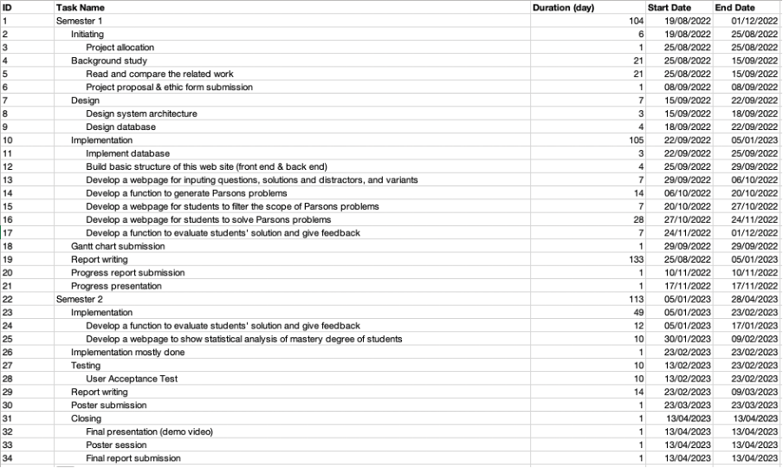

Figure 91 Program plan



Figure 92 Gantt chart

Appendix B. Reflection

It was a very tough year to complete my final year project. On the one hand, the final project was very demanding on my overall skills. It was a comprehensive application of all the courses I had taken over the past four years, testing my skills in programming, database design and management, and user interface design. On the other hand, it is a personal project with a tight schedule, quite testing my ability to solve problems under high pressure. However, that is why the final year project is so effective in improving my practical skills and enabling me to translate my knowledge into practical skills for my future work. The project also gives me some initial exposure to research skills that will be useful for my future graduate studies.